**A PROPOSED DESIGN AND IMPLEMENTATION OF GYM MANAGEMENT SYSTEM**

### A PROJECT REPORT

***Submitted by***

**Shiva Sharma** (21MCA10004)

**Vinay Vincent** (21MCA10021)

**Rishi Shukla** (21MCA10105)

*in partial fulfillment for the award of the degree of*

## MASTER OF COMPUTER APPLICATION

*in*

### COMPUTER SCIENCE AND ENGINEERING



**SCHOOL OF COMPUTING SCIENCE AND ENGINEERING**

## VIT BHOPAL UNIVERSITY

**KOTHRIKALAN, SEHORE MADHYA PRADESH – 466114**

#### July 2022

**VIT BHOPAL UNIVERSITY, KOTHRIKALAN, SEHORE MADHYA PRADESH – 466114**

## BONAFIDE CERTIFICATE

Certified that this project report titled **“Shiksha Anudan”** is the bonafide work of “**Shiva Sharma (21MCA10004), Vinay Vincent (21MCA10021), Rishi Shukla (21MCA10105)”** who carried out the project work under my supervision. Certified further that to the best of my knowledge the work reported at this time does not form part of any other project/research work based on which a degree or award was conferred on an earlier occasion on this or any other candidate.

##### PROGRAM CHAIR PROJECT GUIDE

Dr. Kanchan Lata Kashyap, Dr. Kanchan Lata Kashyap,

Assistant Professor (Senior) and Assistant Professor (Senior) and Program Chair – MCA Program Chair – MCA

School of Computer Science and Engineering School of Computer Science and Engineering VIT BHOPAL UNIVERSITY VIT BHOPAL UNIVERSITY

The Project Exhibition I Examination is held on 14-07-2022

## ACKNOWLEDGEMENT

First and foremost I would like to thank the Lord Almighty for His presence and immense blessings throughout the project work.

I wish to express my heartfelt gratitude to Dr. Kanchan Lata Kashyap, Head of the Department, School of Computer Science and Engineering for much of her valuable support encouragement in carrying out this work.

I would like to thank my internal guide Dr. Kanchan Lata Kashyap, for continually guiding and actively participating in my project, giving valuable suggestions to complete the project work.

I would like to thank all the technical and teaching staff of the School of Computer Science and Engineering, who extended directly or indirectly all support.

Last, but not least, I am deeply indebted to my parents who have been the greatest support while I worked day and night for the project to make it a success.

## LIST OF FIGURES

| **FIGURE NO.** | **TITLE** |
| --- | --- |
| **1** | **Context level DFD** |
| **2** | **Login** |
| **3** | **Membership** |
| **4** | **Profile** |
| **5** | **Attendance** |
| **6** | **Workout** |
| **7** | **Product** |
| **8** | **Payment** |

**LIST OF TABLES**

| **TABLE NO.** | **TITLE** |
| --- | --- |
| **1** | **Student** |
| **2** | **Donor** |
| **3** | **Transaction** |

### Abstract of the Project Shiksha Anudan:

Shiksha Anudan is a cross platform application which facilitates Student to raise fund for their higher studies by donors who are willing to fund them. Shiksha Anudan bridges the gap between Student and Donor.

Here is our feature list which is continually growing:

* Manage Student
* Manage Donor
* Complete payment statistics
* Verify Details submitted by Donor as well as Student.
* Approve or Block Student based on the document verification.
* Monitor Student donation received.
* Student can see their own statistics and payment history.
* Donor can see their own statistics and payment history

## TABLE OF CONTENTS

| **CHAPTER NO.** | **TITLE** | **PAGE NO.** |
| --- | --- | --- |
|  | List of Abbreviations  List of Figures and Graphs | iv v |
| List of Tables | vi |
| Abstract | vii |
| 1 | **CHAPTER-1:** |  |
|  | **PROJECT DESCRIPTION AND OUTLINE** | 1 |
|  | 1.1 Introduction |  |
|  | 1.2 Motivation for the work | . |
|  | 1.3 Problem Statement | . |
|  | 1.4 Objective of the work |  |
|  | 1.5 Summary | . |
|  |  |  |
| 2 | **CHAPTER-2: RELATED WORK INVESTIGATION**   * 1. Introduction   2. Core area of the project   3. Existing Approaches/Methods   4. Pros and cons of the stated Approaches/Methods | 12 |
| 3 | **CHAPTER-3: REQUIREMENT ARTIFACTS**   * 1. Hardware and Software requirements   2. Tools And Technology Used | 16 |

| 4 | **CHAPTER-4:**  **DESIGN METHODOLOGY AND ITS NOVELTY**   * 1. Methodology and goal   2. Functional modules design and analysis   3. Software Architectural designs   4. Subsystem services   5. User Interface designs   6. Summary | 17 |
| --- | --- | --- |
| 5 | **CHAPTER-5: TECHNICAL IMPLEMENTATION & ANALYSIS**   * 1. Technical coding and code solutions   2. Working Layout of Forms | 93 |
| 6 | **CHAPTER-6:**  **PROJECT OUTCOME AND APPLICABILITY**   * 1. Outline   2. Significant project outcomes   3. Project applicability on Real-world applications   4. Inference | 95 |
| 7 | **CHAPTER-7: CONCLUSIONS AND RECOMMENDATION**   * 1. Outline   2. Limitation/Constraints of the System   3. Future Enhancements   4. Inference | 98 |

**Introduction**

The aim of creating this project is to help students in getting financial aid for education. This helps them to

pursue their dream without thinking about financial constraints. This app also helps the donors by

providing them an easy and simple platform to donate money and keep track of previous donations.

Admin can track of donations. Admin can block a student or a donor in case of violation of T&C.

Admin will verify the details of students after the have registered.

This application helps Student to track donation they received and also the amount which is remaining. It also allows Donor to see the profile of the student to whom he/she wants to donate the amount. Donor can donate even partially or whole of the amount which is being asked by that respective Student. Admin can track donor donation provided as well as the donation received by the student and remove those student whose donation amount is fully endowed.

##### Entities:

* + Admin
  + Donor
  + Student

## Motivation for the work:

According to a survey conducted by the National Statistical Office (NSO) of the Indian government, one out of every eight students enrolled in a school or college drops out before completing their education and the prominent reason of drop out is the financial condition of the student. There are peoples who want to help those children to want them to get back to their studies but not have enough contacts to them are not having them at all make it lots of harder for the students. So in order to cater the needs of the students and to help them to restart their education and make significant positive changes in the society, Shiksha Anudan is created. Shiksha Anudan is a non-profitable app which connects donor and the student who require donation.

## Problem Statement:

The currently used donation management system is heavily pruned to data loss due to certain cause’s misplacement of Registers, Destruction of Registers, Unauthorized access to registers etc. which can bring in disastrous consequences. The cost of maintenance of data and records of occurrence of transactions is very high. Retrieving specific data specific to specific requirements is also very tedious in such a system. Retrieving a record can be time consuming as the

Student and Donor must digitally find the corresponding register and keep track of the donation received by the student and also the donation which is offered by the Donor respectively.

## Objective of the work:

Ø The main objective of the project is to design and develop a user friendly system. Ø Easy to use and efficient computerized system.

Ø To develop an accurate and flexible system, it will eliminate data redundancy. Ø Computerization can be helpful as means of saving time & money.

Ø To provide better graphical user interface. Ø Less chances of information leakage.

Ø Provides security to data by using login & password

**Related Work Investigation**

##### Introduction:

Our System is having 3 types of users. All the functions which can be performed by these users are listed below:

##### ADMIN:

Admin is the one who manages the whole application and have every access right in the application. Admin can do following things:-

* Admin can login.
* Admin can approve or block Student.
* Admin can remove Student on the basis of the detail submitted by him/her at the time of registration.
* Admin can remove Student from the list of Student which are available for donation when the Student asked value has been achieved.
* Admin can remove Donor as well, after detecting some suspicious activity done by him/her.
* Admin can manage the Student and Donor.
* Admin can manage payments.

##### Donor:

Donor are like one of the type of customer of Shiksha Anudan. Things Donor can access on our application is the list of Student which are available for the particular slab of donation, view Student profile etc.

Donor can do following things:-

* Donor can login.
* Donor can manage his/her profile.
* Donor can search Student which are available for Donation.
* Make donation to the respective Student in full or partially.
* Donor can view or track donation of his/her own.
* See Student profile. His/her educational qualification and SOP etc.

##### Student:

Student are important aspect of the application. These are the ones who are on the application for the fund. Student can do following things:-

* Student can login.
* Student can manage his/her own profile.
* Student can view donation received by him/her.
* Student update SOP.
* Student update contact details.

## Existing system

* Donor are flooded with the people asking for donation that makes difficult for the Donor to find Student asking for donation.
* Student are compelled to register in the applications which are not centered around educational donation.
* Nobody keeps track of the Donation made and donation received by the donor and Student respectively.

## Proposed system

* In this system student and donor can register (this will be approved by admin).
* In this system student will be able to keep track of their progress (donation received).
* In this system donor can see all their previous donations.
* This app provides an easy to use interface and payment gateway.

## Pros and cons of the stated Approaches/Methods:

### Existing System:

In the existing system the work is done only manually but in proposed system we have to computerize the work using this application

##### Cons of Existing System:

* Lack of security of data
* More manpower
* Time consuming
* Consumes large volume of pare work
* Needs manual calculations

### Proposed System:

The aim of proposed system is to develop a system of improved facilities. The proposed system can overcome all the limitations of the existing system. The system provides proper security and reduces the manual work.

##### Pros of proposed System:

* Security of data.
* Ensures data accuracy
* Minimize manual data entry
* Minimum time needed for the various processing
* Greater efficiency
* Better service
* User friendliness and interactive
* Minimum time required

### REQUIREMENT ARTIFACTS

* 1. **HARDWARE REQUIREMENTS**
     + CPU Type : Pentium dual or above
     + RAM : 1 GB or above
     + Display Type : VGA
     + Hard Disk Drive : 20 GB or greater
     + Printer : Any Printer Supported by the OS

### SOFTWARE REQUIREMENTS

* + - Operating System : WINDOWS 7 or higher
    - Front End : Flutter
    - Back End : Firebase

### Tools and Technology Used

* + - Frontend: Flutter
    - Backend: Firebase
    - Other Tools: Microsoft PowerPoint 2019, EDraw max 9.0, Microsoft Visio 2016 and Microsoft Word 2019

### DESIGN METHODOLOGY AND ITS NOVELTY

**4.1 Entity Relationship Diagram**

E-R Model is a popular high level conceptual data model. This model and its variations are frequently used for the conceptual design of database application and many database design tools employ its concept.

A database that confirms to an E-R diagram can be represented by a collection of tables in the relational system. The mapping of E-R diagram to the entities are:

* Attributes
* Relations
  + Many-to-many
  + Many-to-one
  + One-to-many
  + One-to-one
* Weak entities
* Sub-type and super-type

The entities and their relationships between them are shown using the following conventions.

* An entity is shown in rectangle.
* A diamond represents the relationship among number of entities.

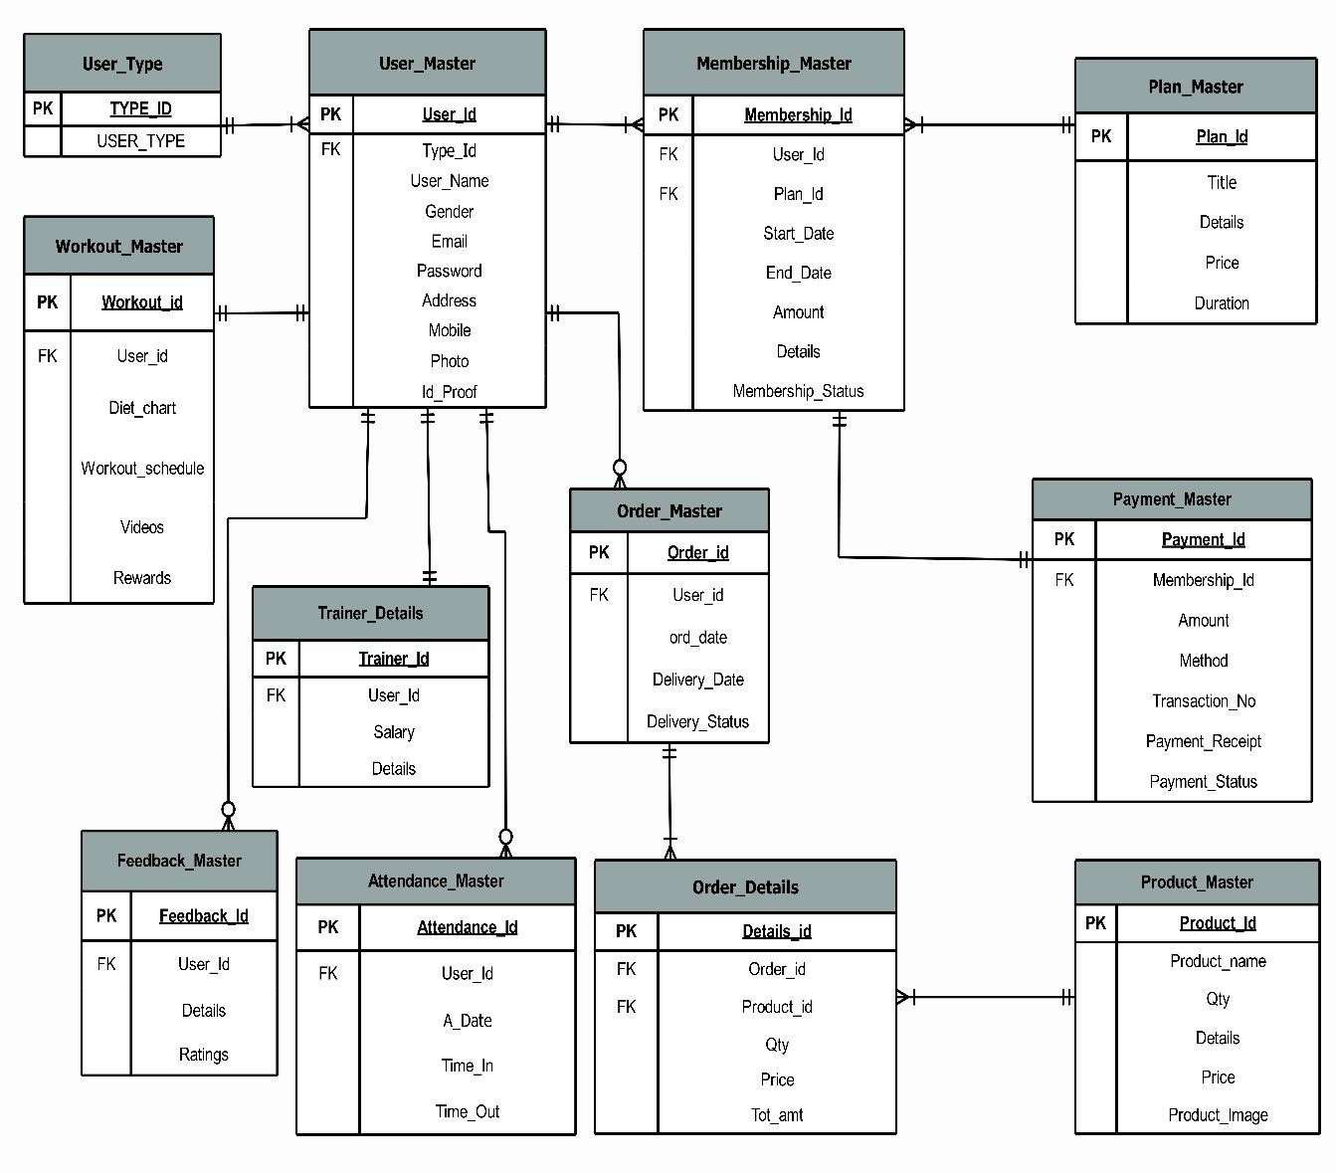

## Data Flow Diagram

A data flow diagram (DFD) maps out the flow of information for any process or system. It uses defined symbols like rectangles, circles and arrows, plus short text labels, to show data inputs, outputs, storage points and the routes between each destination. Data flowcharts can range from simple, even hand-drawn process overviews, to in-depth, multi-level DFDs that dig progressively deeper into how the data is handled. They can be used to analyze an existing system or model a new one. Like all the best diagrams and charts, a DFD can often visually “say” things that would be hard to explain in words, and they work for both technical and nontechnical audiences, from developer to CEO. That’s why DFDs remain so popular after all these years. While they work well for data flow software and systems, they are less applicable nowadays to visualizing interactive, real-time or database-oriented software or systems.

##### Context Level:

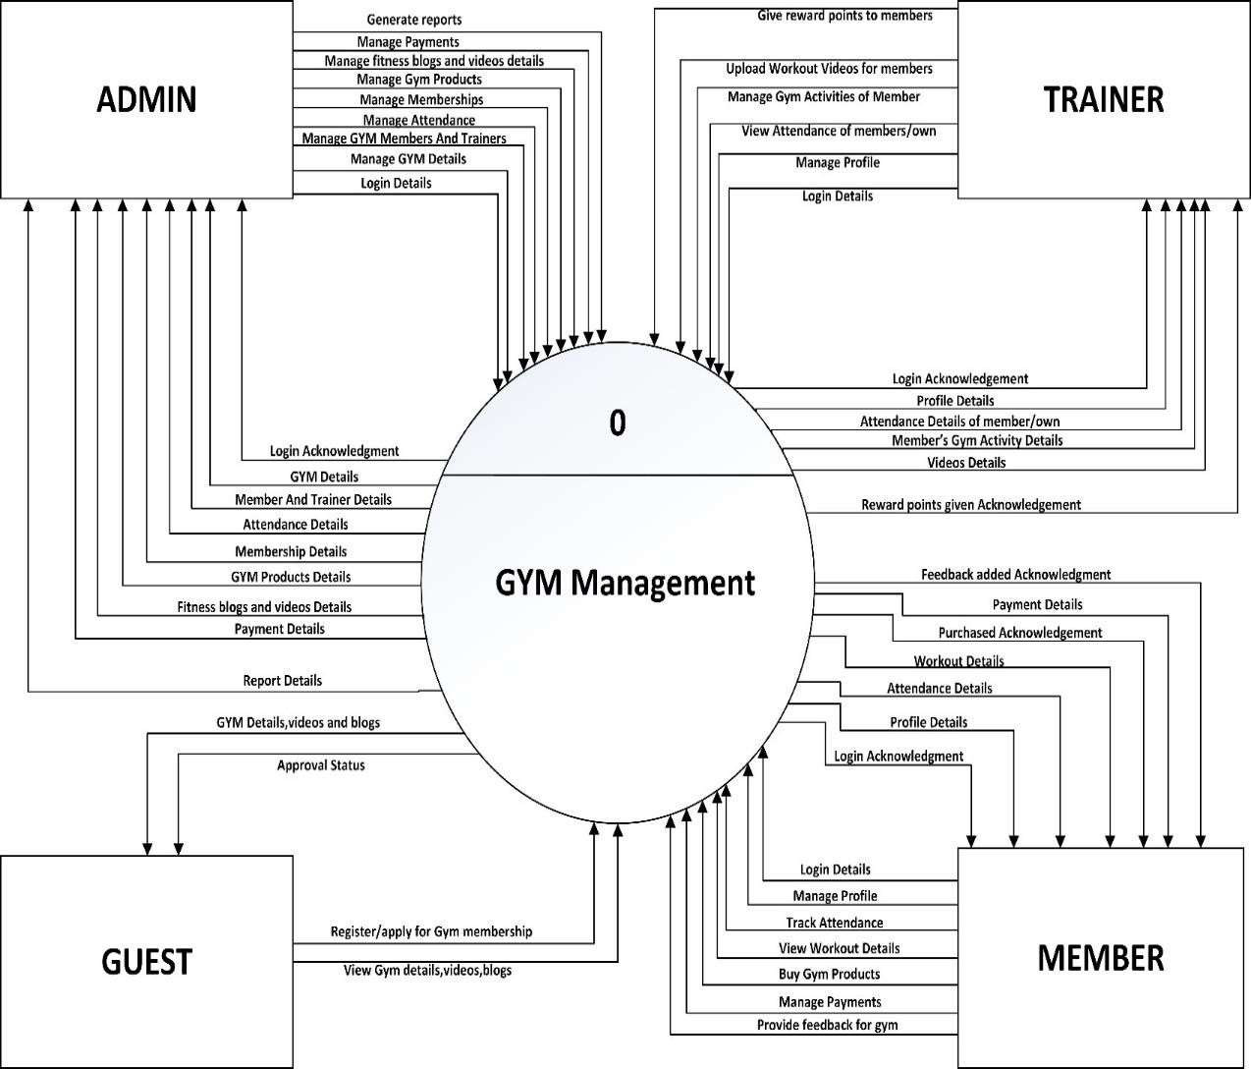

**Level 1:**

Level 1

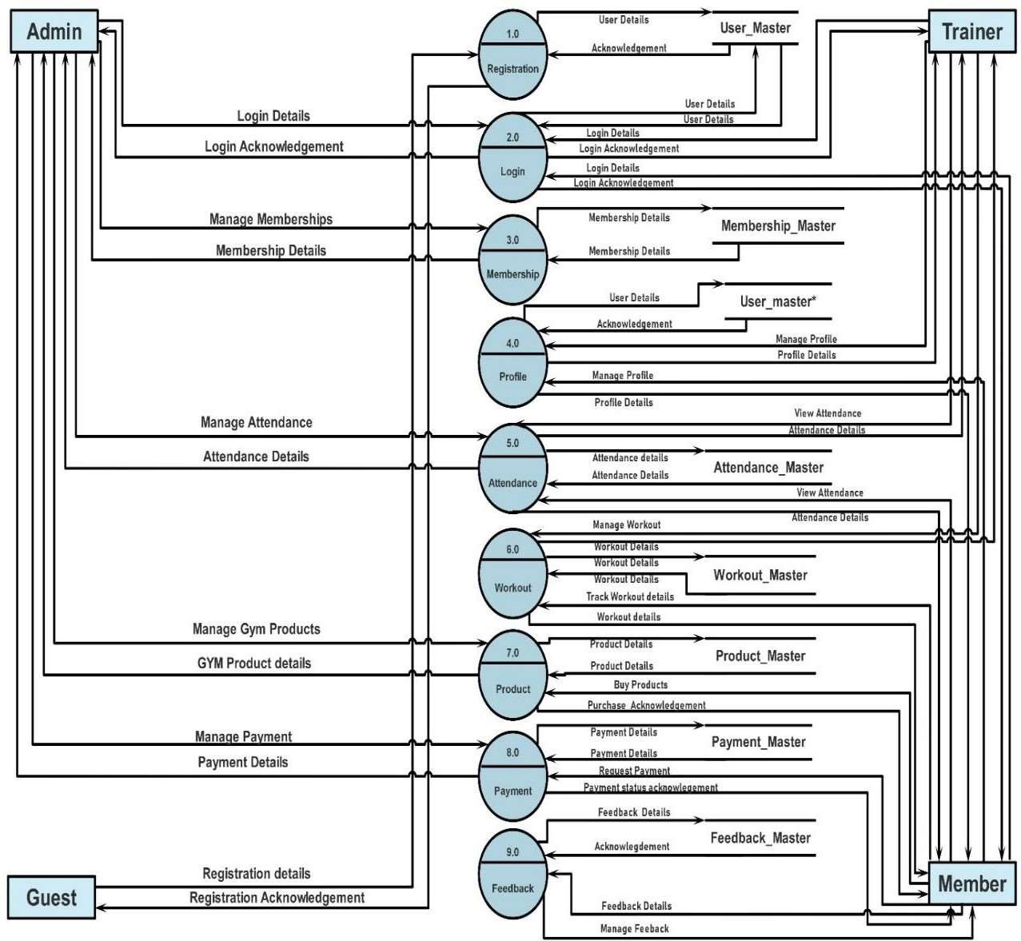

##### Level 2- Login(2.0):

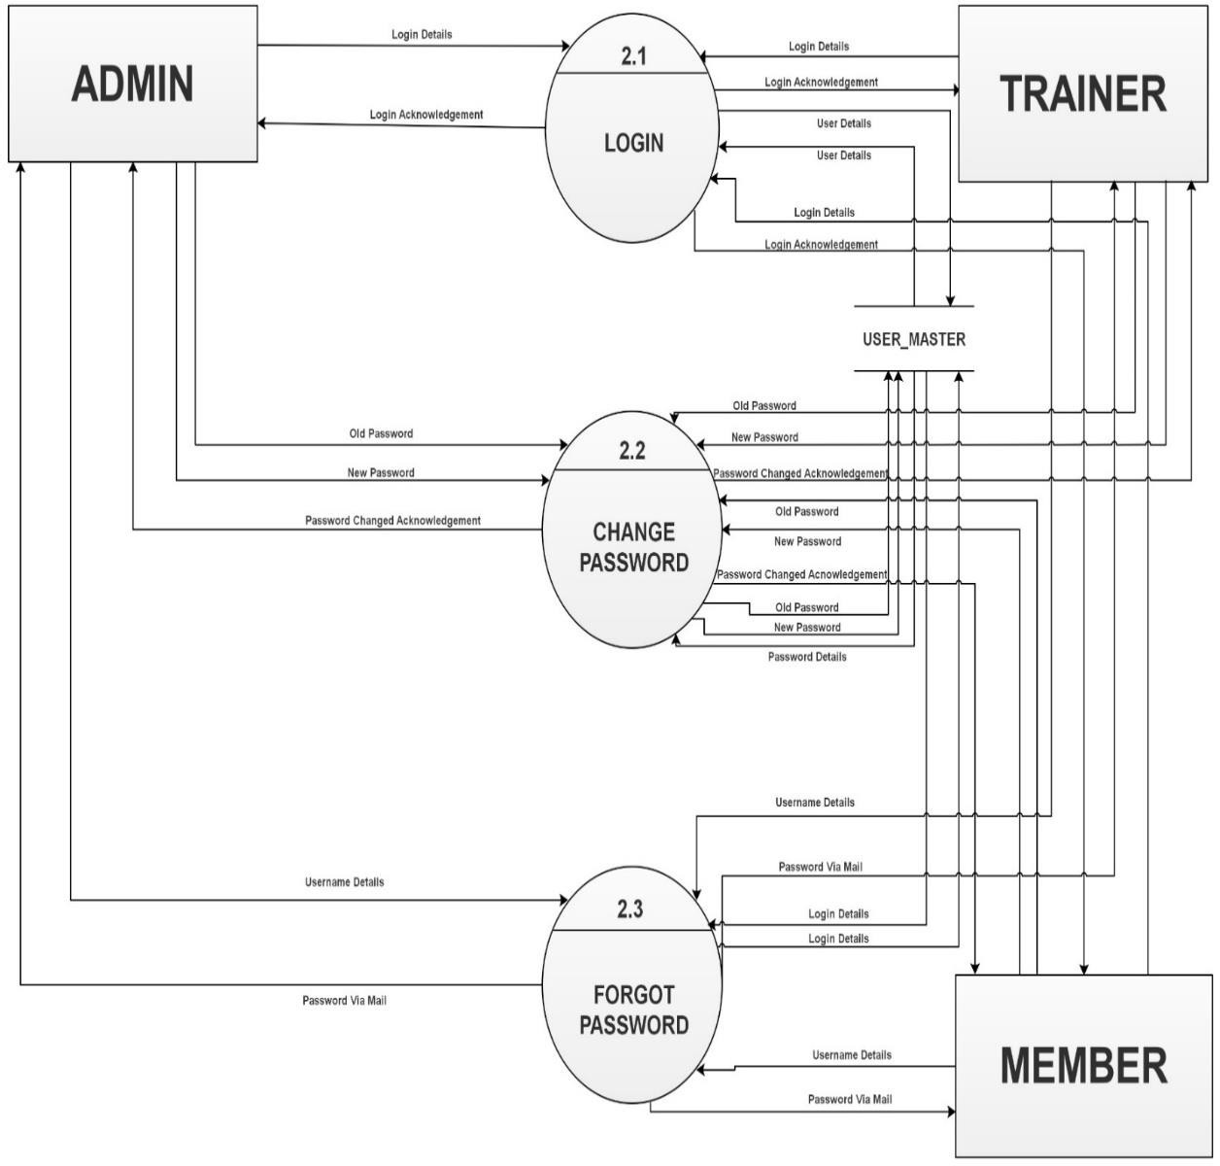

**Level 2– Membership(3.0):**

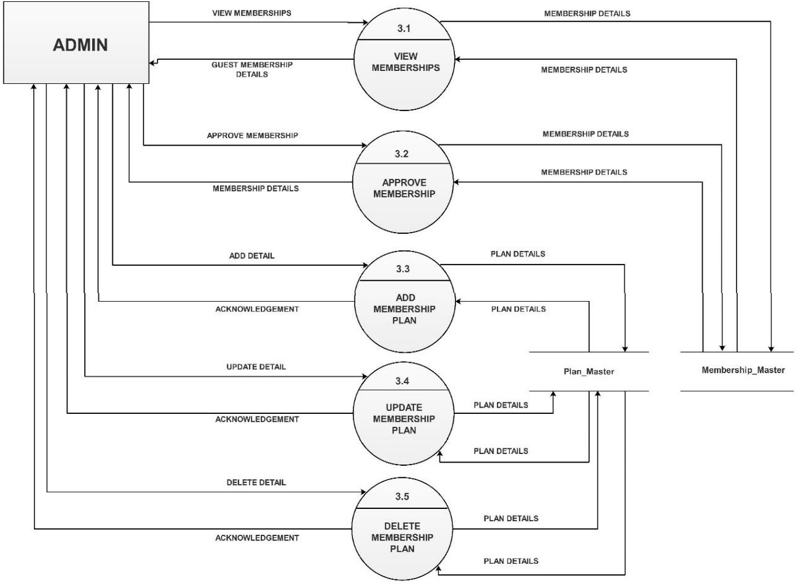

##### Level 2- Profile(4.0):

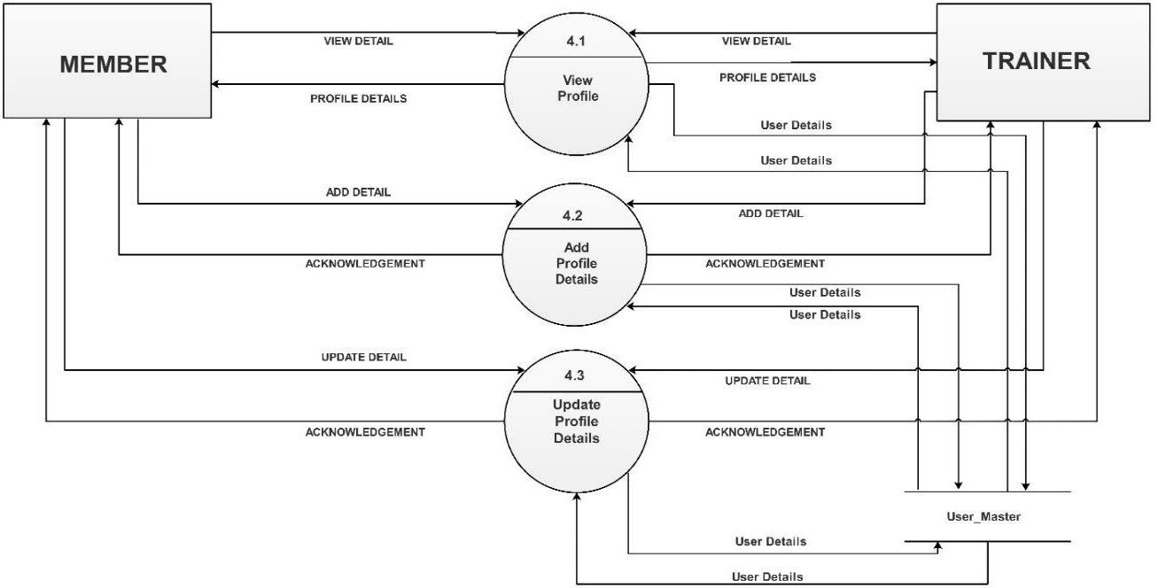

**Level 2- Attendance(5.0):**

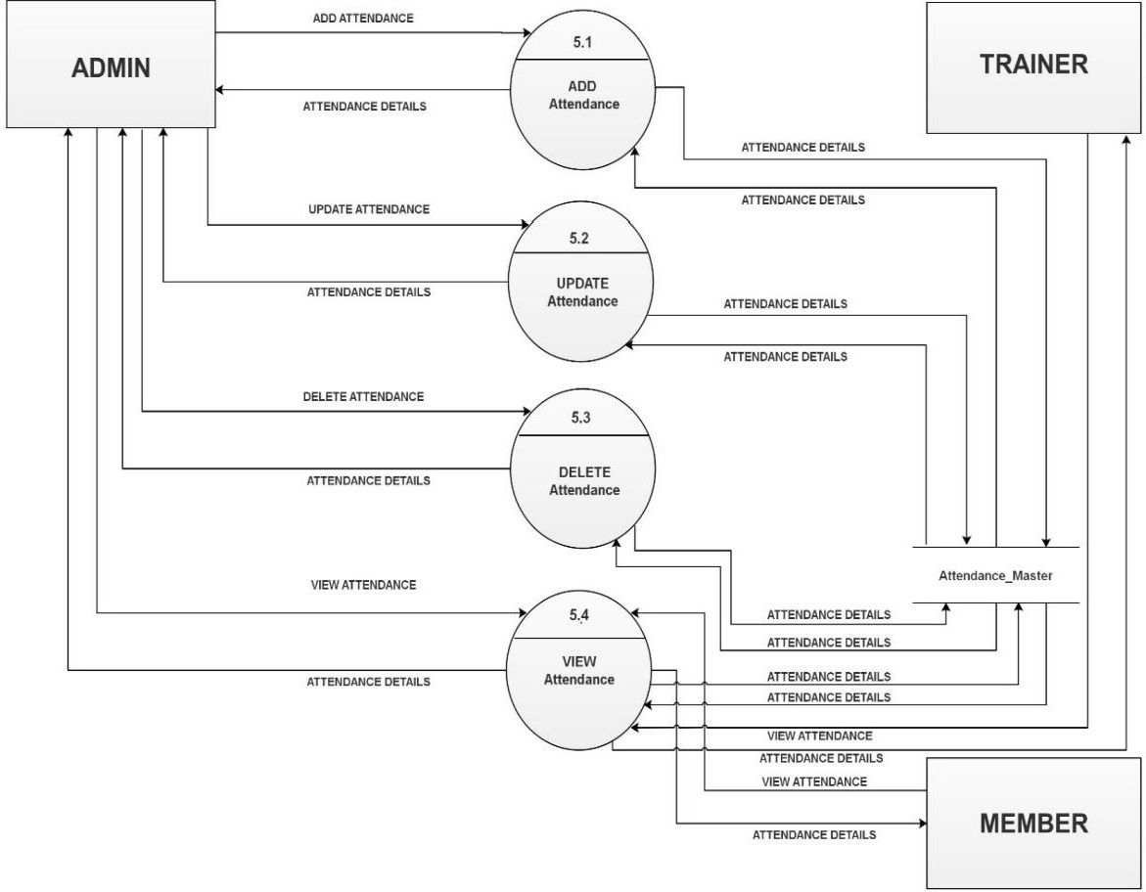

##### Level 2- Workout(6.0):

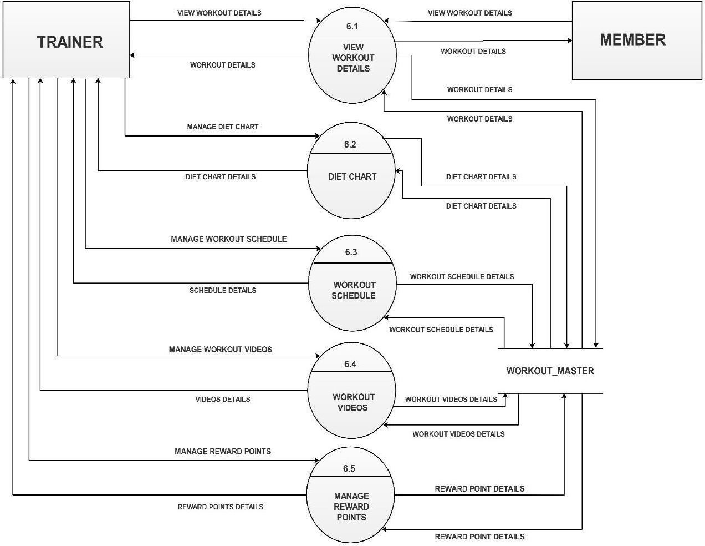

**Level 2- Product(7.0):**

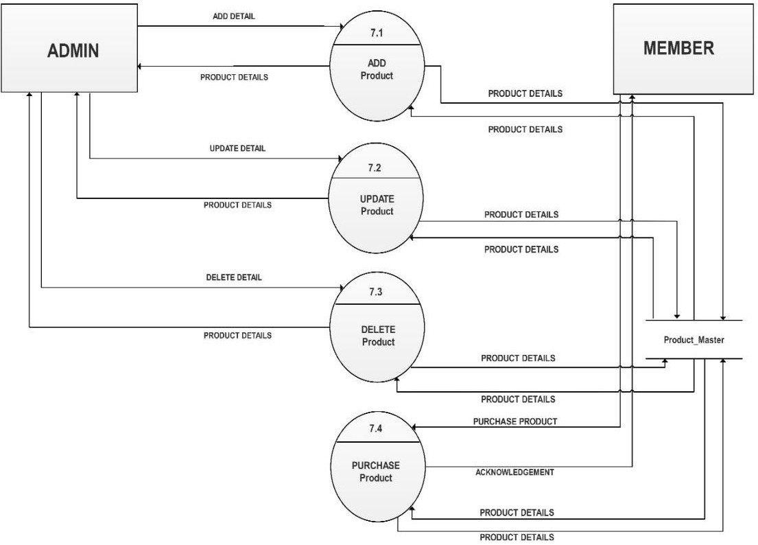

##### Level 2- Payment(8.0):

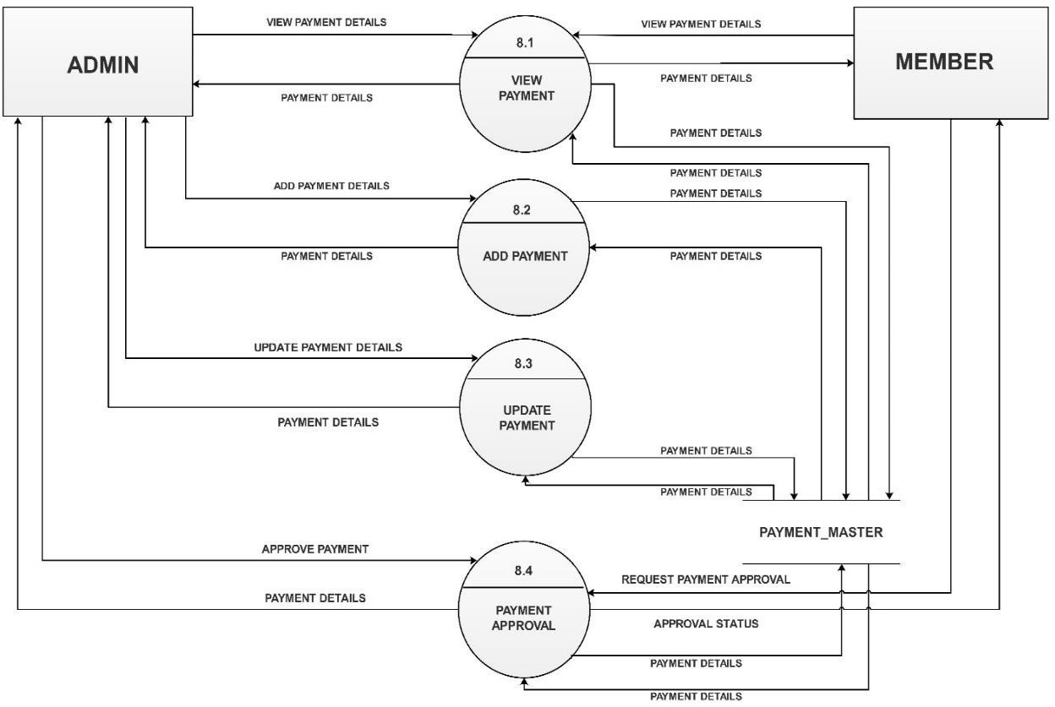

**Level 2- Feedback(9.0):**

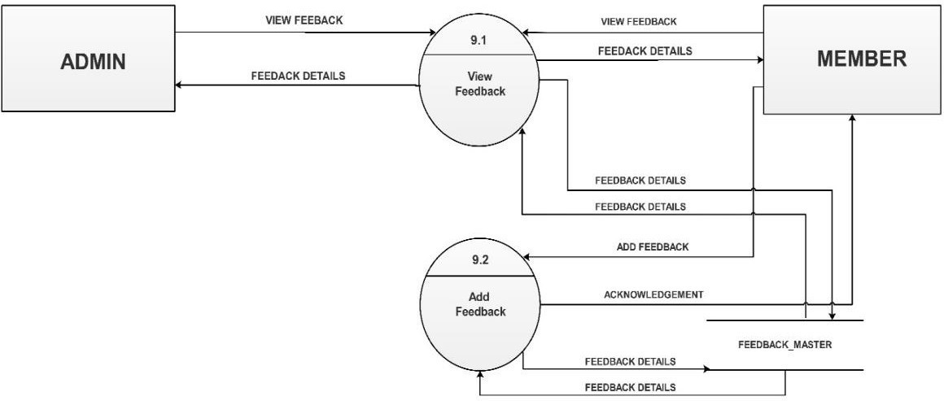

##### Level 3- Reward Points(6.5):

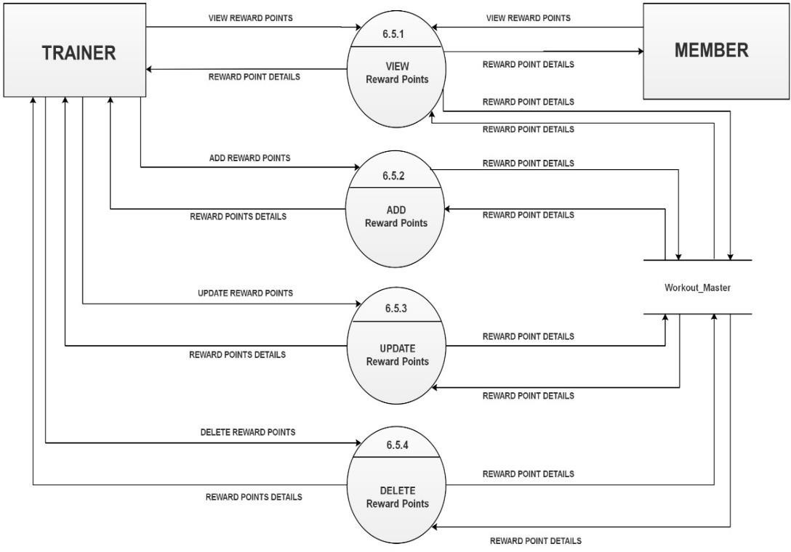

**Level 3- Diet Chart(6.2):**

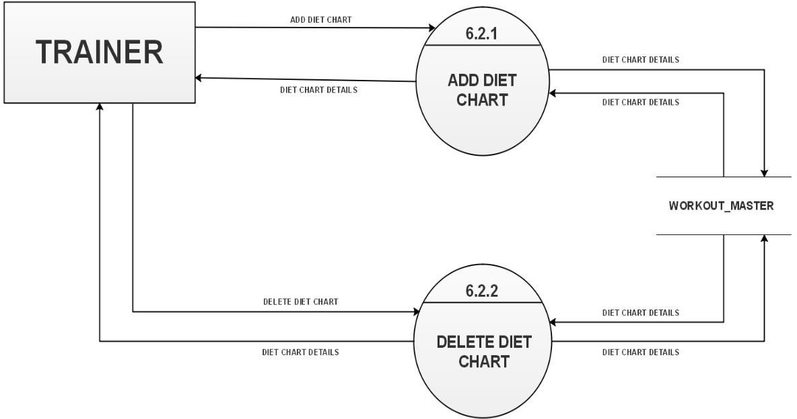

##### Level 3- Workout Schedule(6.3):

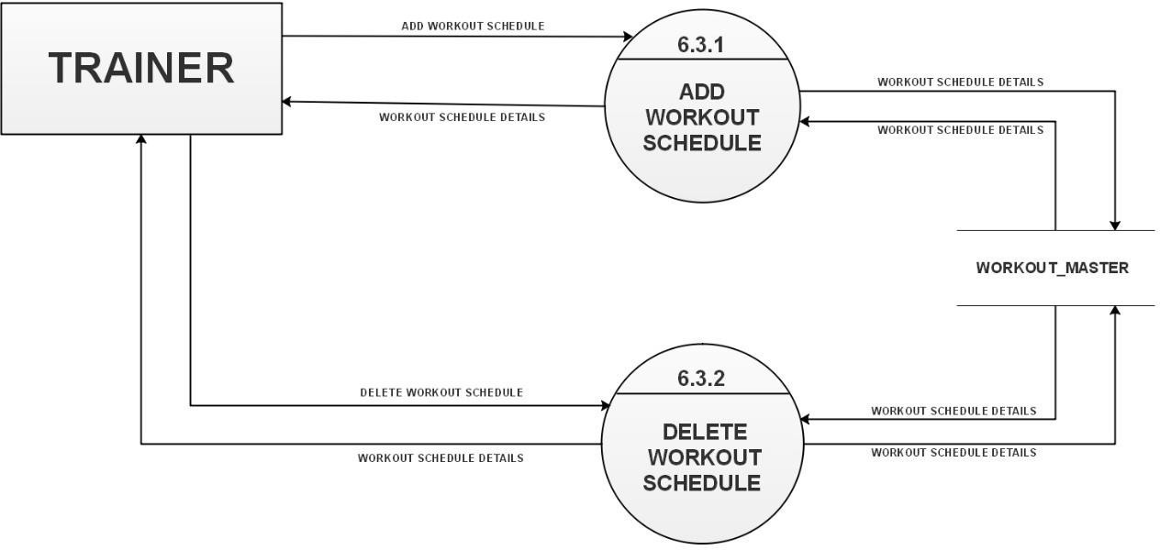

**Level 3- Workout Videos(6.4):**

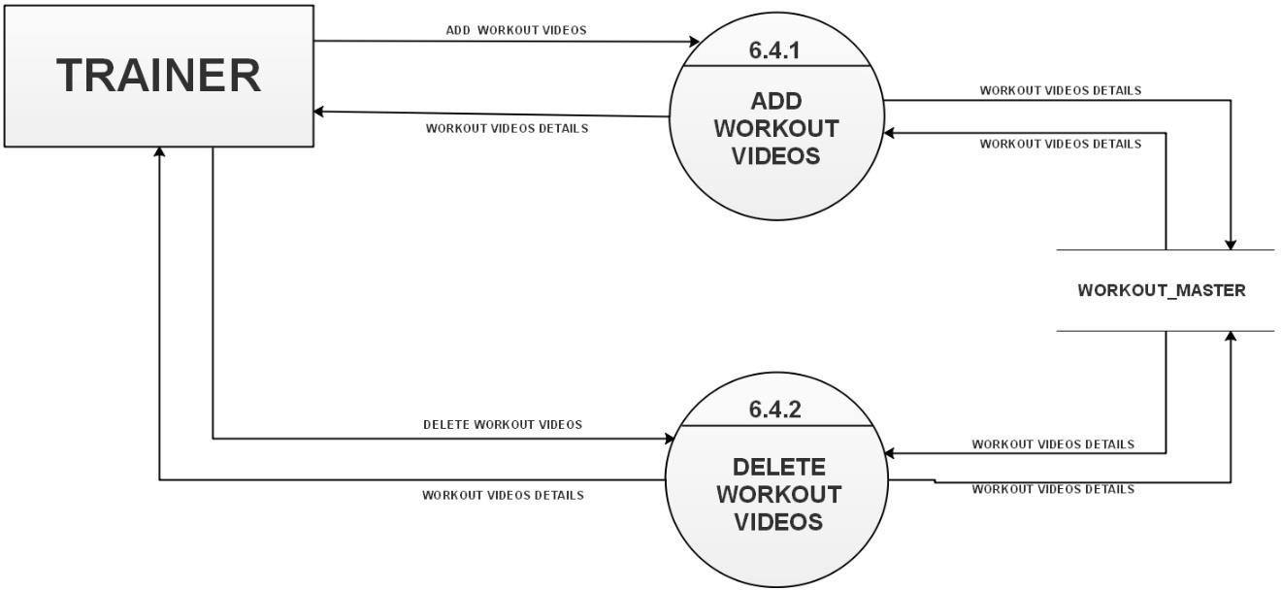

##### Level 3- Purchase Product(7.4):

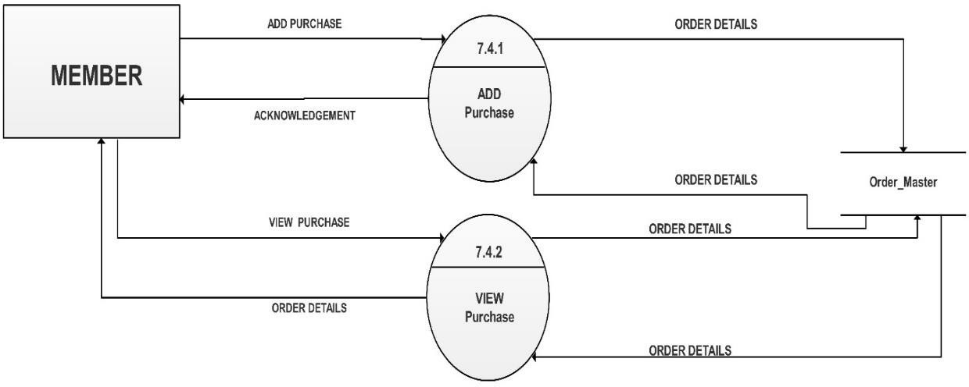

| Data Dictionary  Data Dictionary  **1) Table Name:** User_Type  **Table Description**: Contains details of user type. It will give information about type of user like whether it is a member, trainer or admin in the User_Master table. | | | | | |
| --- | --- | --- | --- | --- | --- |
| **Field Name** | | **Data Type** | **Size** | **Constraints** | **Description** |
|  | Type_Id | Integer | 5 | Primary Key | It stores the type id of the user type |
| User_Type | Varchar | 7 | Not Null | It stores the type of the user |
| **2) Table Name:** User_Master  **Table Description**: Contains details about users. It will contain all the basic information about users like name, email, gender, address, mobile no. etc along with type of user. | | | | |

|  |  |  |  |  |
| --- | --- | --- | --- | --- |
| **Field Name** | **Data Type** | **Size** | **Constraints** | **Description** |
| User_Id | Integer | 5 | Primary Key | It stores the user id of the  admin/trainer/customer |
| Type_Id | Integer | 5 | Foreign Key | It stores the user type_id  from User_type table |
| User_Name | Varchar | 25 | Not Null | It stores the name of the user |
| Gender | Varchar | 1 | Not Null | It stores the gender of the user |
| Email | Varchar | 30 | Unique | It stores email of the user |
| Password | Varchar | 16 | Unique | It stores password of the user |
| Address | Varchar | 150 | Not Null | It stores Address of the user  It stores mobile no. of the user |
| Mobile | Integer | 10 | Not Null |
| Photo | Varchar | 100 | Not Null | It stores path of the image of user |
| ID_Proof | Varchar | 100 | Not Null | It stores path of ID Proof of the user |

1. **Table Name:** Plan_Master

**Table Description:** Contains details about membership plans. It will contain all basic details about plans which a member can choose for a gym membership.

| **Field Name** | **Data Type** | **Size** | **Constraints** | **Description** |
| --- | --- | --- | --- | --- |
| Plan_Id | Integer | 5 | Primary Key | It stores the plan id of the plan. |
| Title | Varchar | 15 | Not Null | It stores the name of the plan. |
| Details | Text |  |  | It stores the details of the plan. |
| Price | Integer | 5 | Not Null | It stores the price of the plan. |
| Duration | Varchar | 10 | Not Null | It stores the duration of the  plan. |

1. **Table Name:** Membership_Master

**Table Description:** Contains details about member’s memberships. It will contain all information regarding memberships of members according to their chosen plan.

| **Field Name** | **Data Type** | **Size** | **Constraints** | **Description** |
| --- | --- | --- | --- | --- |
| Membership_Id | Integer | 5 | Primary Key | It stores Membership_id of the member. |
| User_Id | Integer | 5 | Foreign Key | It stores User_Id from User_Master table. |
| Plan_Id | Integer | 5 | Foreign Key | It stores Plan_Id from Plan_Master table. |
| Start_Date | Date |  | Not Null | It stores the starting Date of  member’s membership |
| End_Date | Date |  | Not Null | It stores the ending Date of  member’s membership |
| Amount | Integer | 5 | Not Null | It stores the amount  charged to the member. |
| Details | Text |  |  | It stores the detail of the  member’s membership |
| Membership_Status | Varchar | 15 | Not Null | It stores the membership status of the member |

1. **Table Name:** Trainer Details

**Table Description:** Contains details about trainer. It will contain additional details about trainers along with details in User_Master Table.

| **Field Name** | **Data Type** | **Size** | **Constraints** | **Description** |
| --- | --- | --- | --- | --- |
| Trainer_Id | Integer | 5 | Primary Key | It stores the Trainer id of the  trainer. |
| User_Id | Integer | 5 | Foreign Key | It stores the user id of the  trainer. |
| Salary | Integer | 5 | Not Null | It stores the salary of that  particular trainer. |
| Details | Text |  |  | It stores the details about  trainer. |

1. **Table Name:** Payment_Master

**Table Description:** Contains details about payments. It will contain payment details of Memberships of a member

| **Field Name** | **Data**  **Type** | **Size** | **Constraints** | **Description** |
| --- | --- | --- | --- | --- |
| Payment_Id | Integer | 5 | Primary Key | It stores the payment identification number. |
| Membership_id | Integer | 5 | Foreign Key | It stores the Membership_Id from Membership_master table. |
| Amount | Integer | 5 | Not Null | It Stores the amount of the  transaction done. |
| Method | Varchar | 15 | Not Null | It stores the mode of payment  used. |
| Transaction _No | Varchar | 40 | Not Null | It stores the transaction number  of the payment made. |
| Payment_Receipt | Varchar | 100 | Not Null | It stores the path of payment receipt of the payment made. |
| Payment_Status | Varchar | 15 | Not Null | It stores the payment status for  payment approval. |

1. **Table Name:** Product_Master.

**Table Description:** Contains details about Gym products. It will contain basic information about products which admin wants to sell and which a member can buy.

| **Field Name** | **Data Type** | **Size** | **Constraints** | **Description** |
| --- | --- | --- | --- | --- |
| Product_Id | Integer | 5 | Primary Key | It stores the product id of the product. |
| Product_name | Varchar | 25 | Not Null | It stores the name of the  product. |
| Qty | Integer | 2 | Not Null | It stores the quantity of the  product available |
| Details | Text |  |  | It stores the details of the  product. |
| Price | Integer | 5 | Not Null | It stores the price of the  product. |
| Product_Image | Varchar | 100 | Not Null | It stores the path number of  the image of the product. |

1. **Table Name:** Feedback_Master

**Table Description:** Contains details about feedbacks. It will contain feedback details given by members about the Gym.

| **Field Name** | **Data Type** | **Size** | **Constraints** | **Description** |
| --- | --- | --- | --- | --- |
| Feedback_Id | Integer | 5 | Primary Key | It stores the feedback id. |
| User_Id | Integer | 5 | Foreign Key | It stores the user id. |
| Details | Text |  |  | It stores the details of the Feedback. |
| Ratings | Integer | 2 | Not Null | It stores Ratings. |

1. **Table Name:** Workout_Master

**Table Description:** Contains workout details of members. It will contain member’s workout details like diet chart, workout schedule, workout videos, reward points provided by trainers.

| **Field Name** | **Data Type** | **Size** | **Constraints** | **Description** |
| --- | --- | --- | --- | --- |
| Workout_Id | Integer | 5 | Primary Key | It stores the workout_id. |
| User_Id | Integer | 5 | Foreign  Key | It stores the user id. |
| Diet_chart | Varchar | 100 | Not Null | It stores path of diet chart. |
| Workout_schedule | Varchar | 100 | Not Null | It stores path of Workout Schedule. |
| Videos | Varchar | 100 | Not Null | It stores path of video. |
| Rewards | Integer | 4 | Not Null | It stores reward points of user. |

1. **Table Name:** Order_Master

**Table Description:** Contains Order Details. It will contain basic order details like which member has made order, date of placing order, delivery date etc. of orders made by members for their purchase of products

| **Field Name** | **Data Type** | **Size** | **Constraints** | **Description** |
| --- | --- | --- | --- | --- |
| Order_id | Integer | 5 | Primary Key | It stores order_id of order. |
| User_id | Integer | 5 | Foreign Key | It stores user id |
| Ord_date | Date |  | not null | It stores date of the order. |
| Delivery_Date | Date |  | Not Null | It stores the Delivery Date of the Order. |
| Delivery_Status | Varchar | 10 | Not Null | It stores Status of the Delivery. |

1. **Table Name:** Order_Details

**Table Description:** It contains order Details. It will contain additional information about order like product purchased, quantity of product, Price of Product etc. in relation with Order_Master table..

| **Field Name** | **Data Type** | **Size** | **Constraints** | **Description** |
| --- | --- | --- | --- | --- |
| Details_Id | Integer | 5 | Primary Key | It stores the order details id of the order. |
| Order_id | Integer | 5 | Foreign Key | It stores the order id |
| Product_id | Integer | 5 | Foreign key | It stores the product id of the  product. |
| Qty | Integer | 2 | Not Null | It stores the quantity of  product ordered. |
| Price | Integer | 5 | Not Null | It stores the price of the product. |
| Tot_amt | Integer | 5 | Not Null | It stores total amount. |

1. **Table Name:** Attendance_Master

**Table Description:** Contains details about attendance of users. It will contain day to day attendance details of members and trainers which will be added by admin.

| **Field Name** | **Data Type** | **Size** | **Constraints** | **Description** |
| --- | --- | --- | --- | --- |
| Attendance_Id | Integer | 5 | Primary Key | It stores the attendance id |
| User_Id | Integer | 5 | Foreign Key | It stores the User_Id from  User_Master table |
| Date | Date |  | Not Null | It stores the Date of the  attendance. |
| Time_In | Date |  | Not Null | It stores the check in time |
| Time_Out | Date |  | Not Null | It stores the check out time |

**SCREEN LAYOUTS**

## ADMIN SIDE:

Login page for admin with validations. Email id Field Should not be empty. Email id should match the requested format which contains @ and (.)

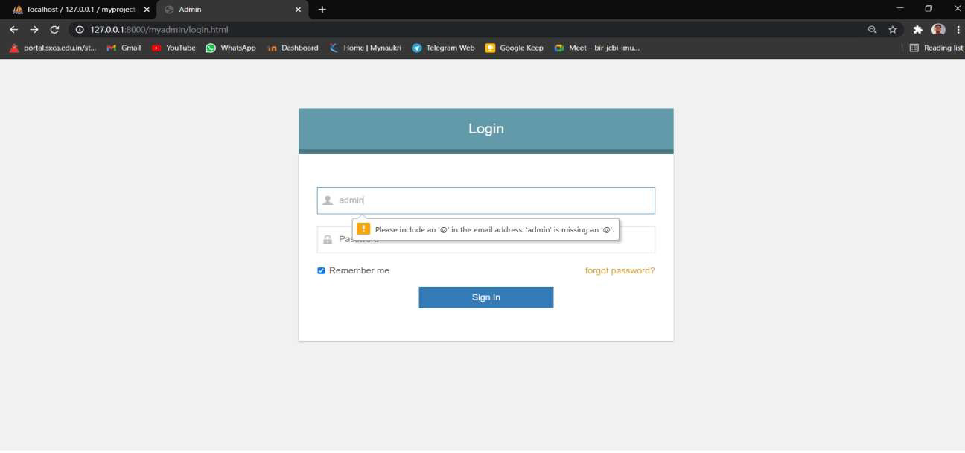

Admin not allowed to login due to invalid username.

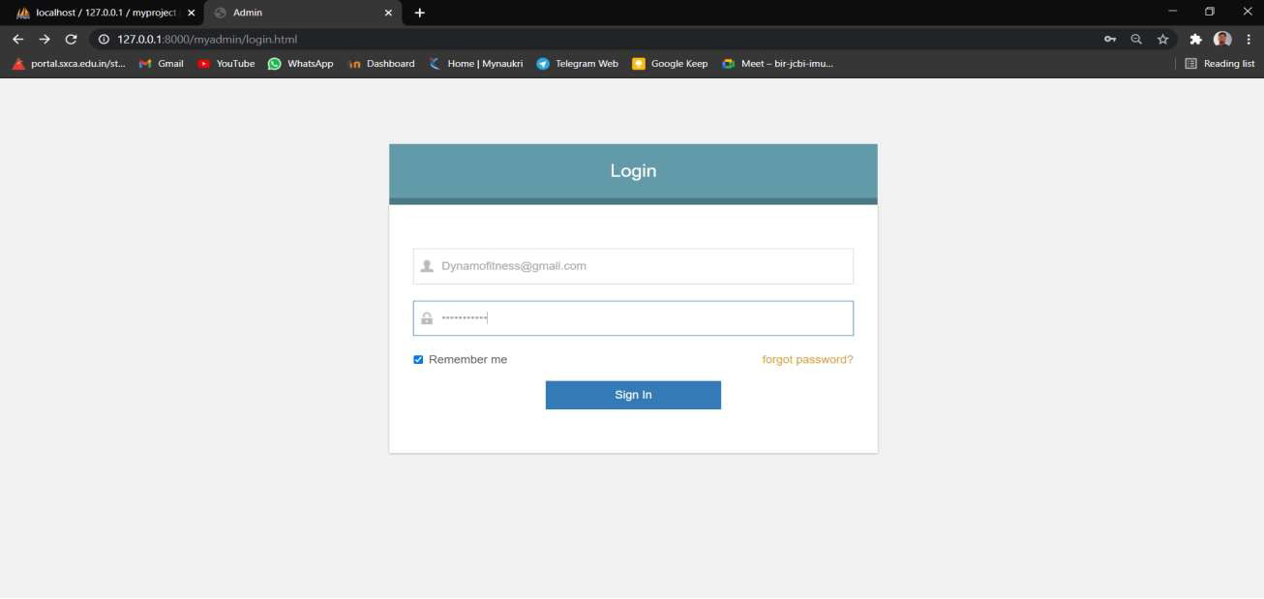

Forgot Password page of Admin

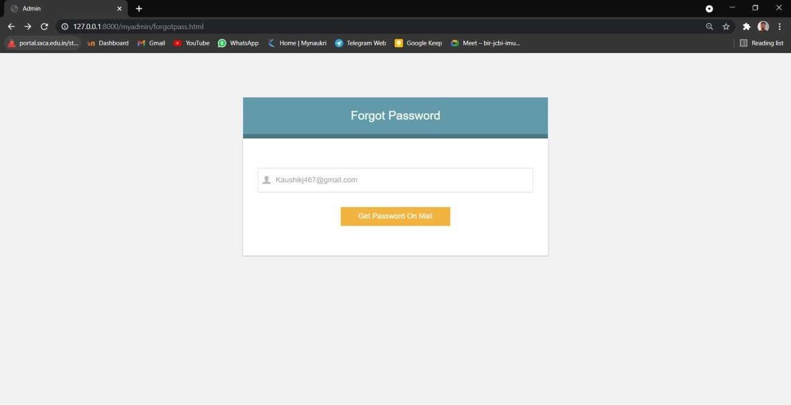

Password received by admin through mail

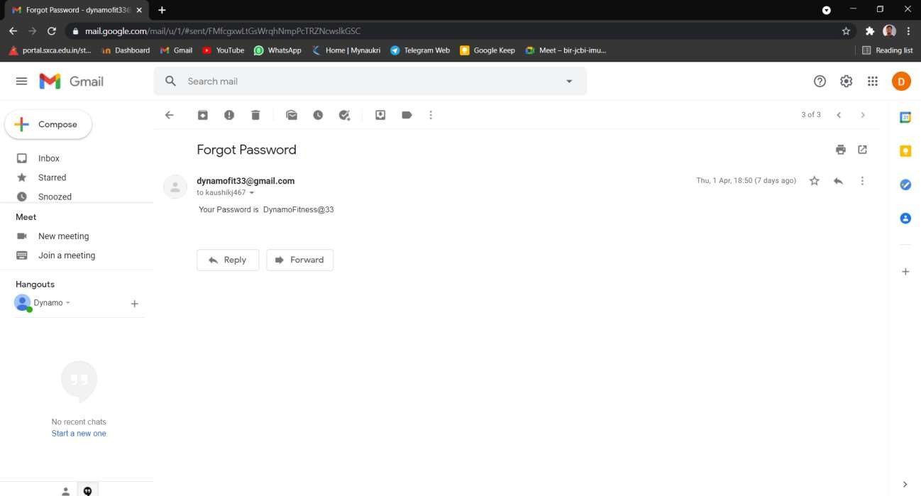

Change Password page of Admin , the retyped password doesn’t match validation

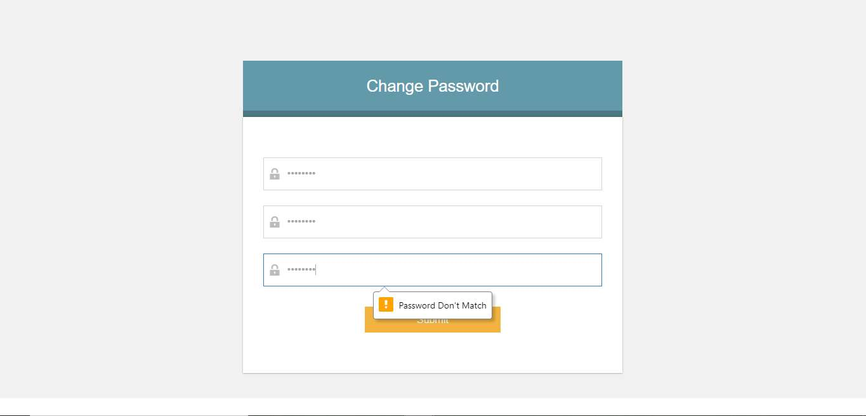

Correct admin username and password:

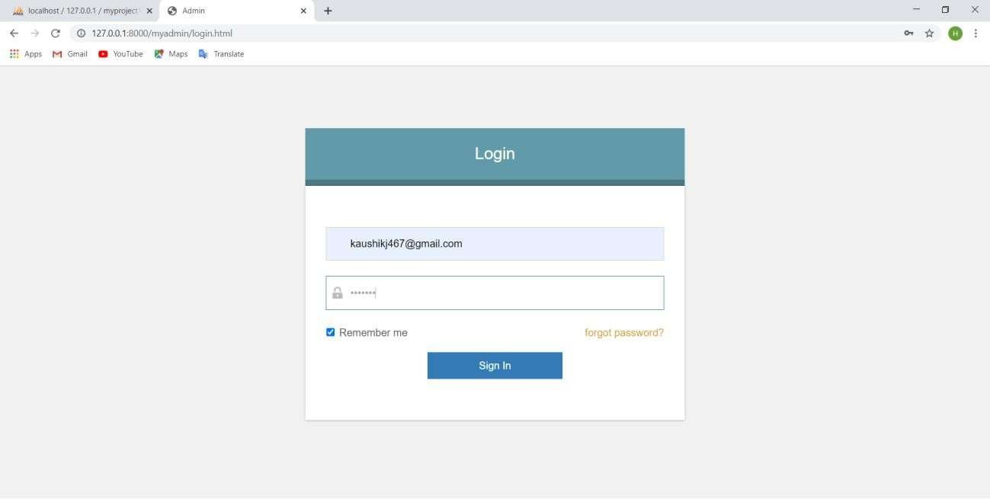

**Home page of Admin:**

Admin dashboard. It Shows Side Panel which directs it to selected page to be visited. The Page shows the direct link and information of User_type, Users, Trainer details, Attendance and plans .

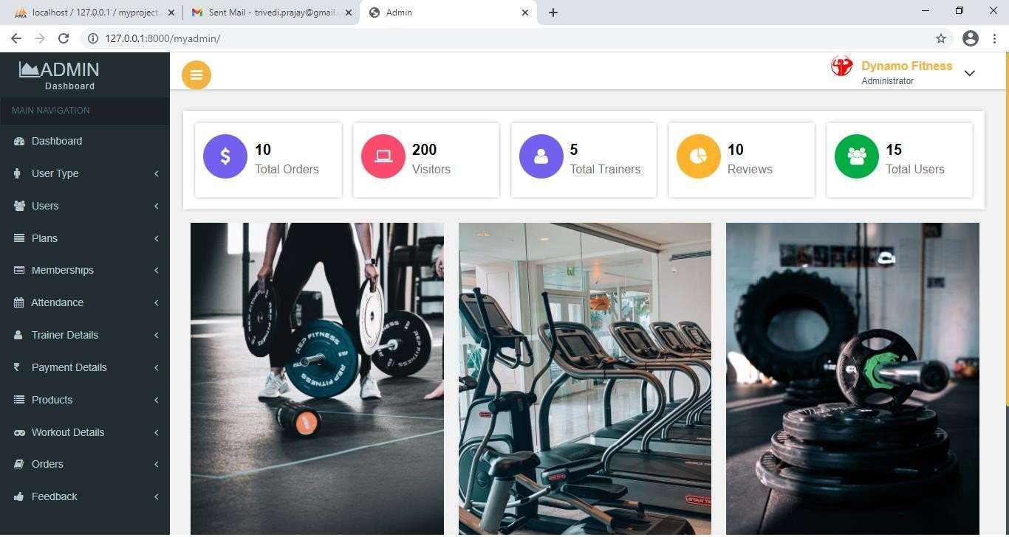

Add User Type: Admin is adding user type member

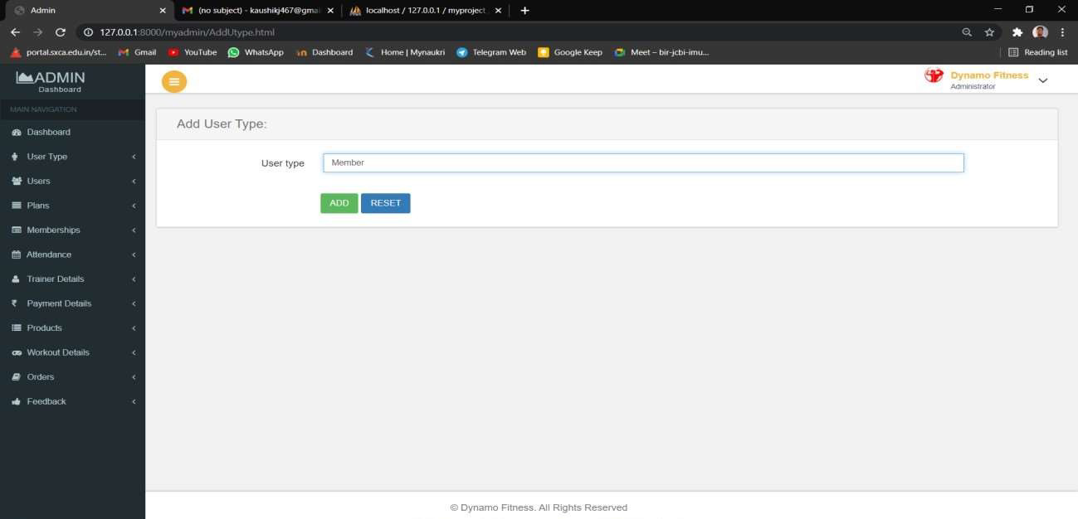

When view tab of User type is clicked type of users are shown in this page

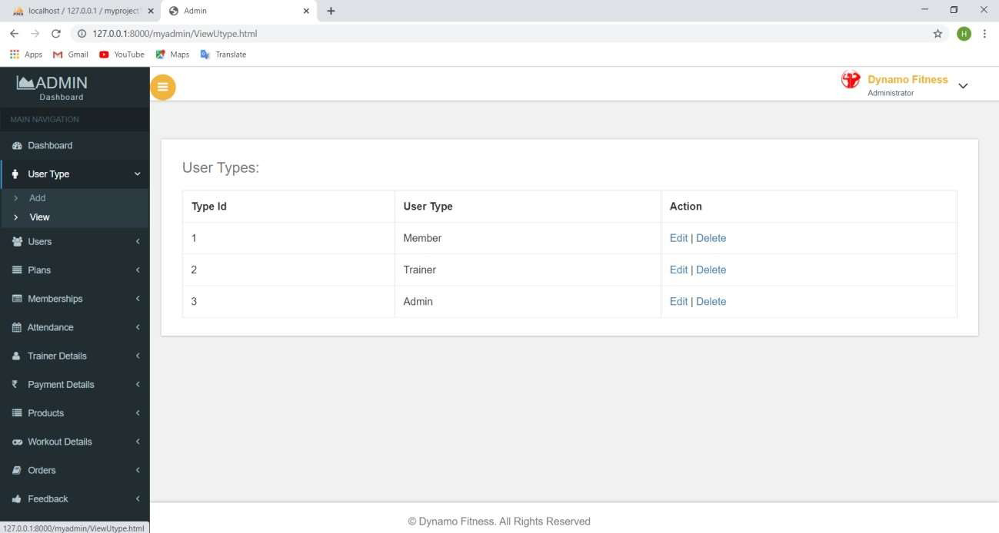

Add Users window can be opened from side panel and Admin can add new user.

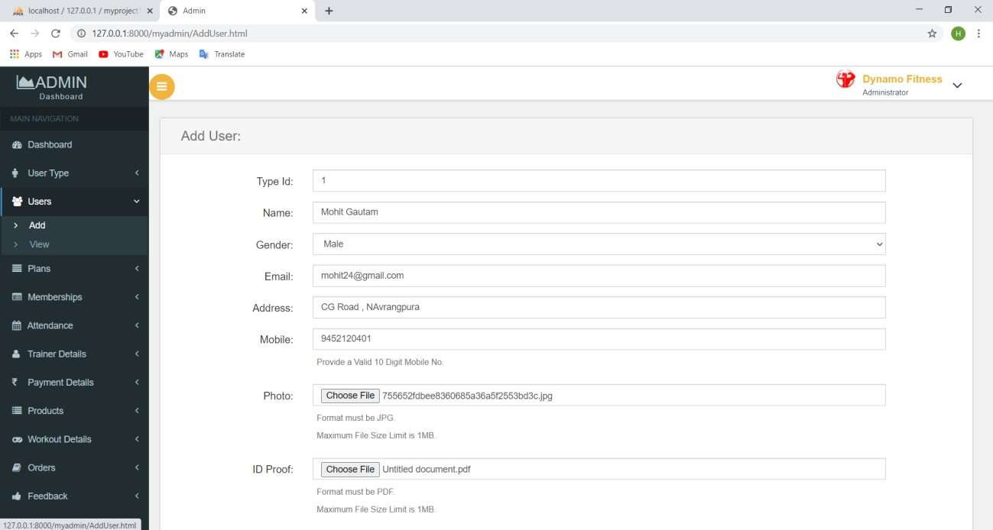

View Users window- All the users are shown here to the admin where admin can take action like edit and delete.

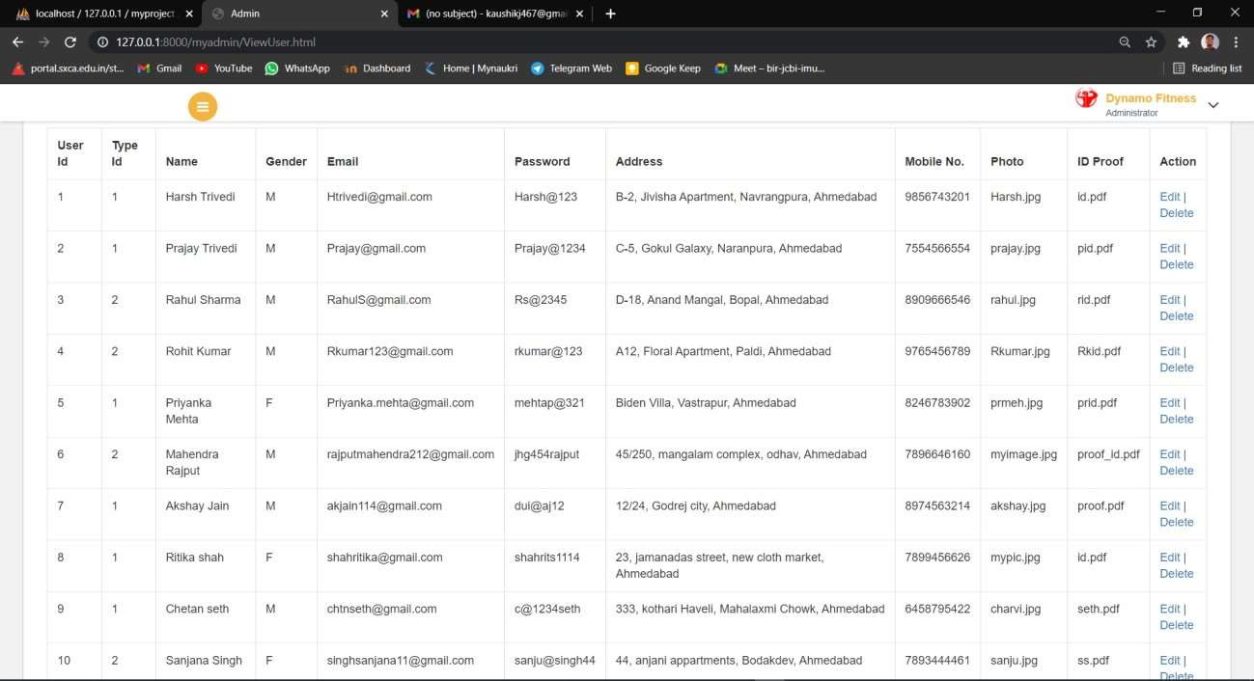

When view part of Plans in side menu is clicked plan details is shown.

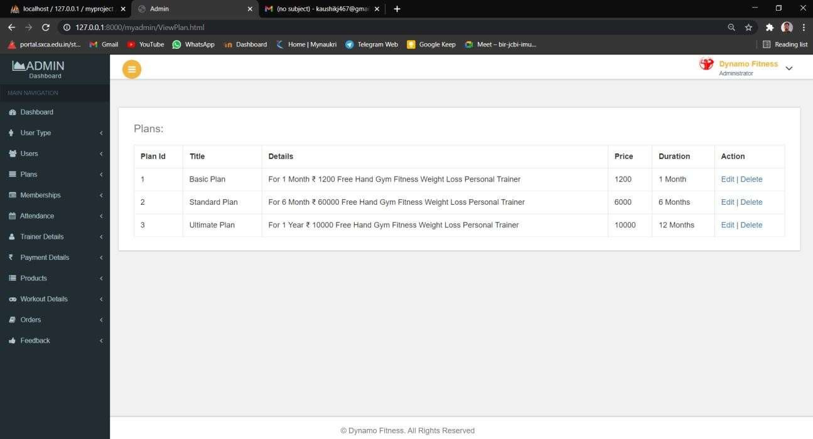

Add Plans window-Admin can add new plan details in this window.

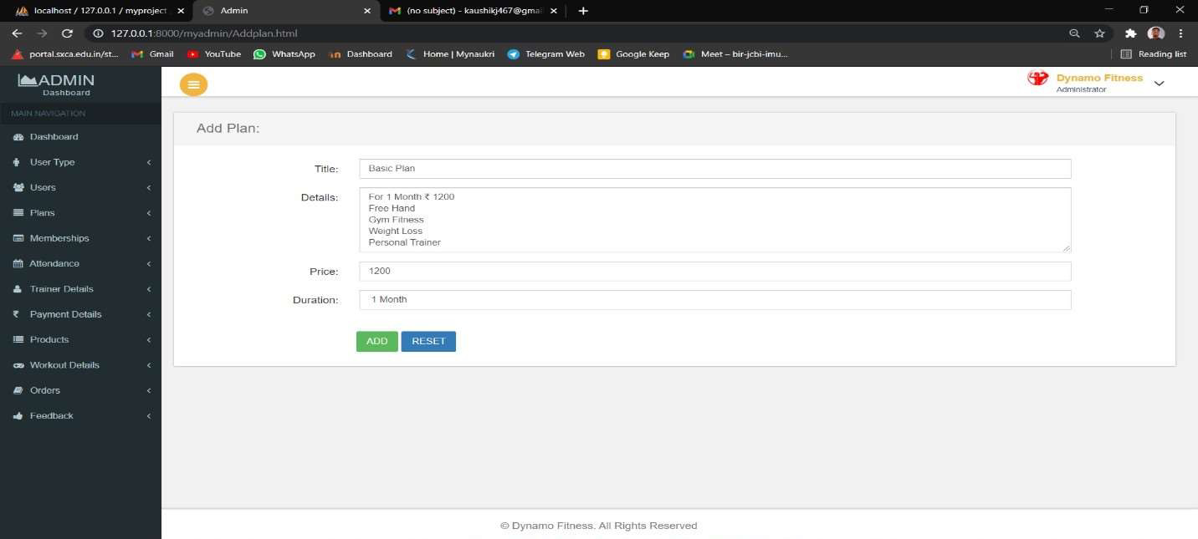

Admin can add membership details of user ,here validation is showing where amount field is required.

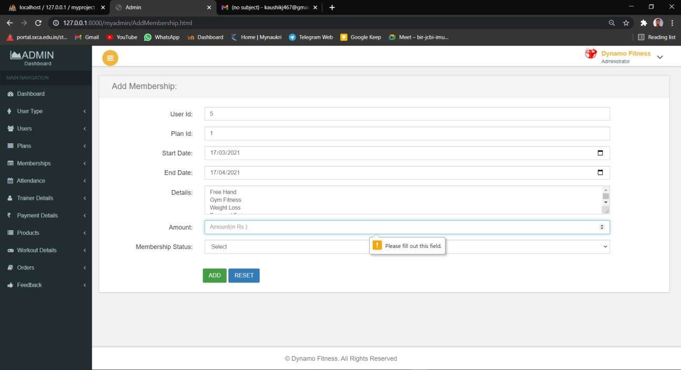

When view part of Membership Details in side menu clicked Membership details table is shown

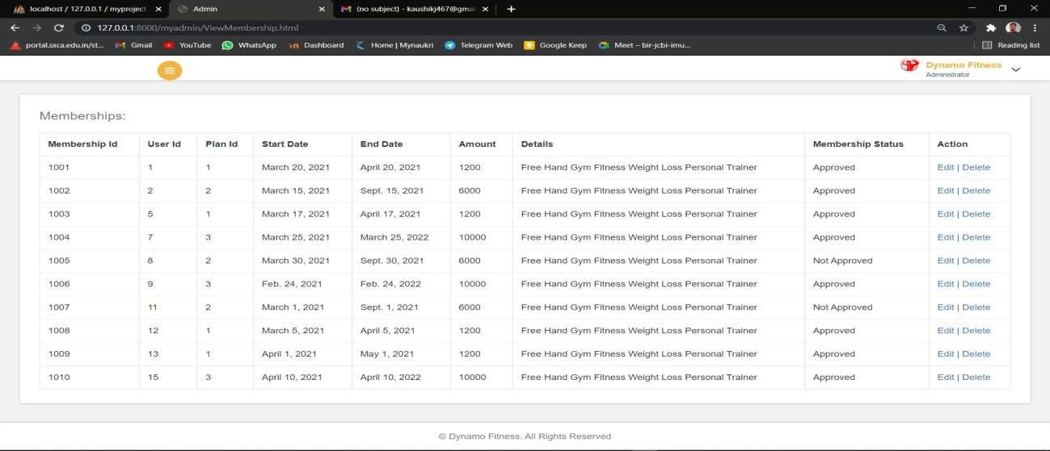

Attendance add window- In add attendance window admin can add attendance details of users.

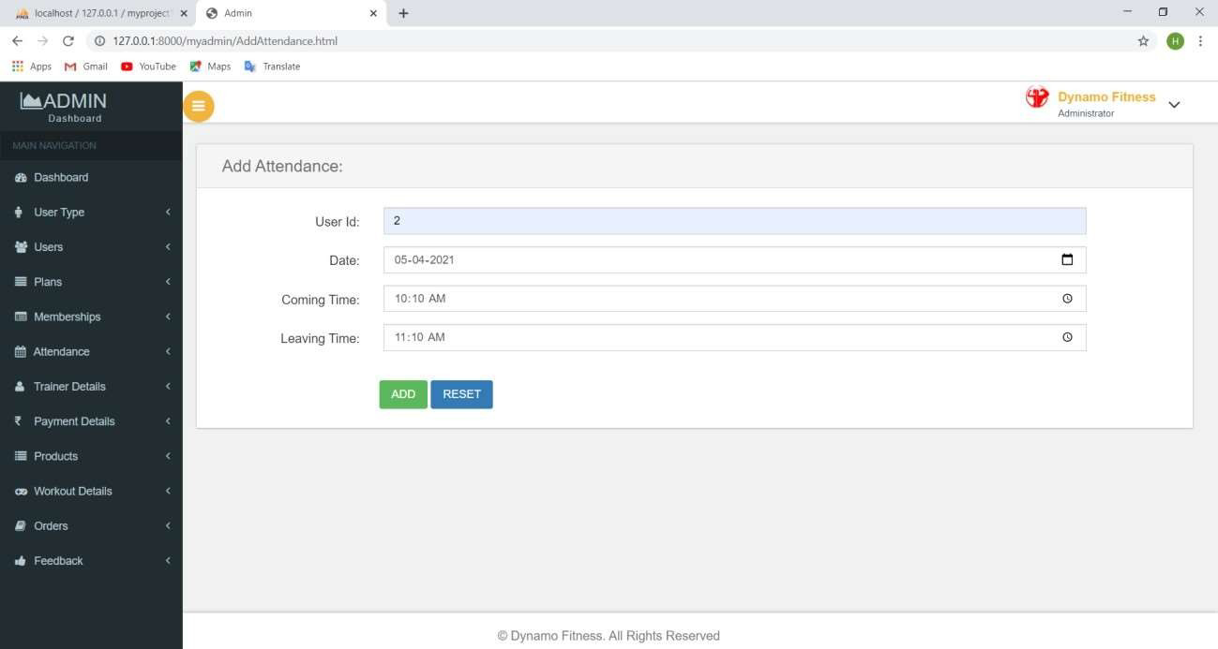

When view part of attendance in side menu is clicked attendance details of users is shown

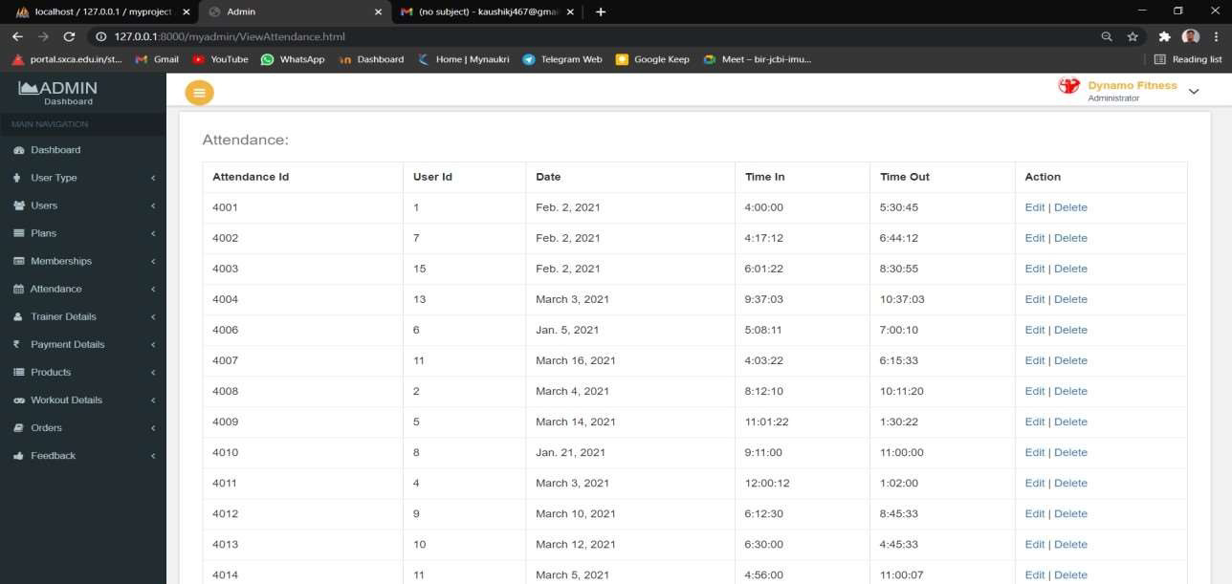

When add part of Trainer Details is clicked , Admin can add details of the trainer.

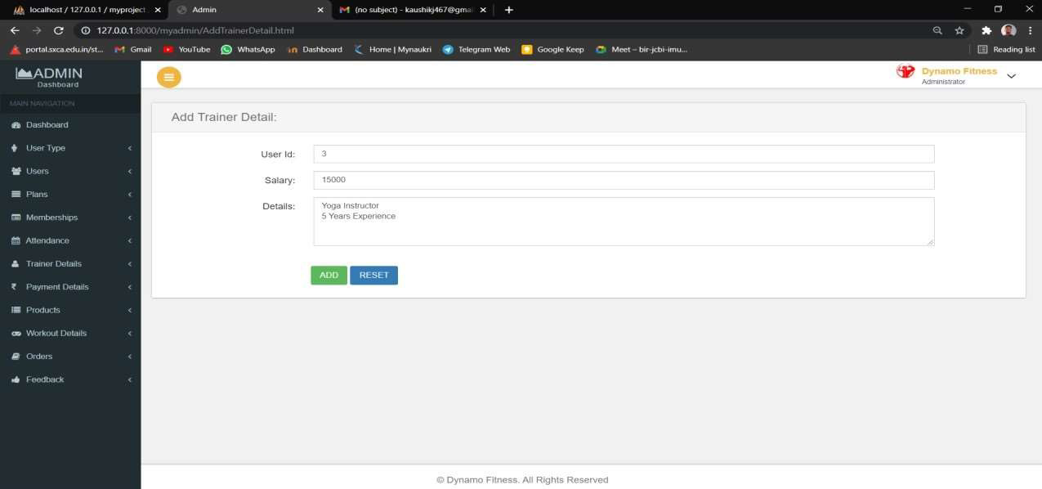

View part of Trainer Details where Details of trainer has been shown.

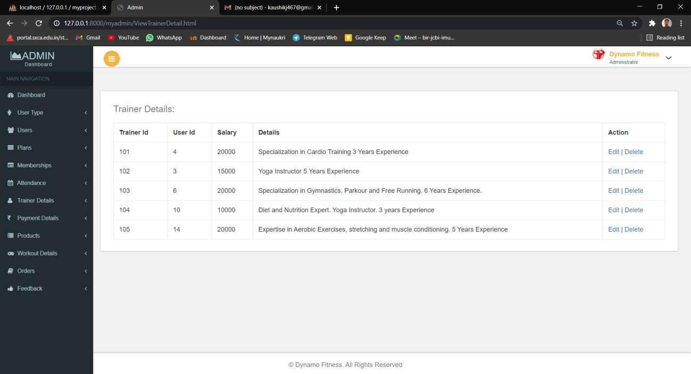

Add payment window is open when add part of Payment Details is clicked ,Admin can approve Payment Status .

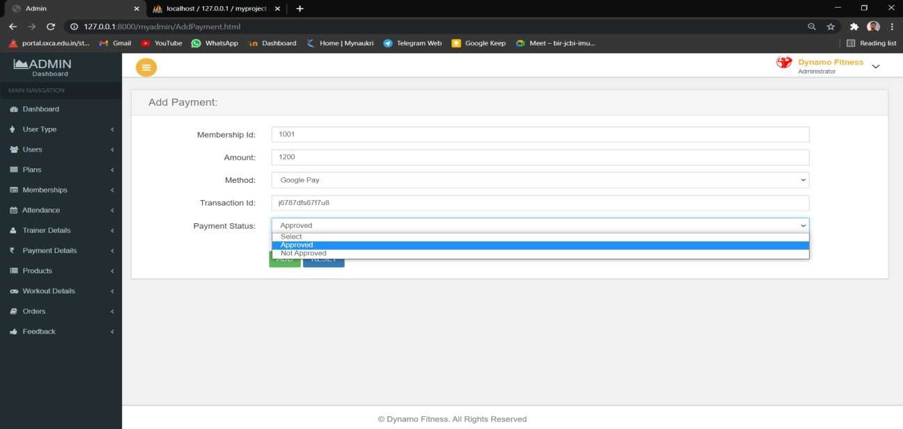

When view part of Payment details is clicked Payment Details is shown.

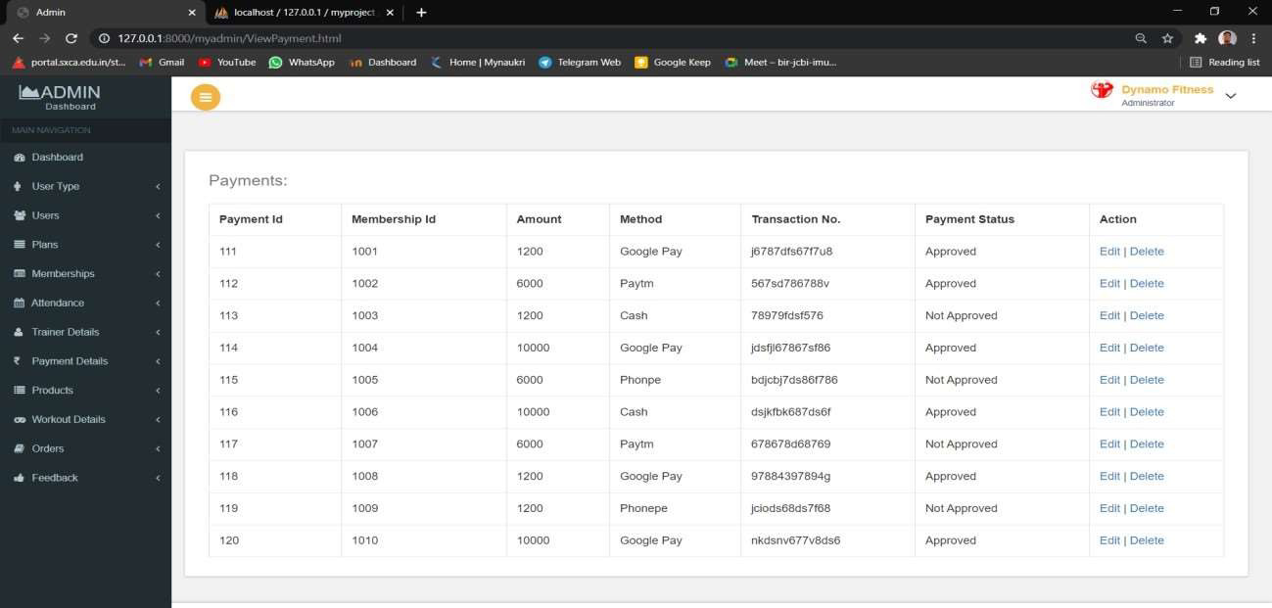

Add product window is shown when clicked on the add part of the Products .

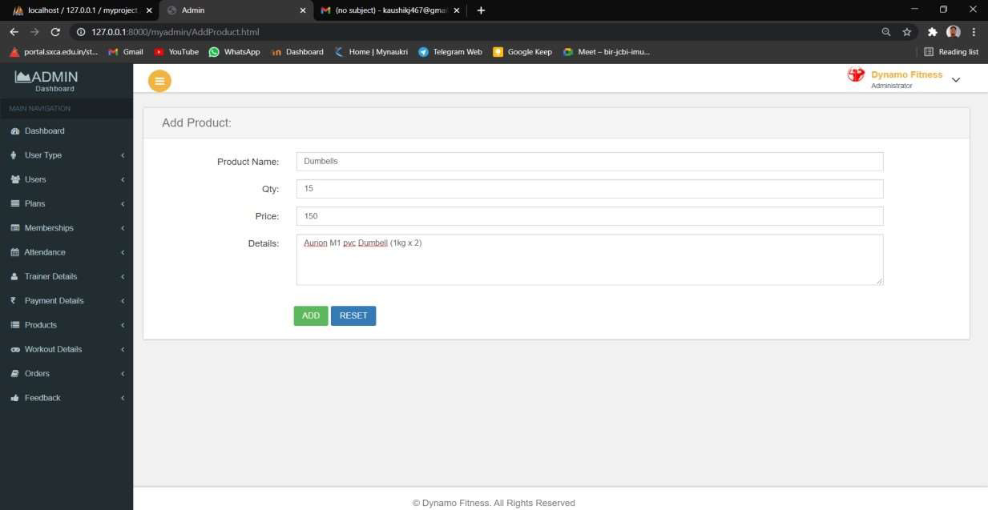

When view part of the Products tab is clicked all product details with price and quantity has been shown.

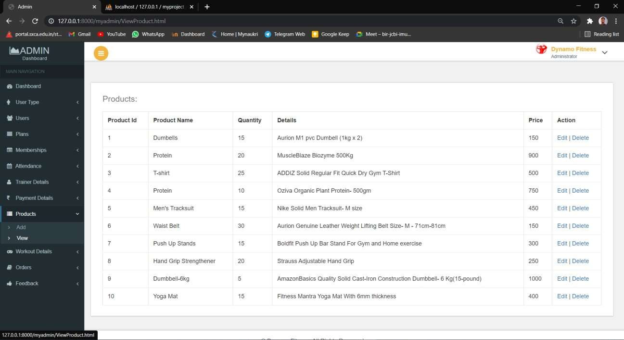

Add Workout Details Window - Admin can add Workout Details of a particular user by adding diet chart, workout schedule and workout videos for the user.

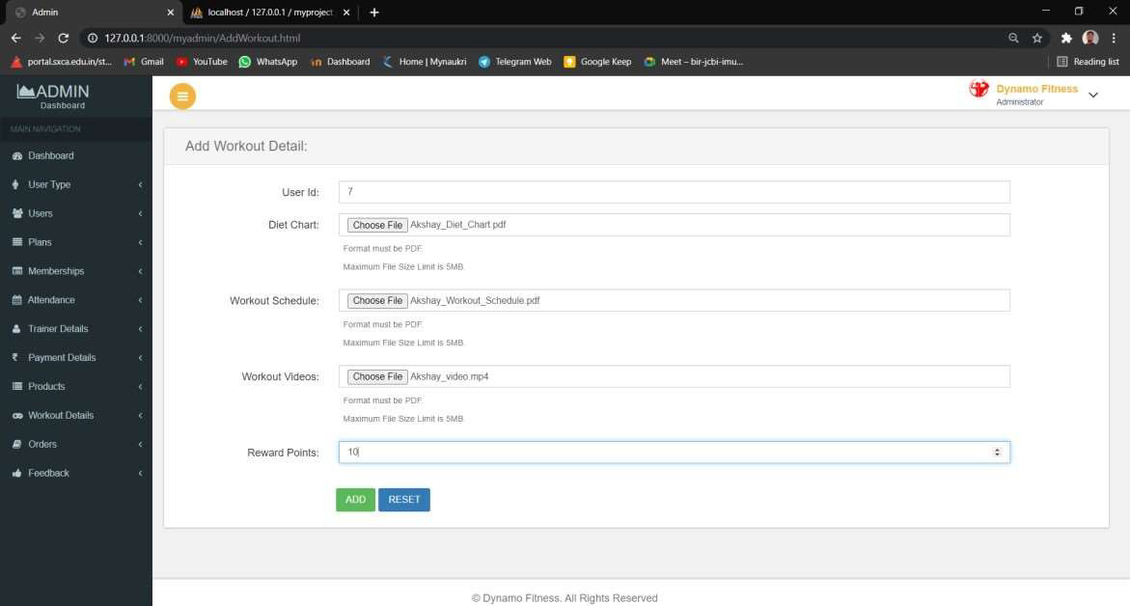

View Workout Details window where all the details of a users workout(including diet chart and schedule) are shown.

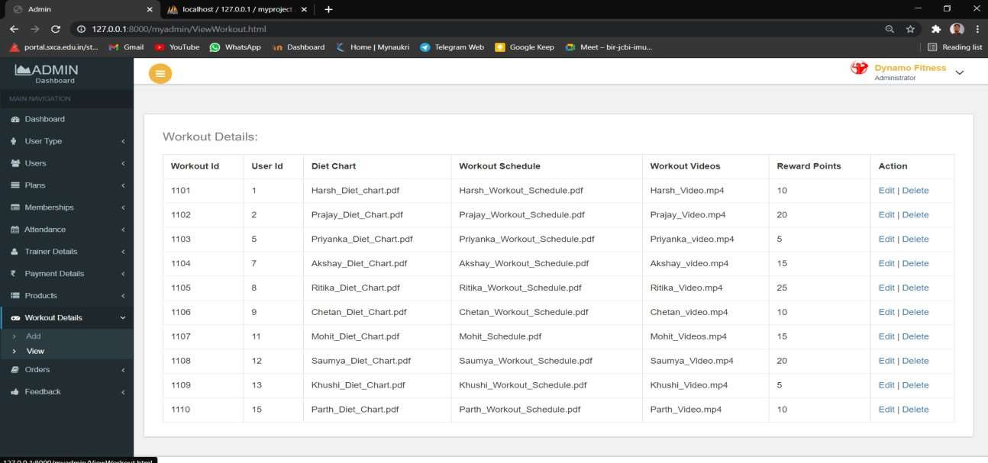

View Order window – All the details with delivery status is shown in this window.

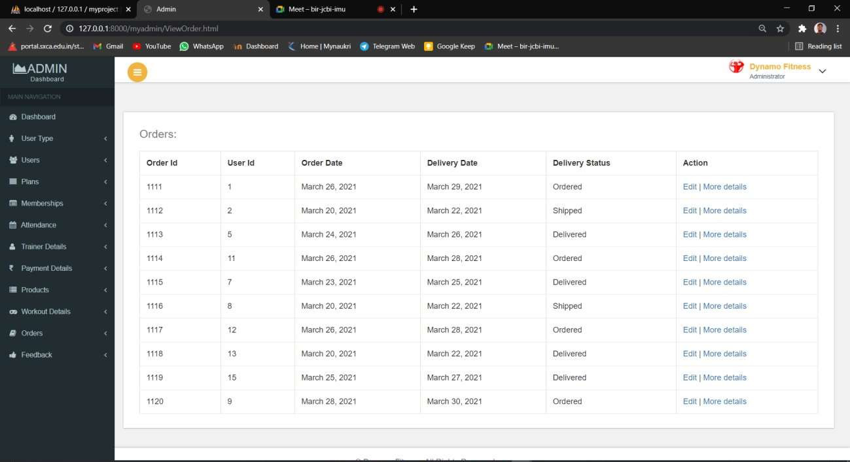

View Feedback window: Admin can view feedback and ratings given by users in this window.

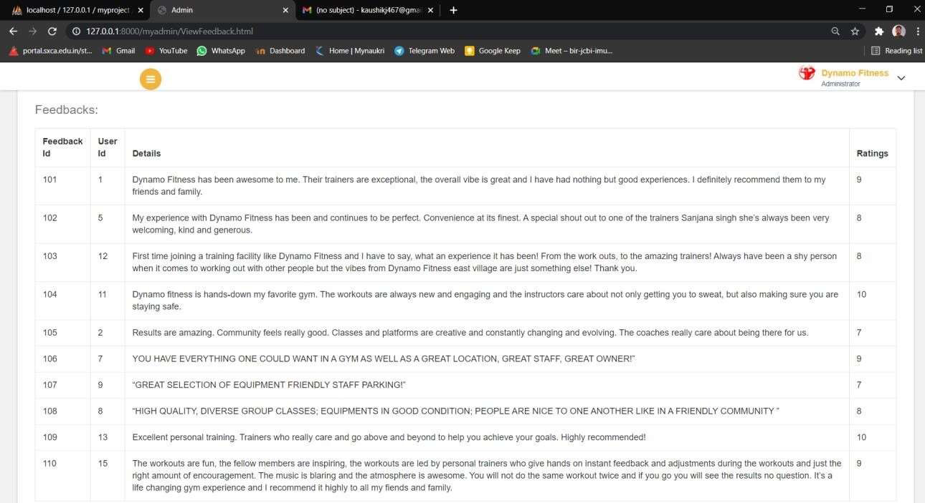

* 1. **TRAINER SIDE:**

Trainer Login Page:

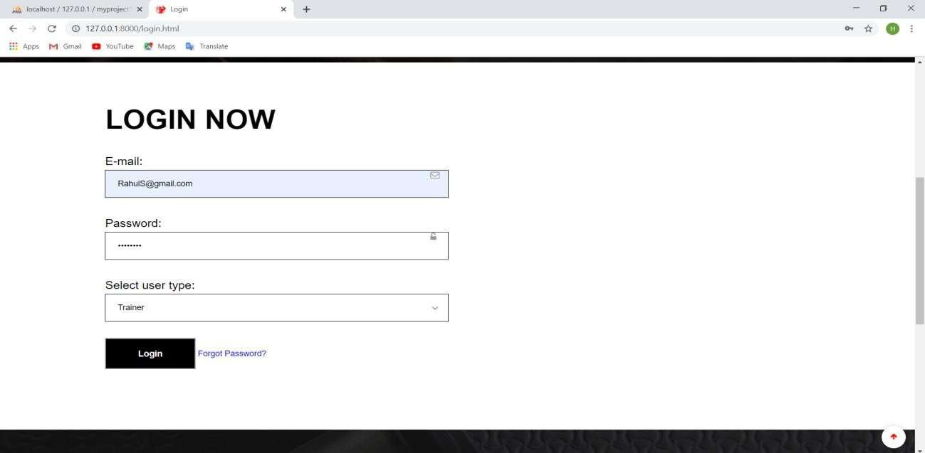

Trainer dashboard which contains information about trainer with Edit Profile and Change Password Link. It Shows Side Panel which directs it to selected page to be visited. The Page shows the direct link and information of Attendance and Workout Details.

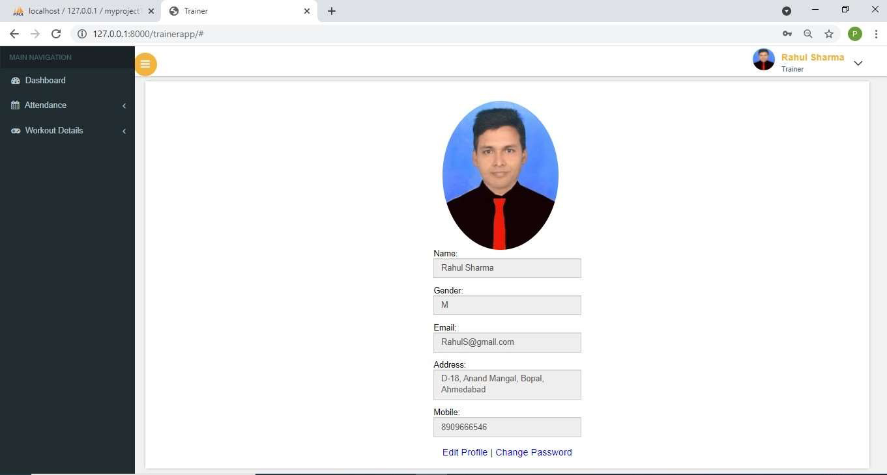

When Change Password Link is clicked, trainer will be redirected to Change password Page where he/she can change their login password:-

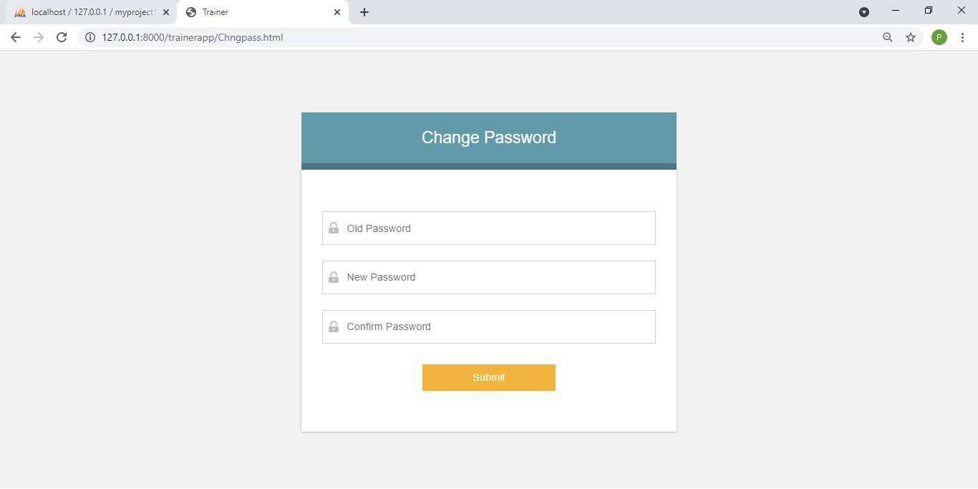

Change Password Validations:-

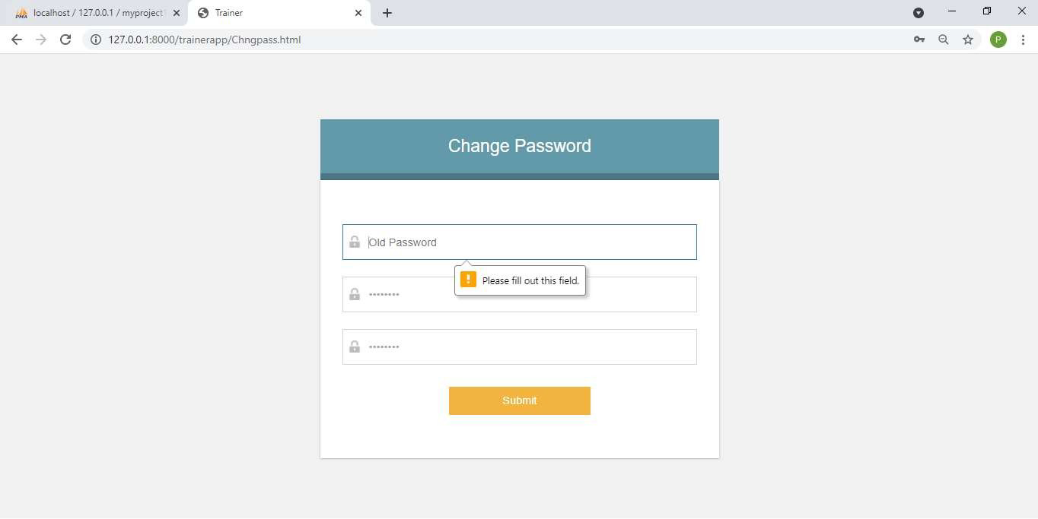

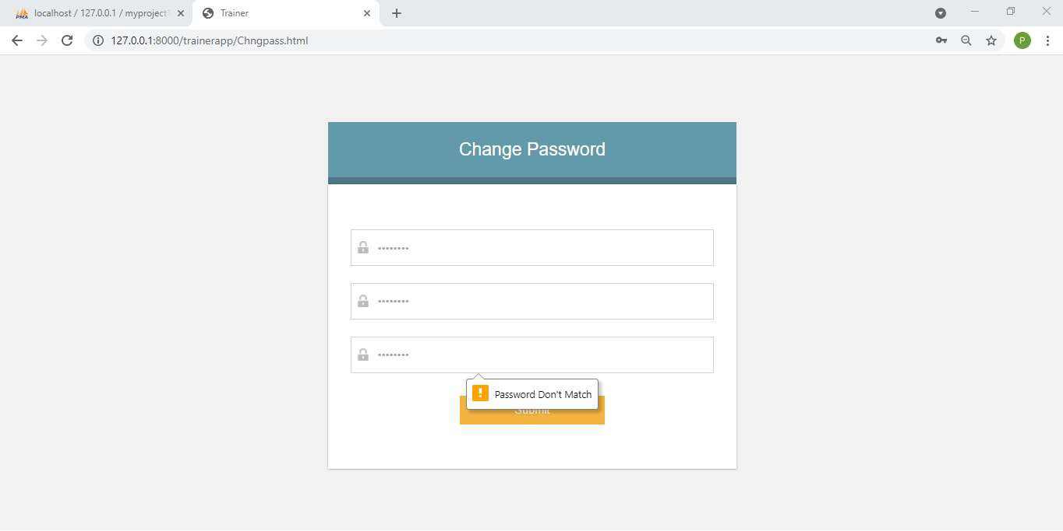

When My Attendance part of Attendance in side menu is clicked attendance details of his/her own is shown:-

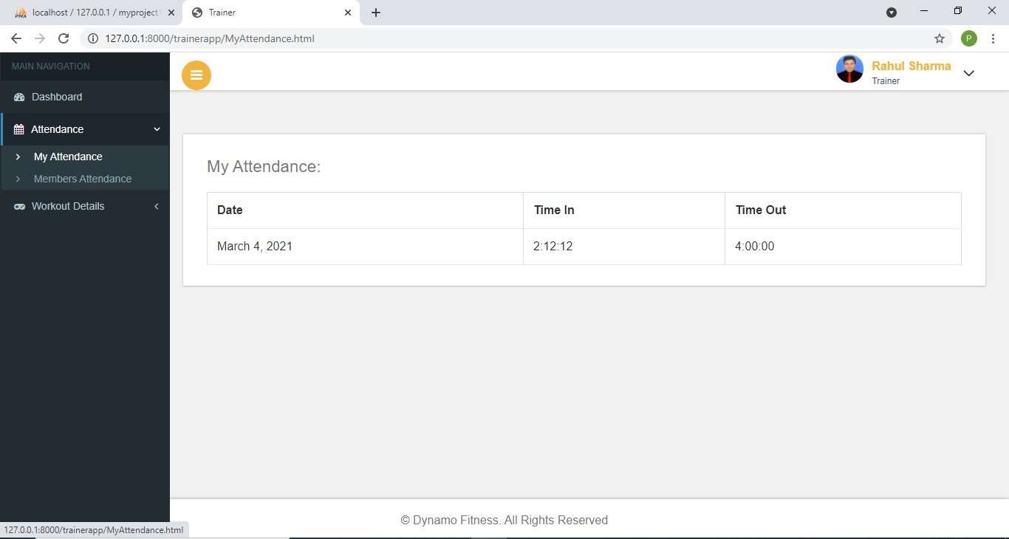

When Members Attendance part of Attendance in side menu is clicked attendance details of member is shown:-

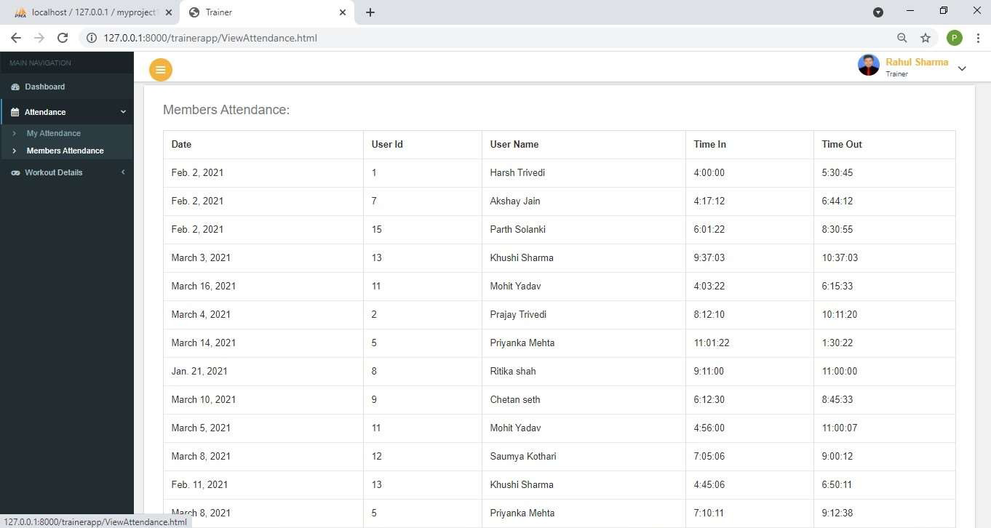

Dashboard Showing Add and View Option in Workout Menu of Side Bar :

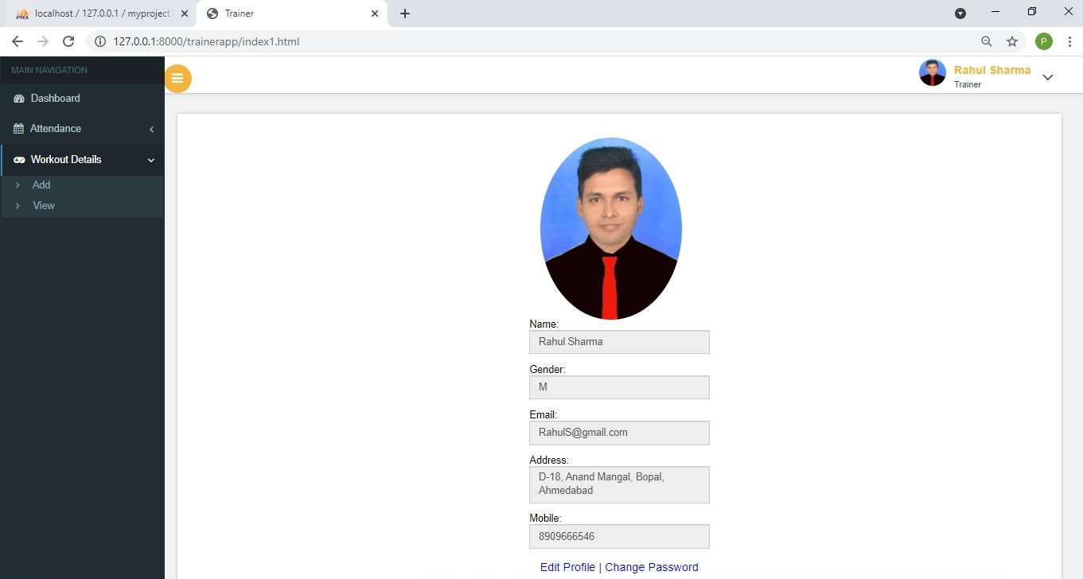

Add Workout Details Window - Trainer can add Workout Details of a particular user by adding diet chart, workout schedule and workout videos for the member.

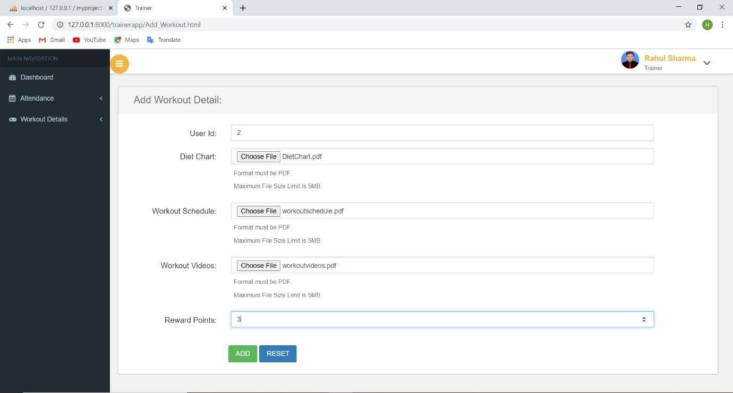

View Workout Details Window: Details of member workout including diet chart, workout schedule and total reward points is shown in this window.

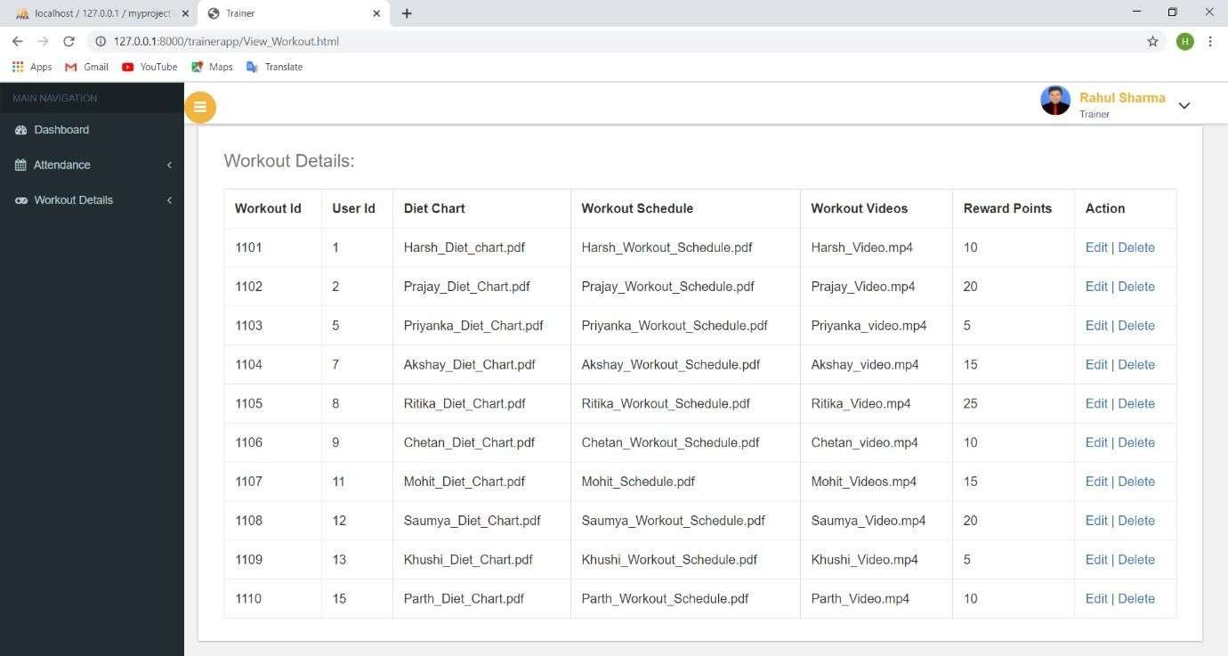

### GUEST SIDE:

HomePage:- Starting point of website/first page of website

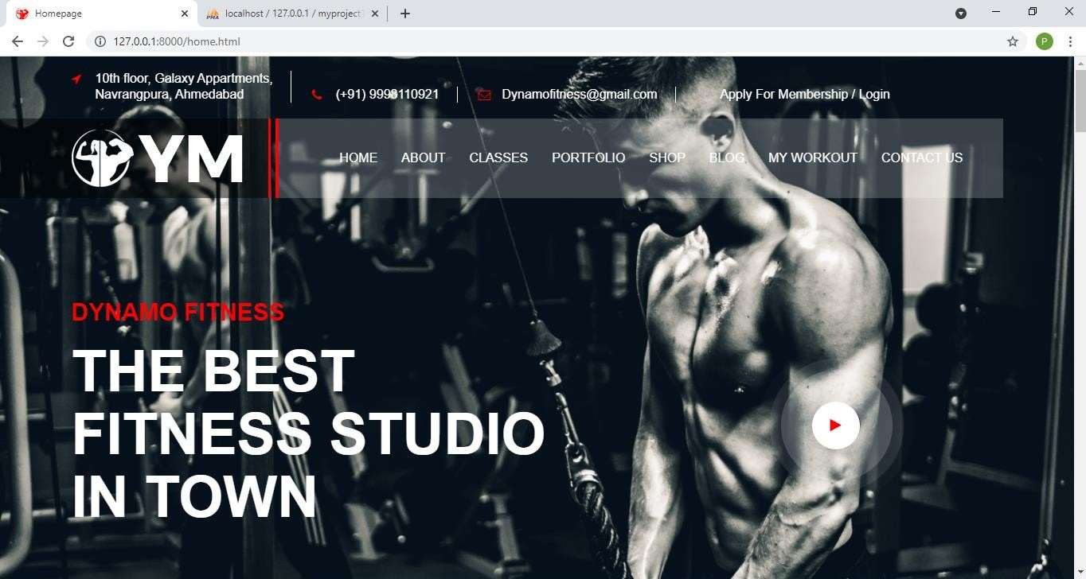

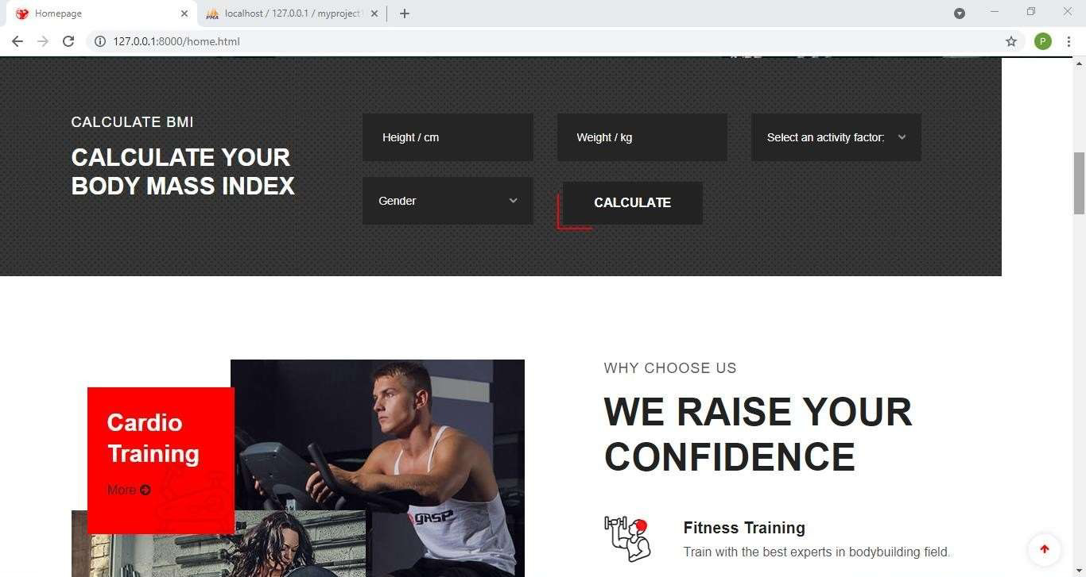

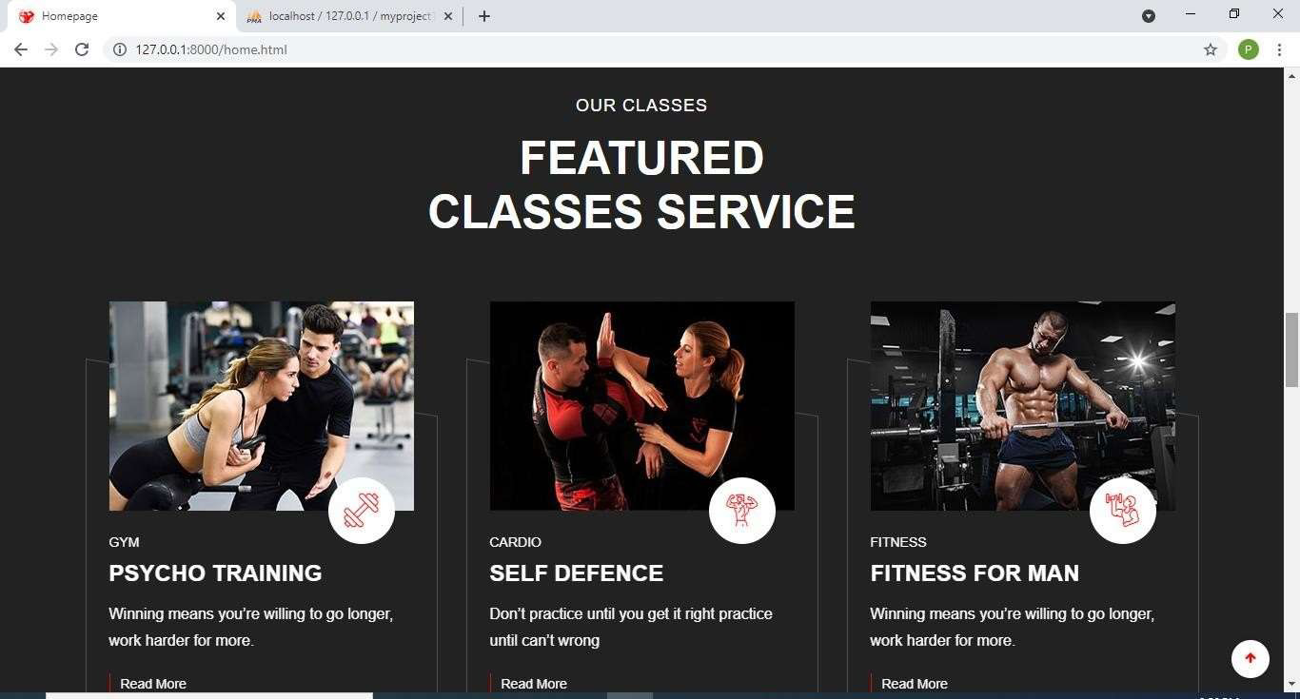

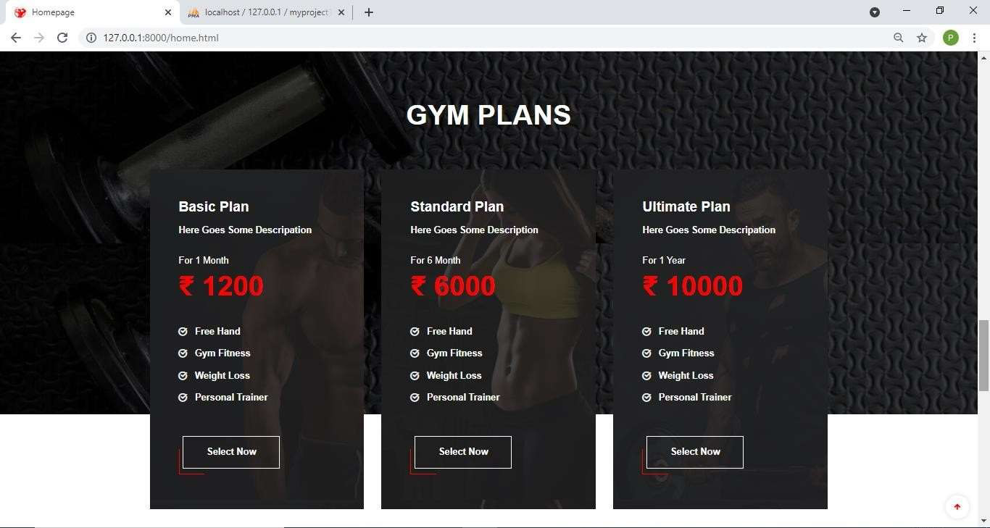

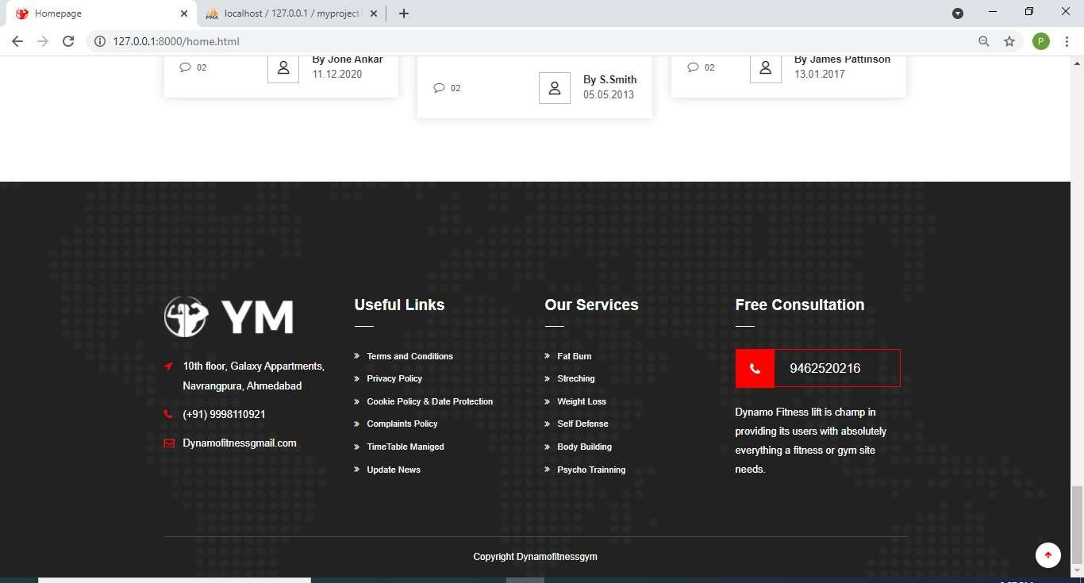

About Options:-

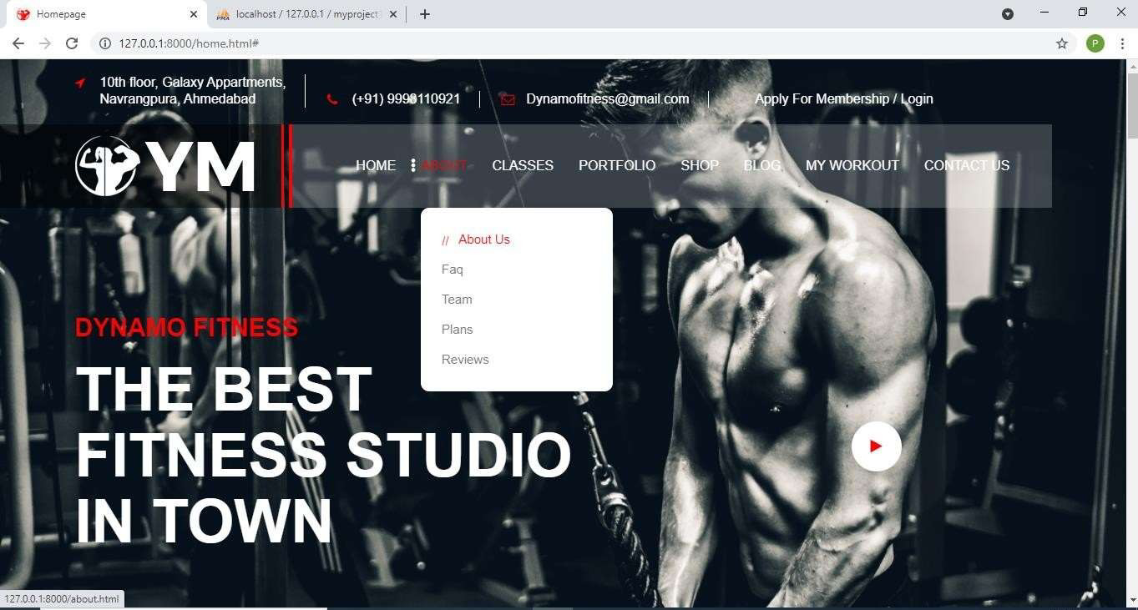

About Us page giving information about GYM:-

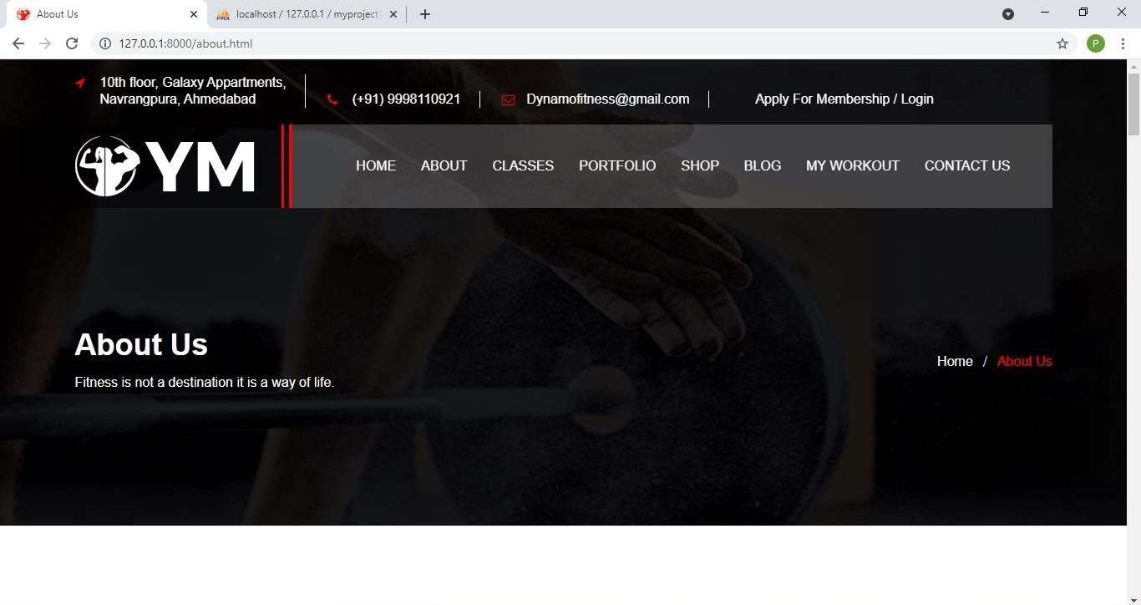

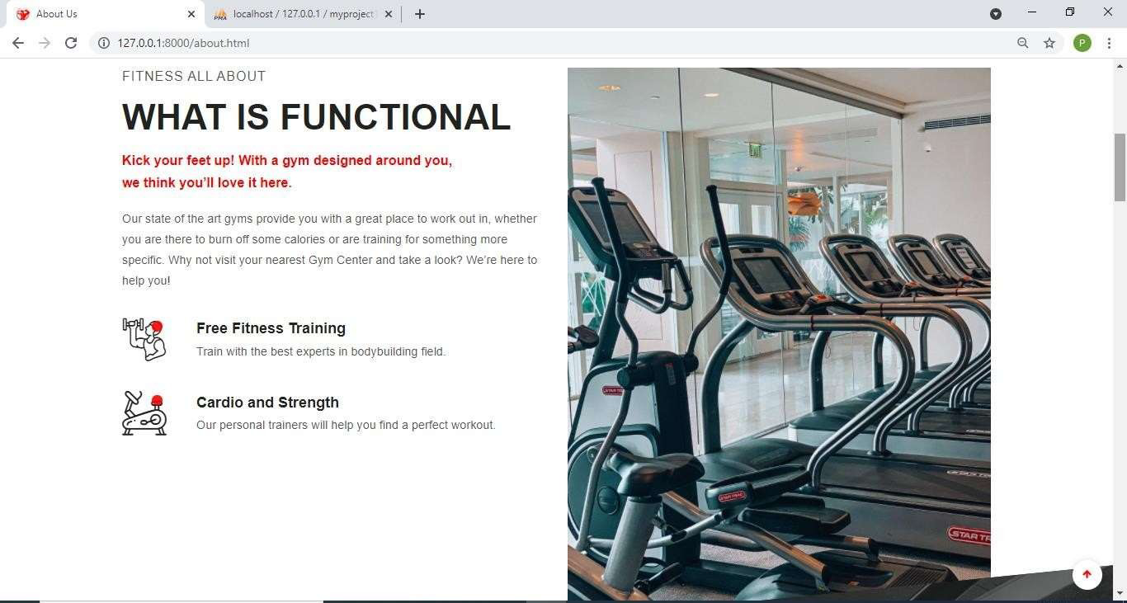

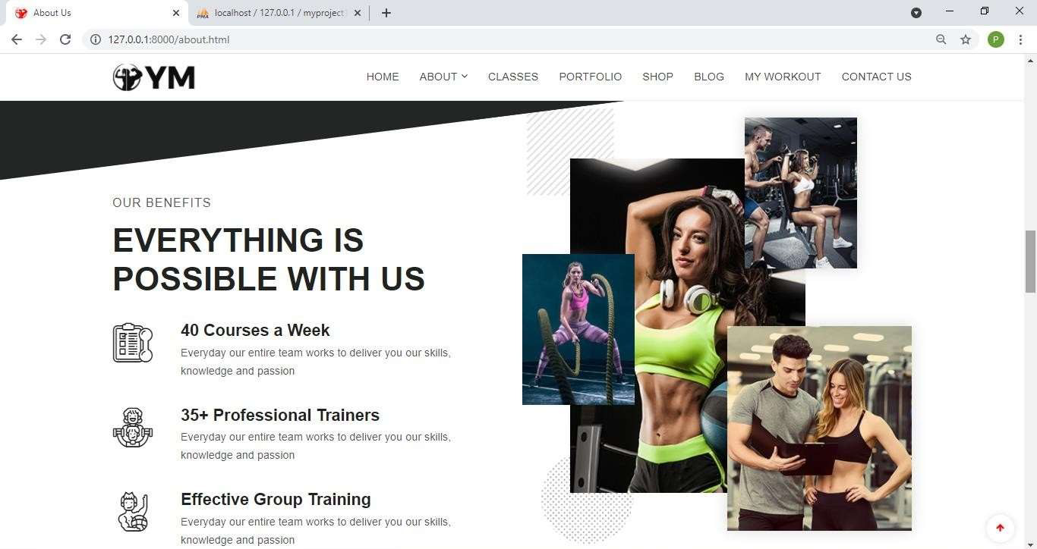

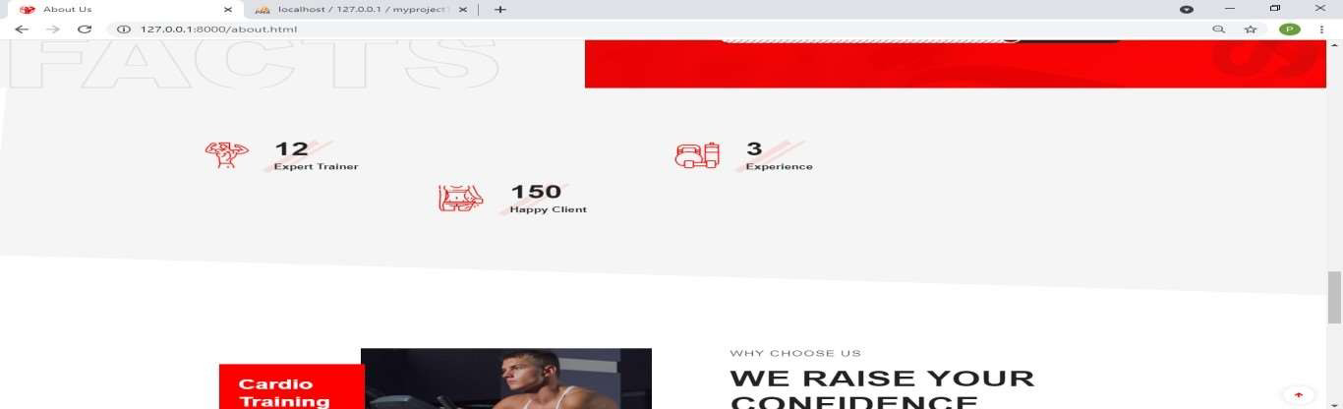



FAQ Page:- It Contains all the frequently asked questions with their answers

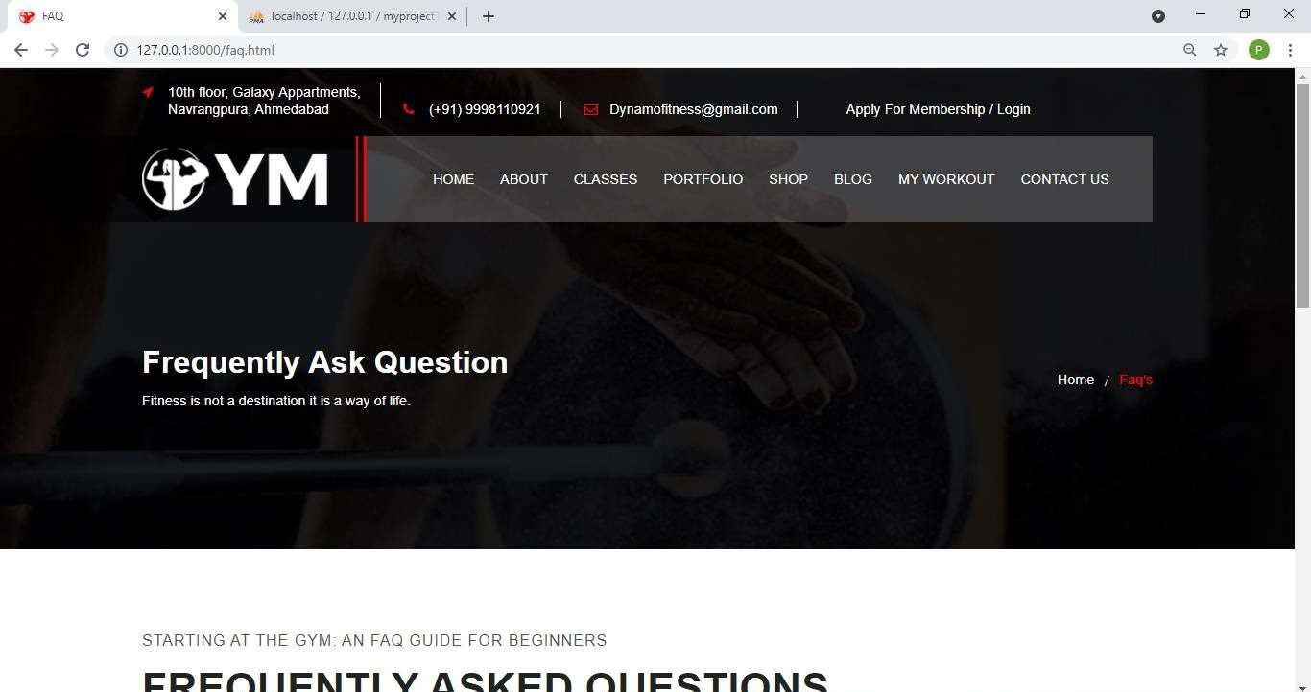

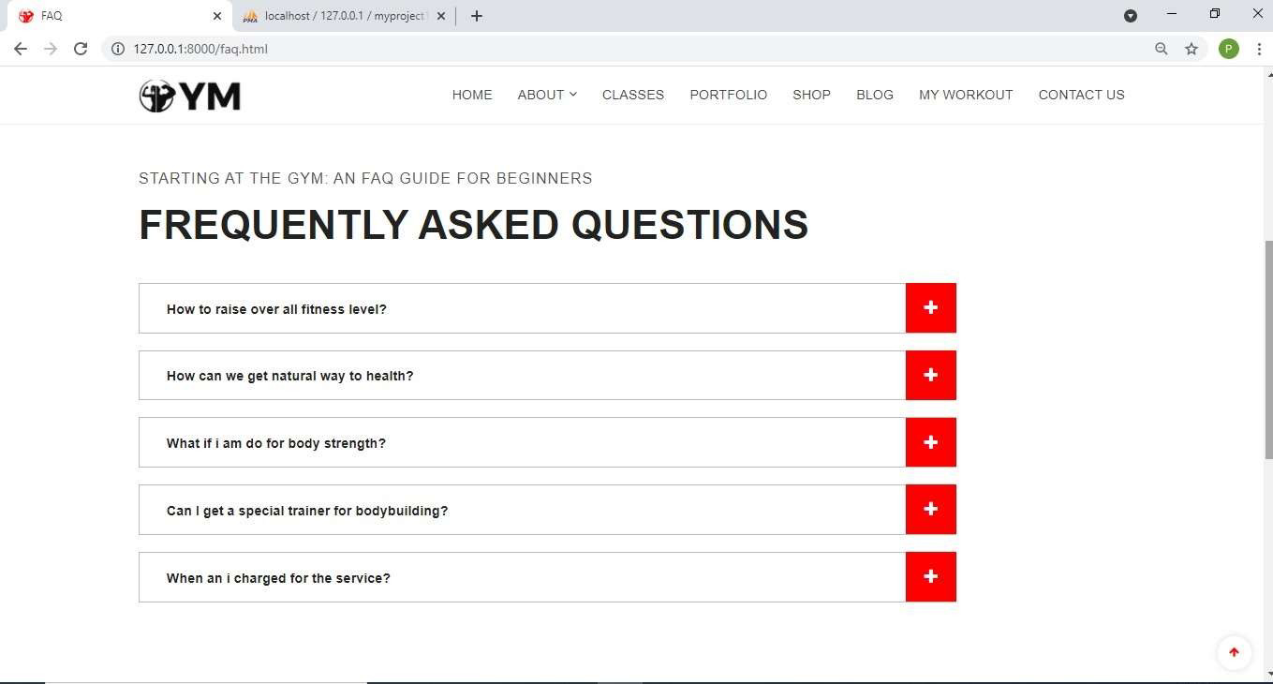

Testimonial Page:- It contains all the reviews given by the members.

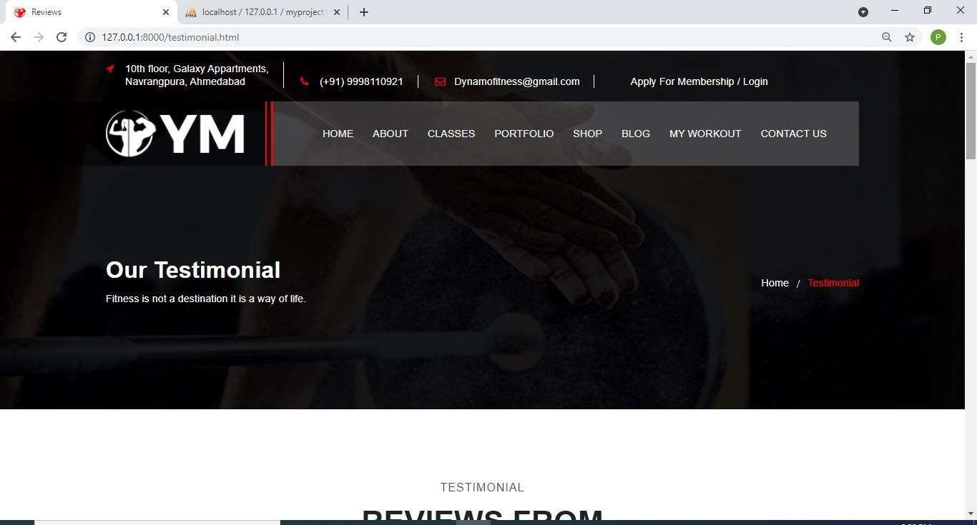

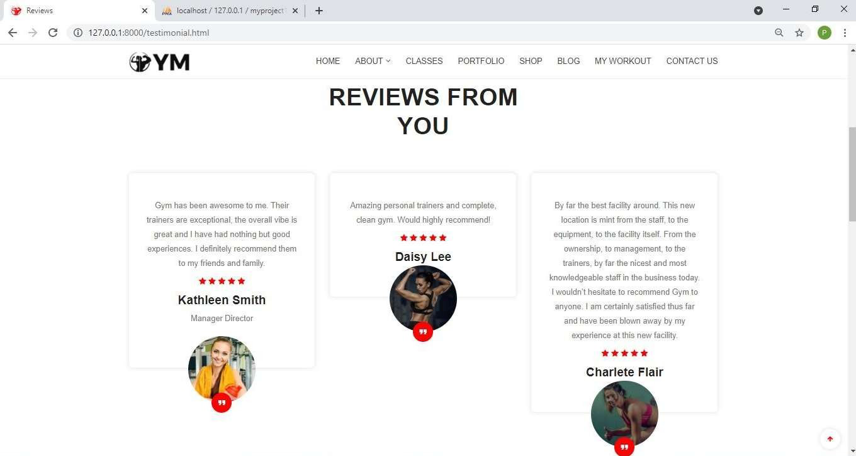

Contact Us Page:- It contains all the contact details of the gym.

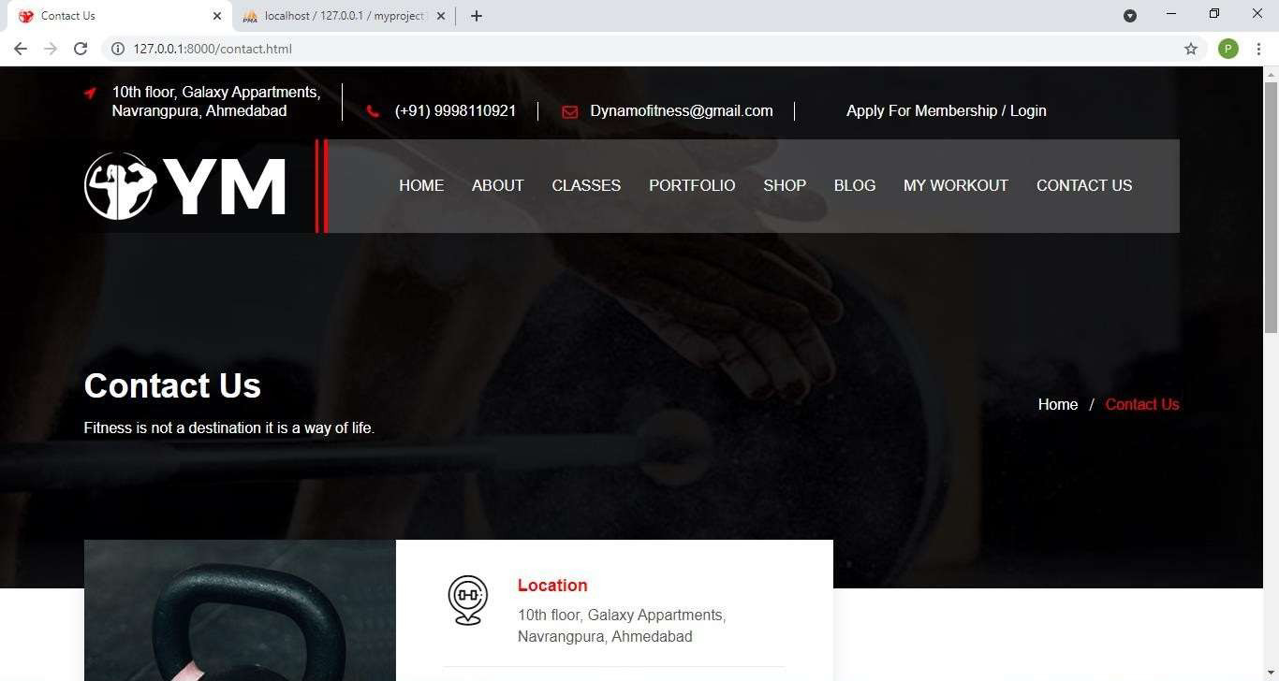

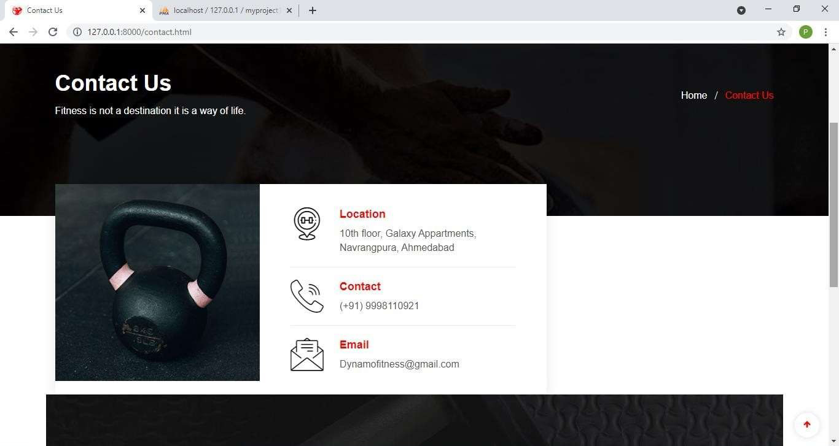

When user clicks on the Apply For Membership tab Registration page is opened which Collects user data for registration so that user can make login.

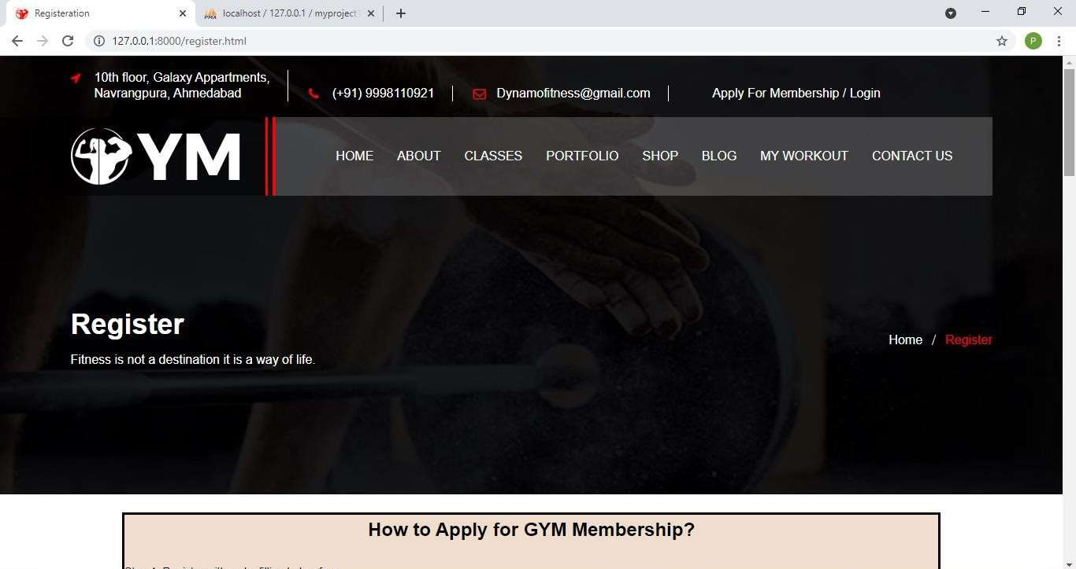

Registration Page Showing How to Apply for the GYM Membership.

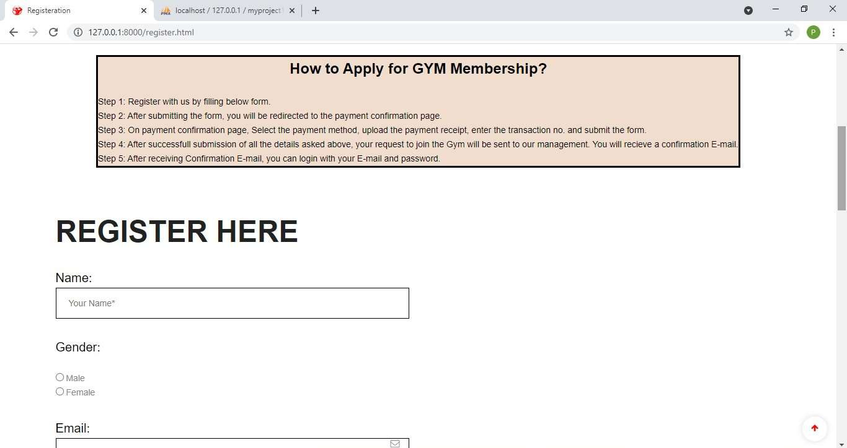

Registration page displaying validation:-

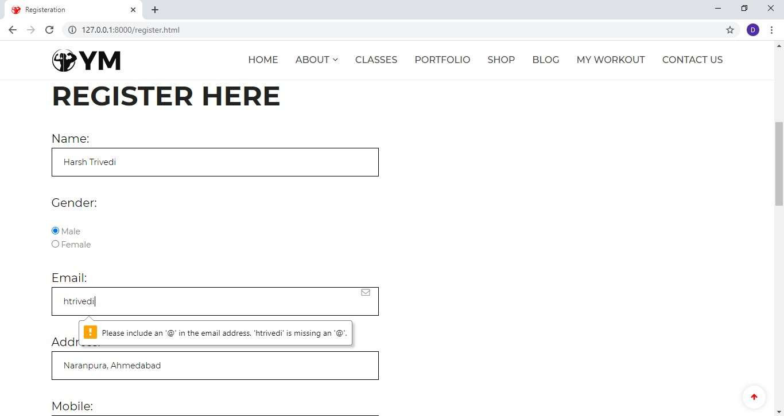

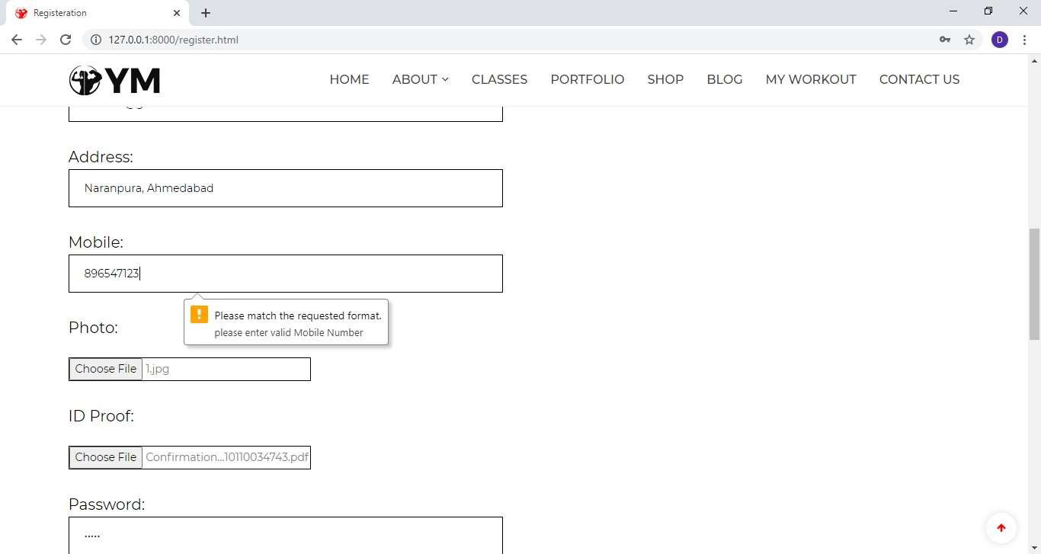

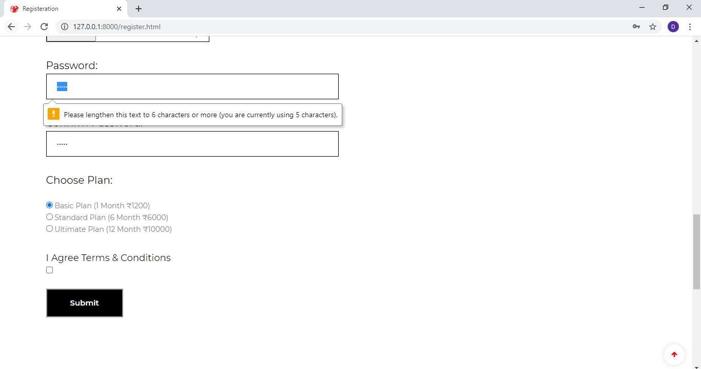

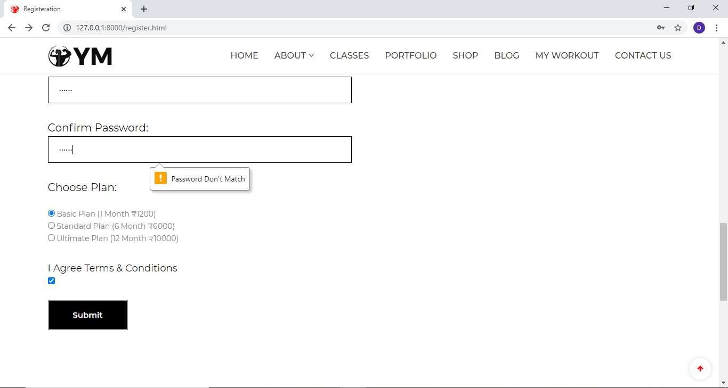

After Successfully filling Registration Form, User will be redirected to Payment Confirmation Form which will show the user information along with plan he has chosen while registering and then user has to choose how payment was done, enter transaction no. and has to upload Payment Receipt.

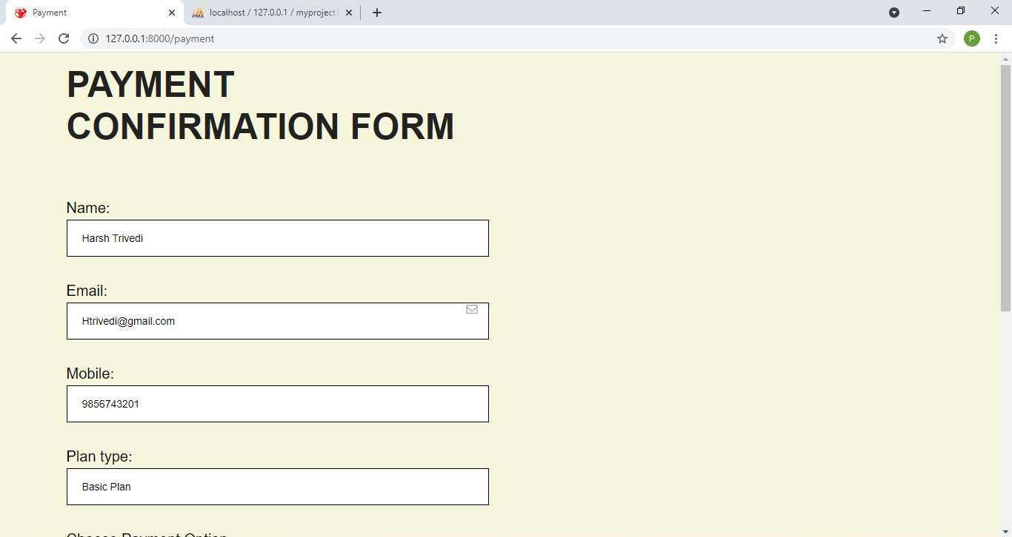

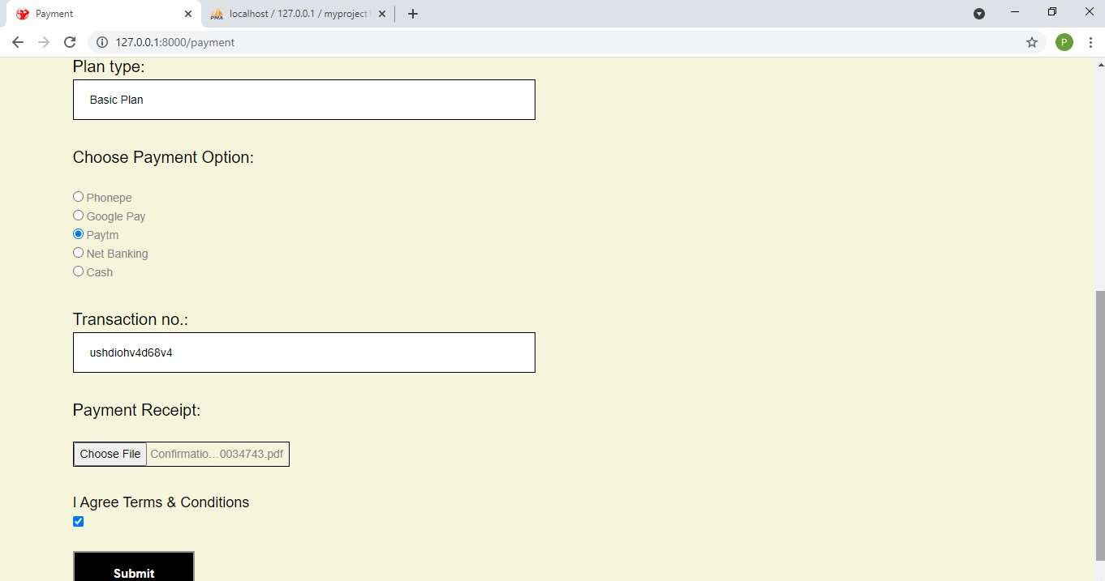

When User will successfully submit the payment confirmation form ,they will redirected to Login page or can open it from Login Tab.

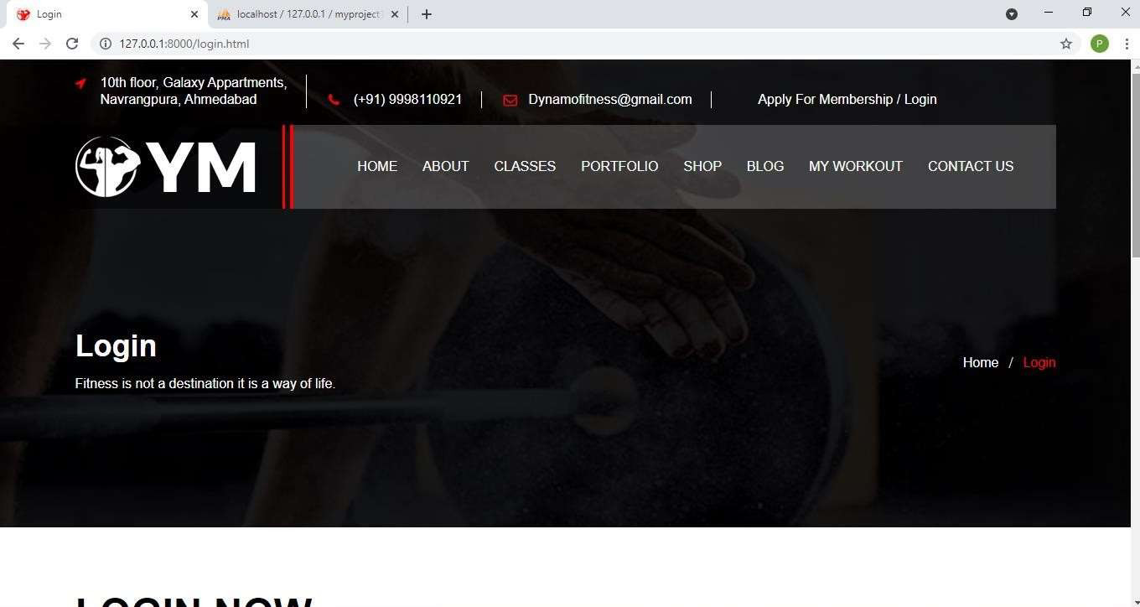

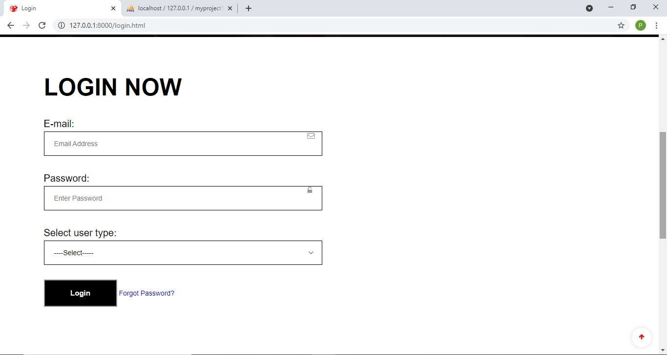

Login Page with Validation:-

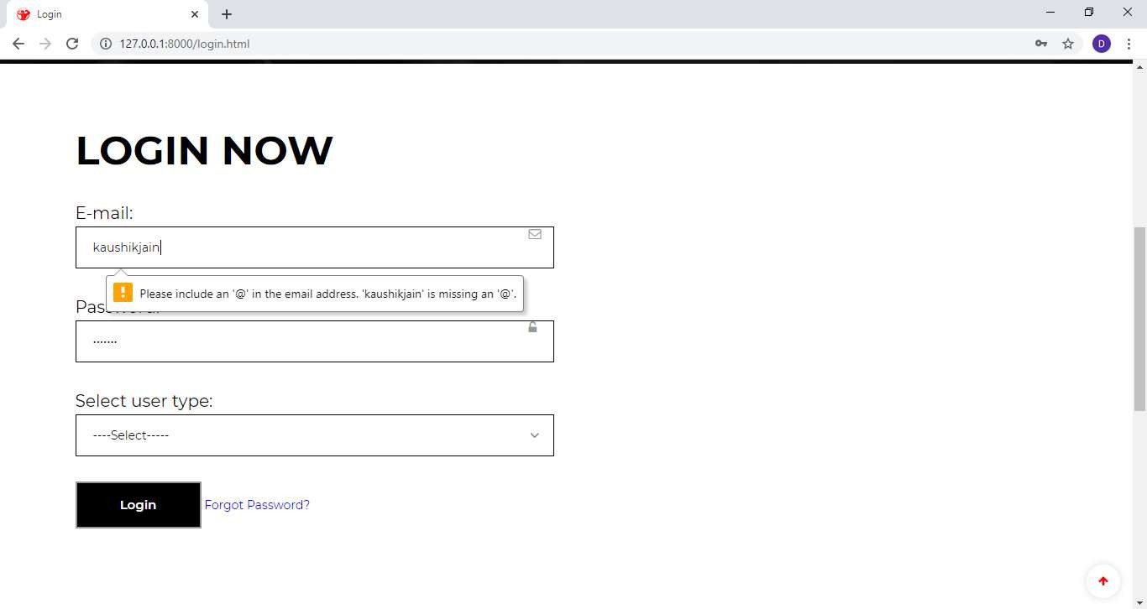

Forgot password? - asking for registered email ID

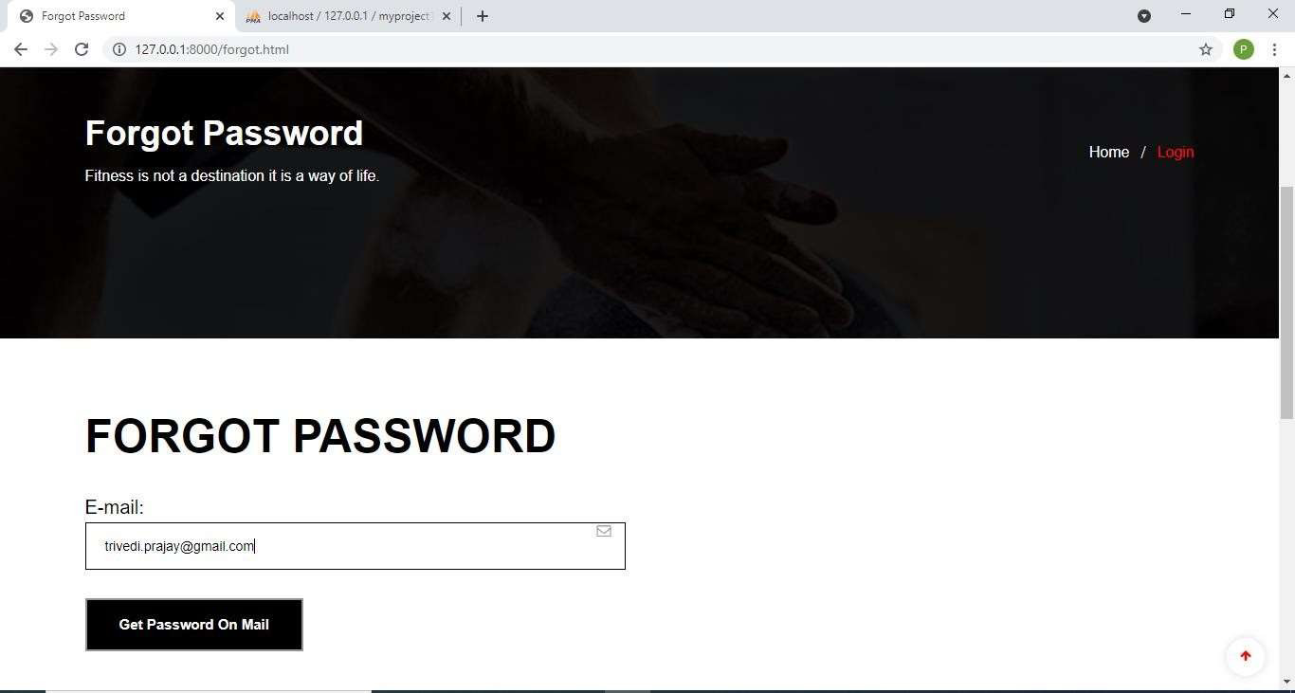

Password received by the customer through email.

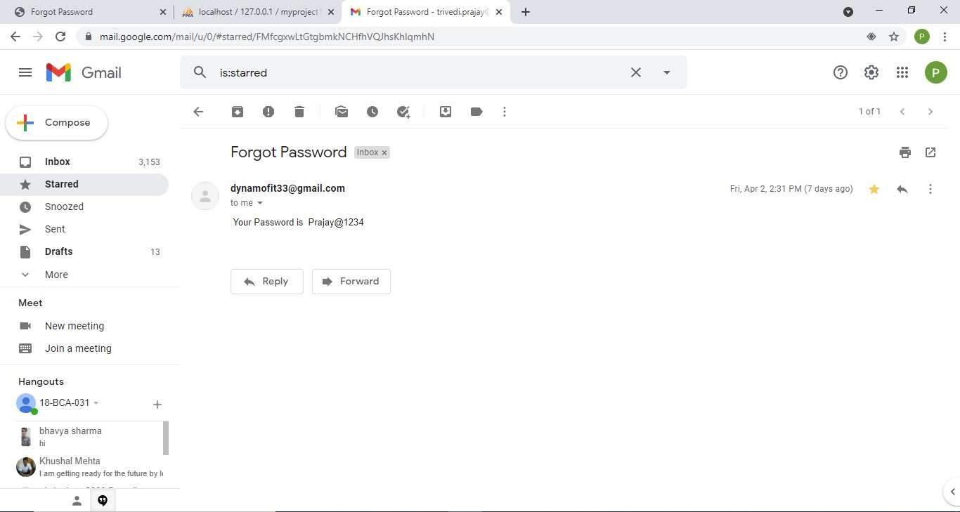

### USER SIDE:

User Login - Email ID,Password and User type

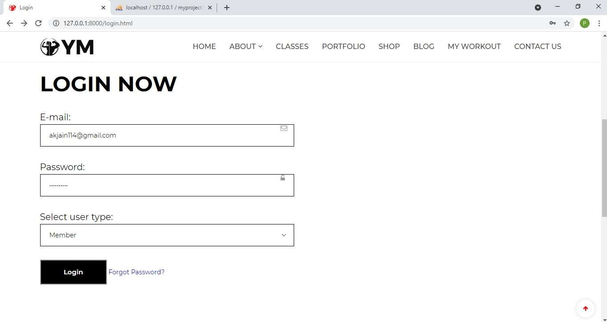

After Successful Login User will be redirected to Homepage .The Apply For Membership and Login from heading is changed to My Account with Profile

,Membership, Attendance and Logout Options.

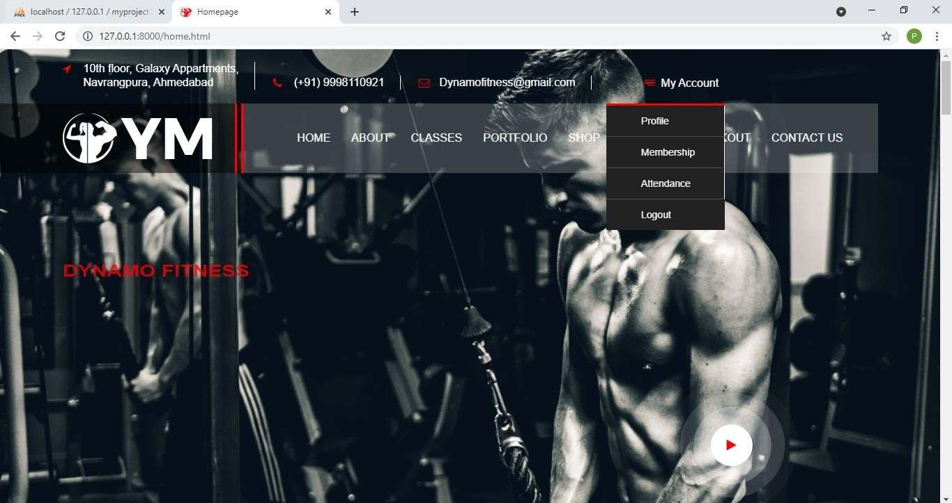

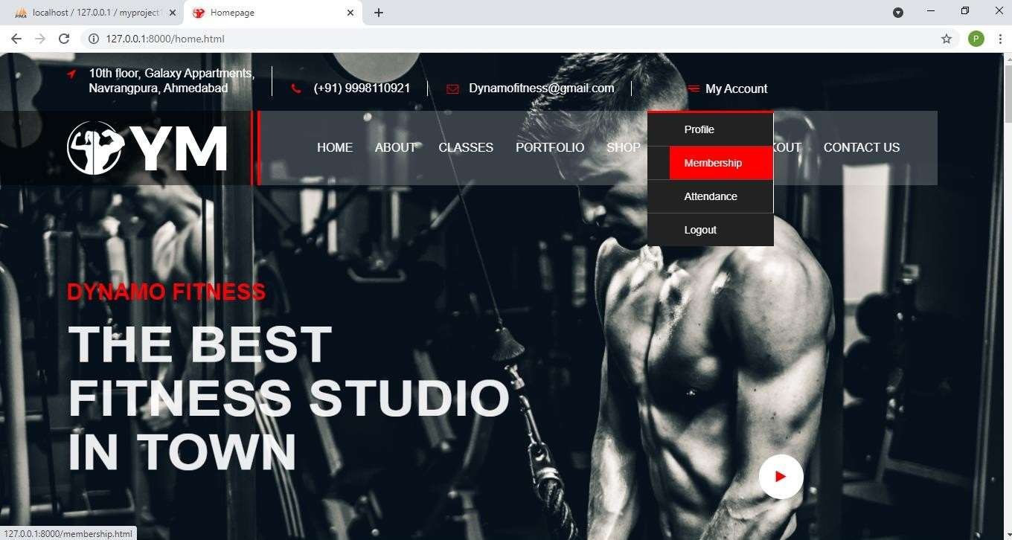

When User Clicks on Membership, He/she will be redirected to membership page which contains membership details of the user.

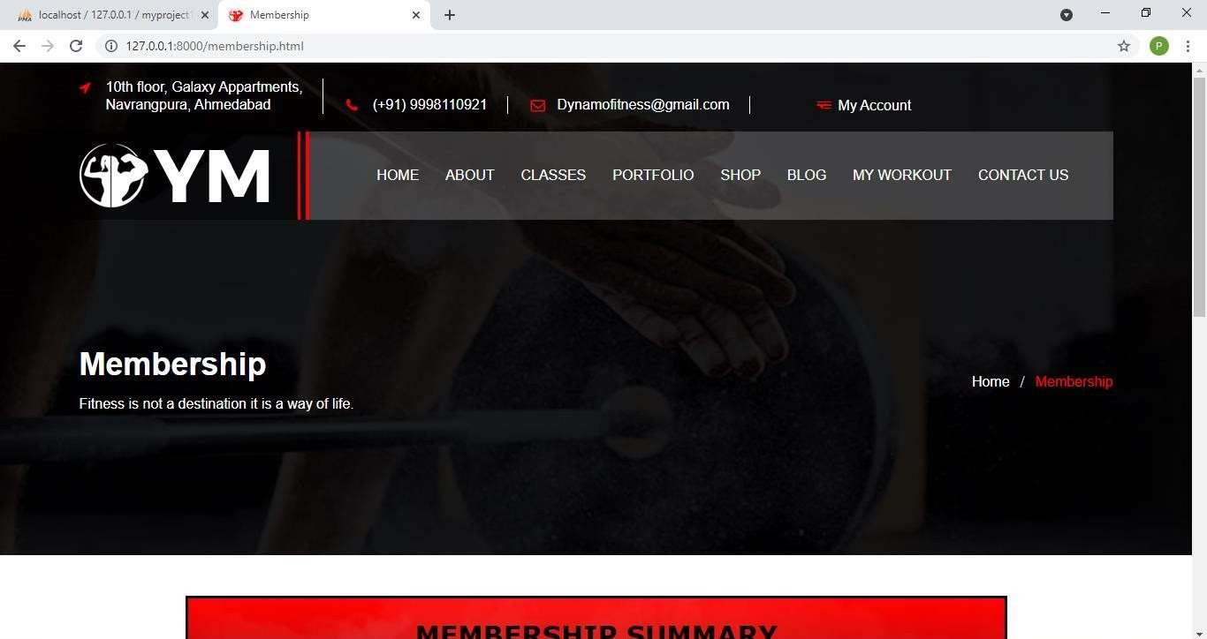

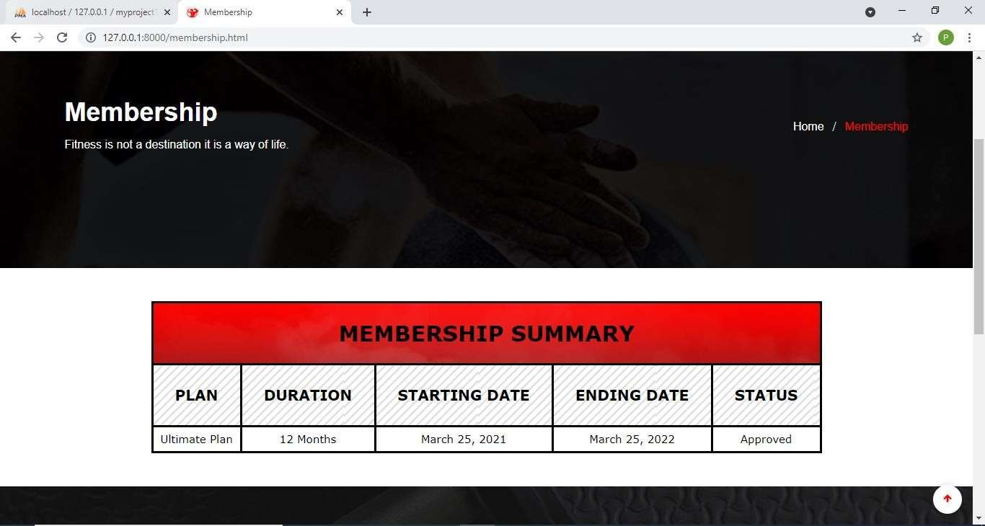

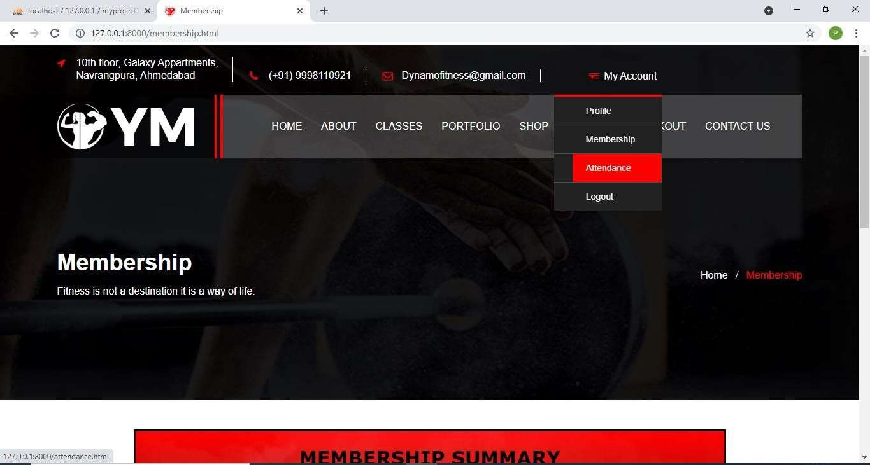

When User Clicks on Attendance option in My Account Section he/she will be redirected to Attendance Page which contains attendance details of user:-

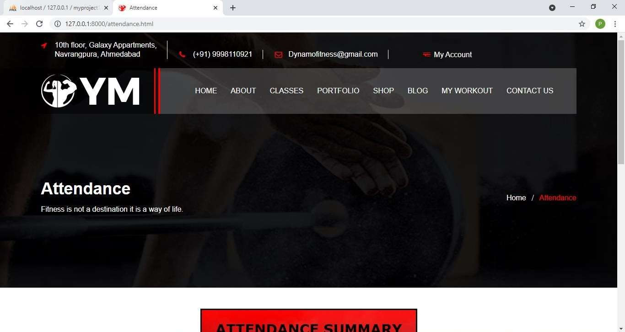

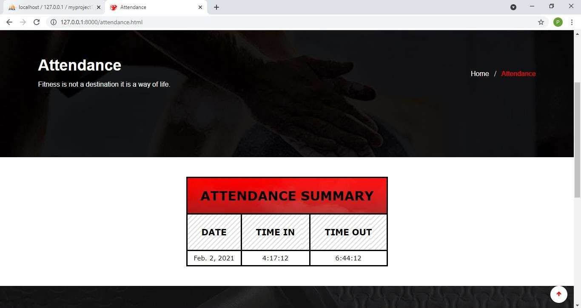

Shop Page:- It contains all the products with details that the gym wants to sell.

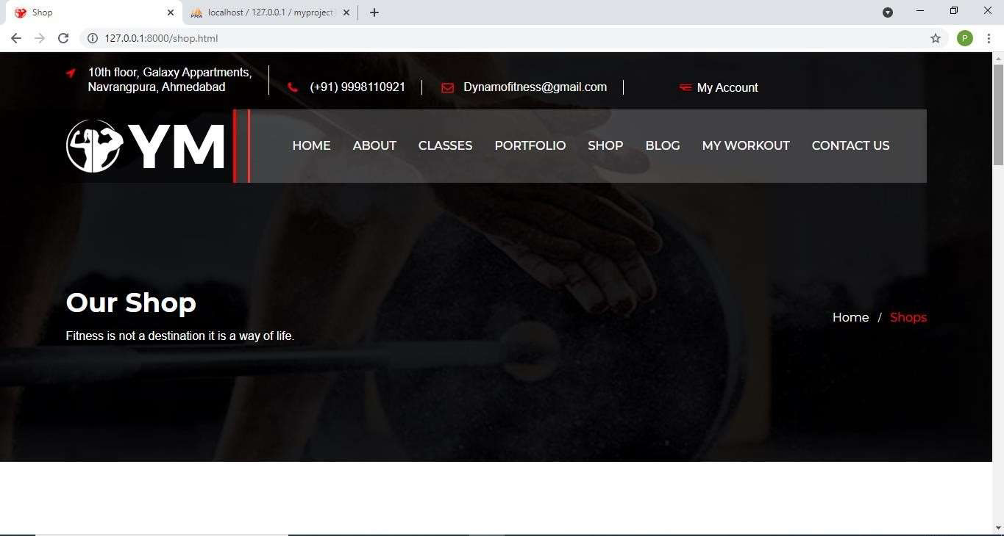

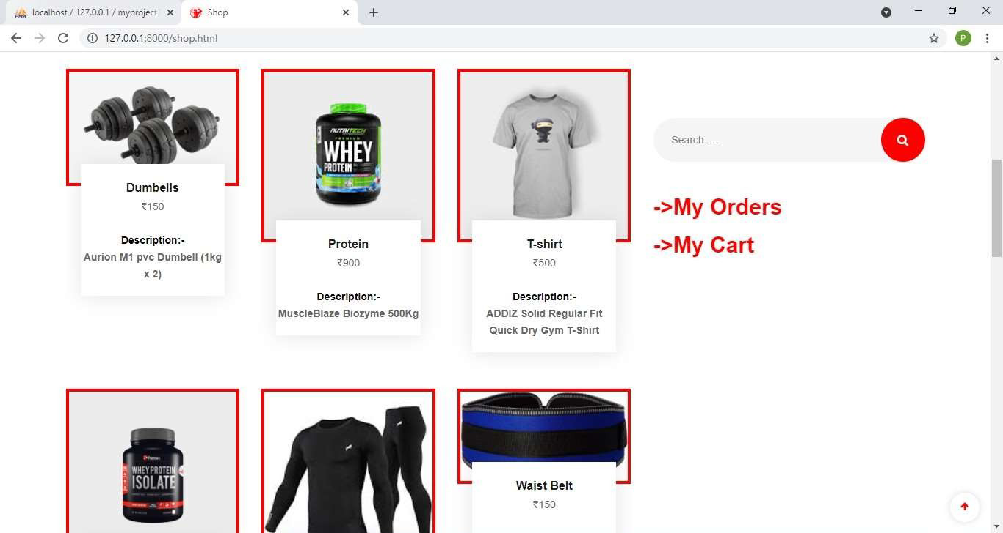

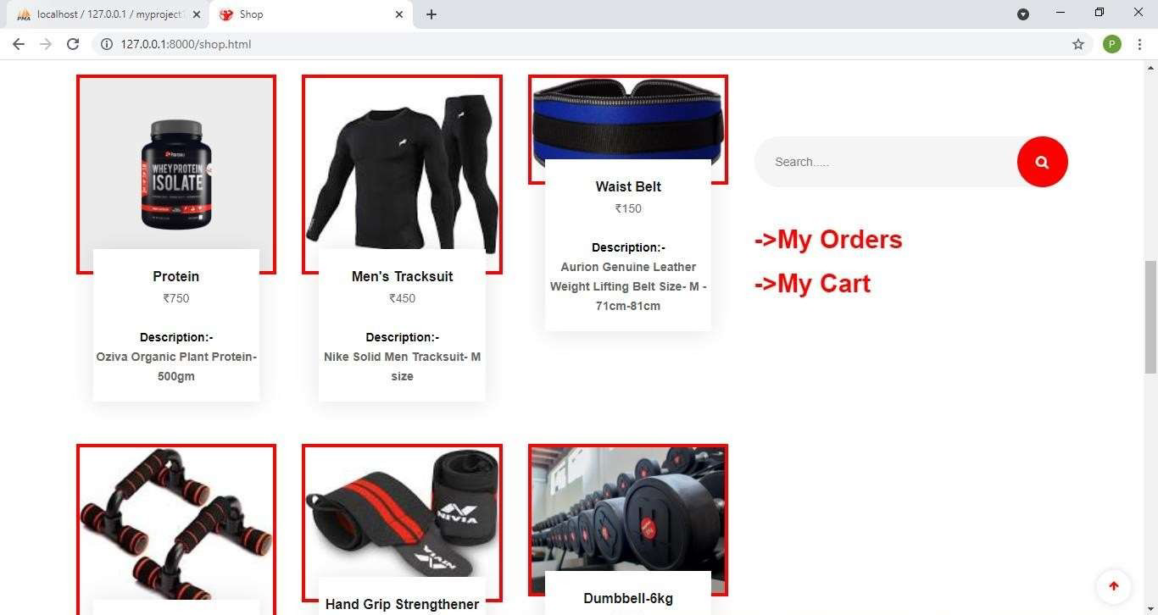

Add to cart option on product:-

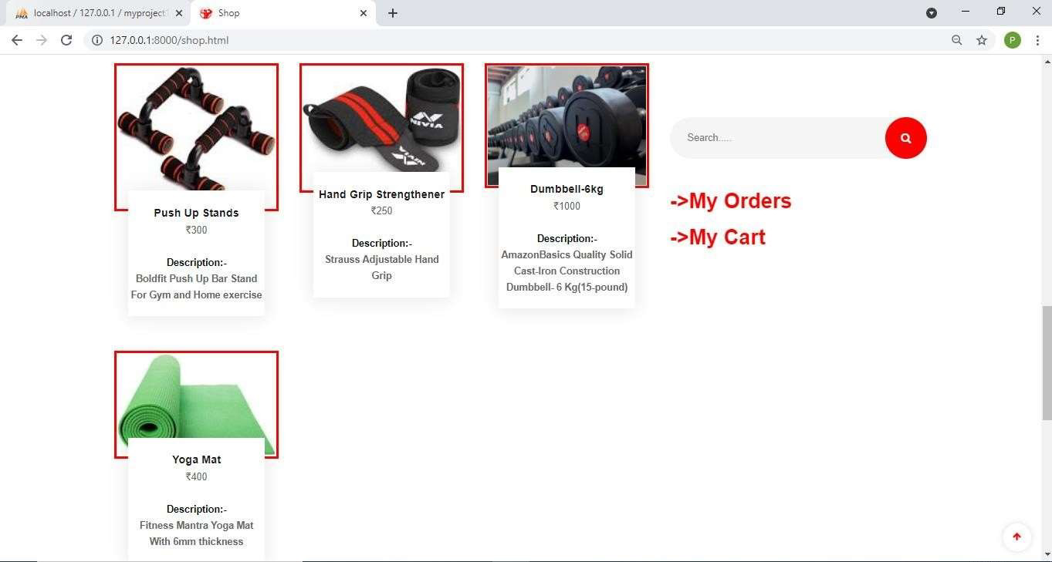

Shop Page showing Add to Cart Option for a product:-

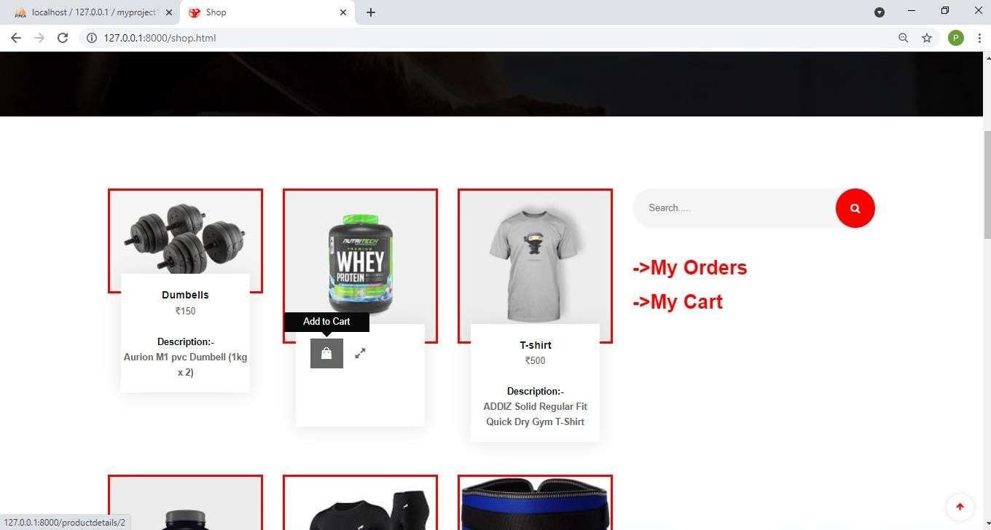

After clicking add to cart from Shop Page, Cart is opened which shows items in your cart.

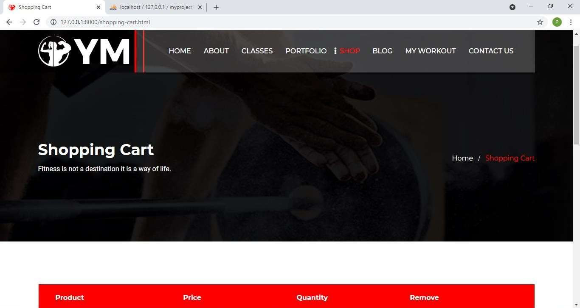

If Customer wants to shop more than one product, he/she can click on Buy More and add other products also.

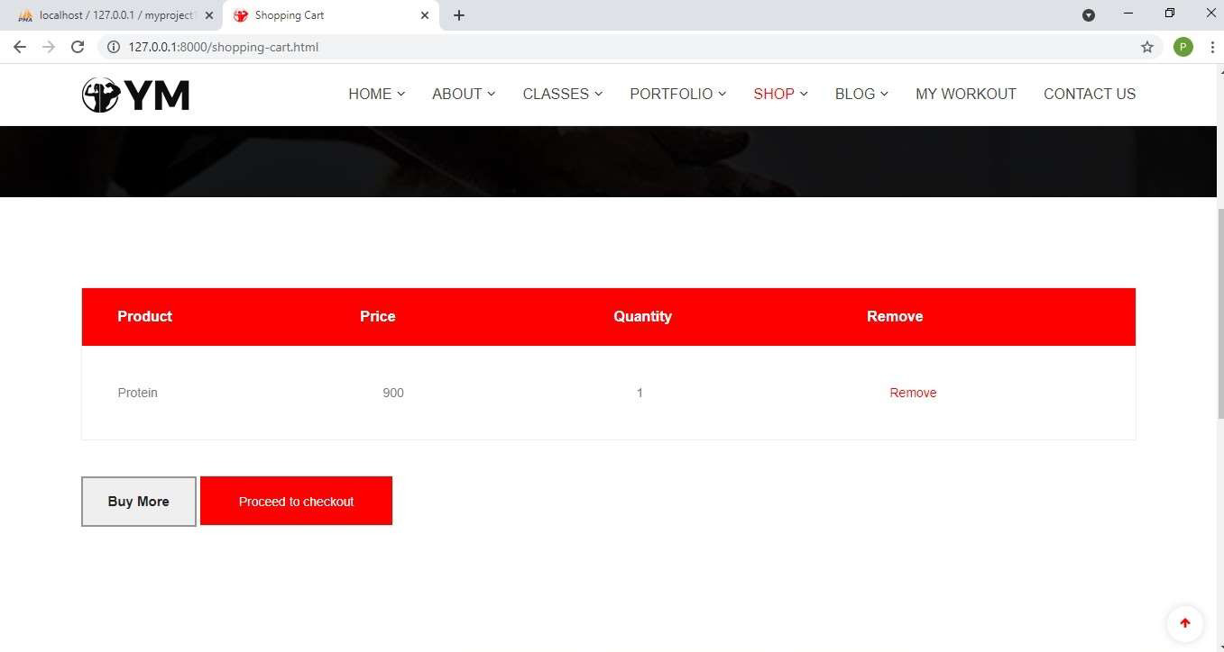

When User clicks on Proceed to Checkout, Checkout page is opened which shows order details and Billing details and gives the summary of your orders.

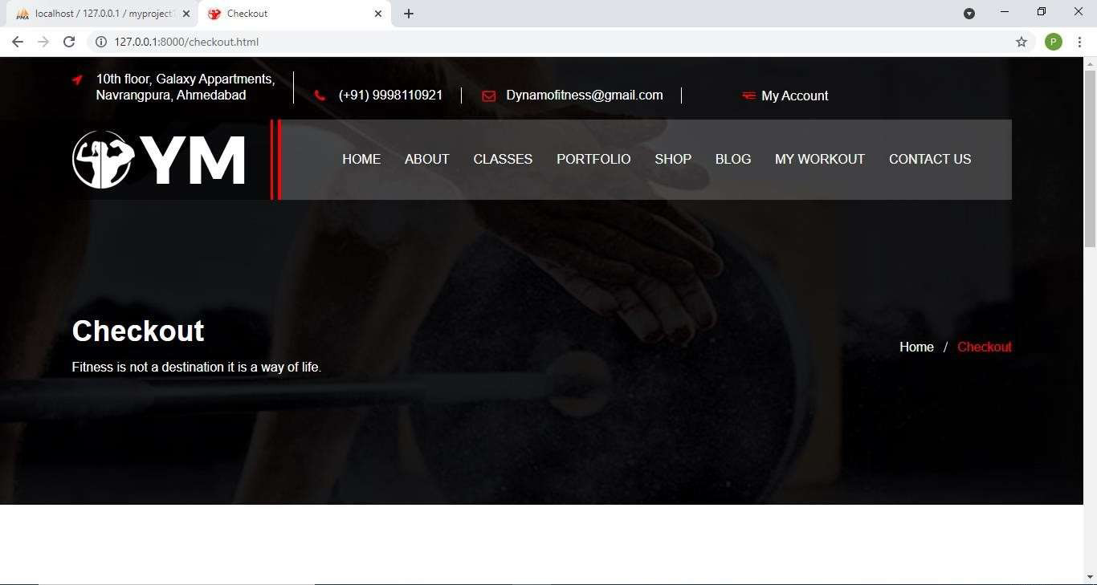

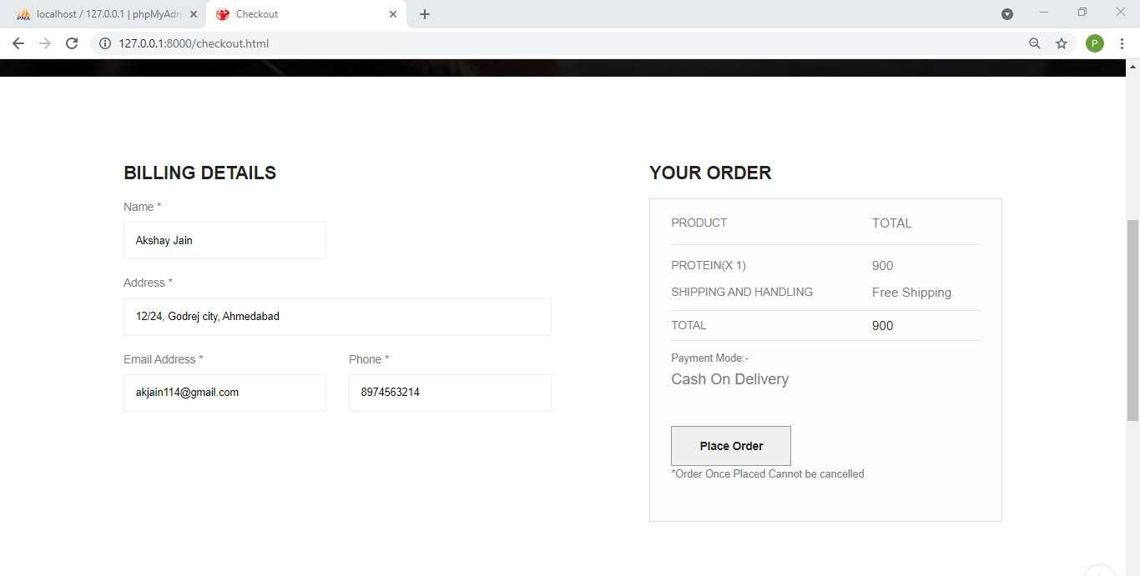

After clicking Place order, user is provided with appropriate order placed message and view order option. On clicking view order user will be shown all the details of his/her orders.

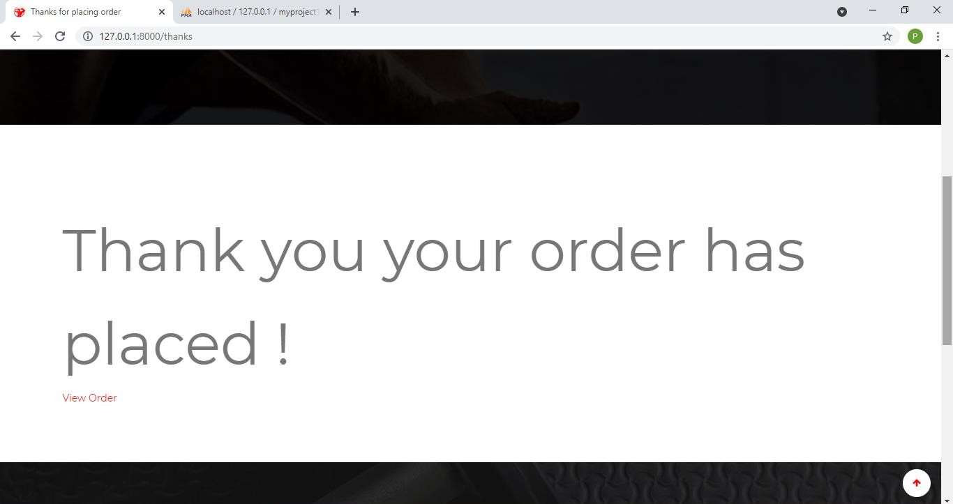

When User Clicks on View Order , he/she will be redirected to My Orders Page which contains all the order details of orders made by the member.

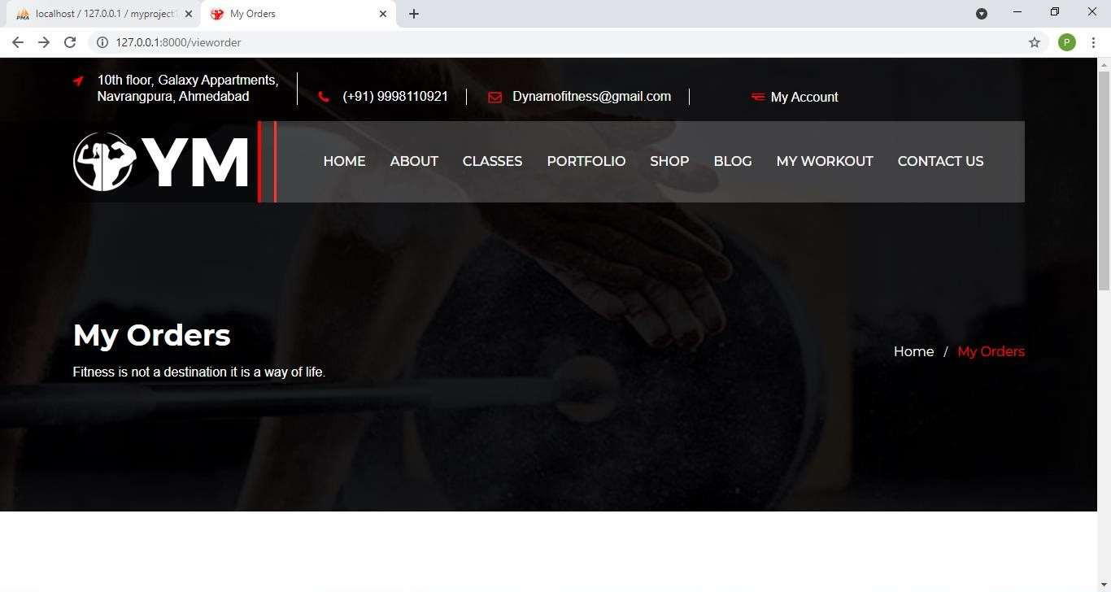

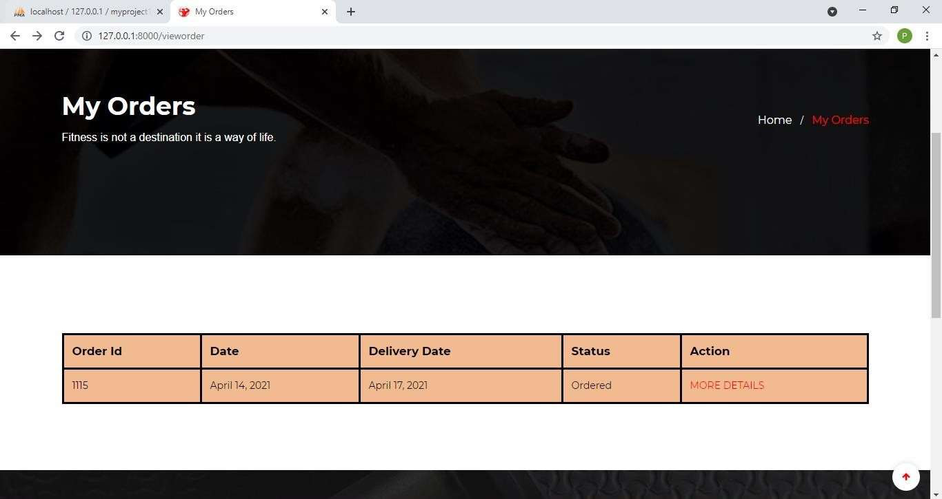

When user Clicks on More details , he/she will be redirected to order details page which contains additional details about the order.

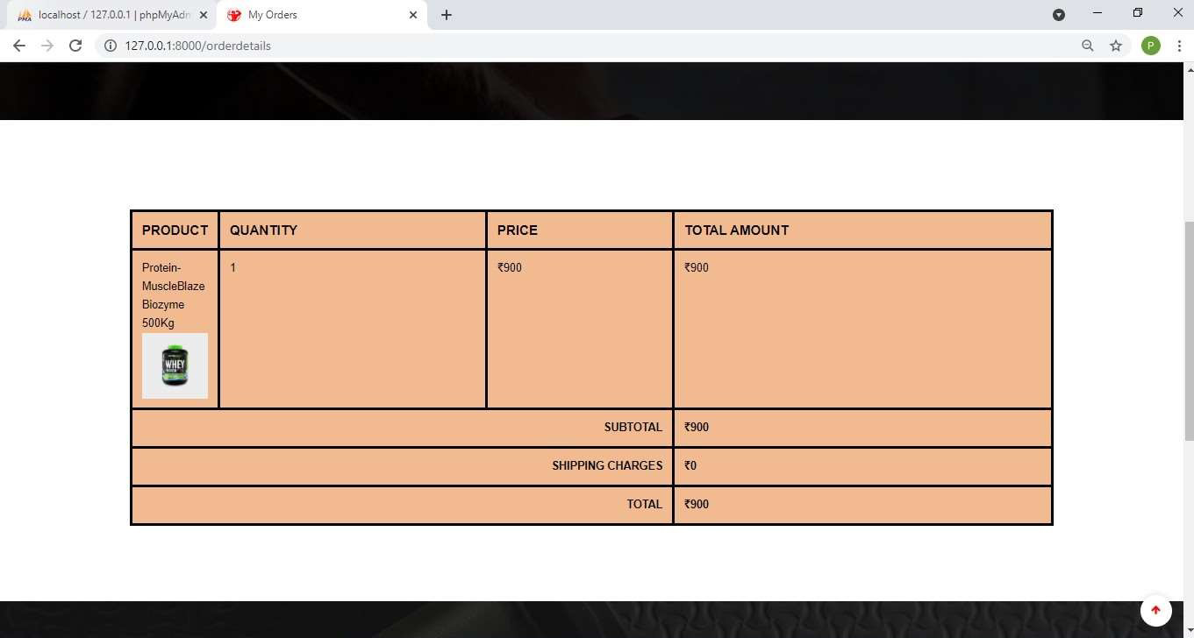

My Workout Page:- It will give user his/her option to download his/her diet chart,workout schedule and workout videos provided by trainer

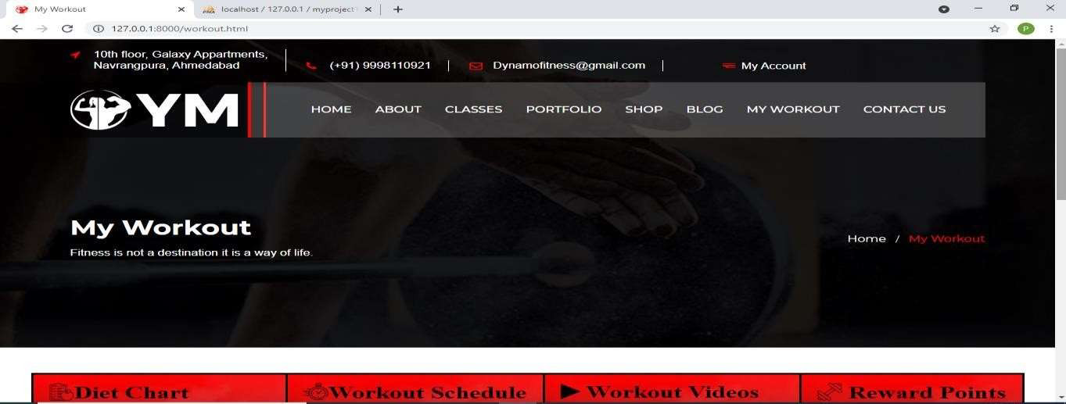

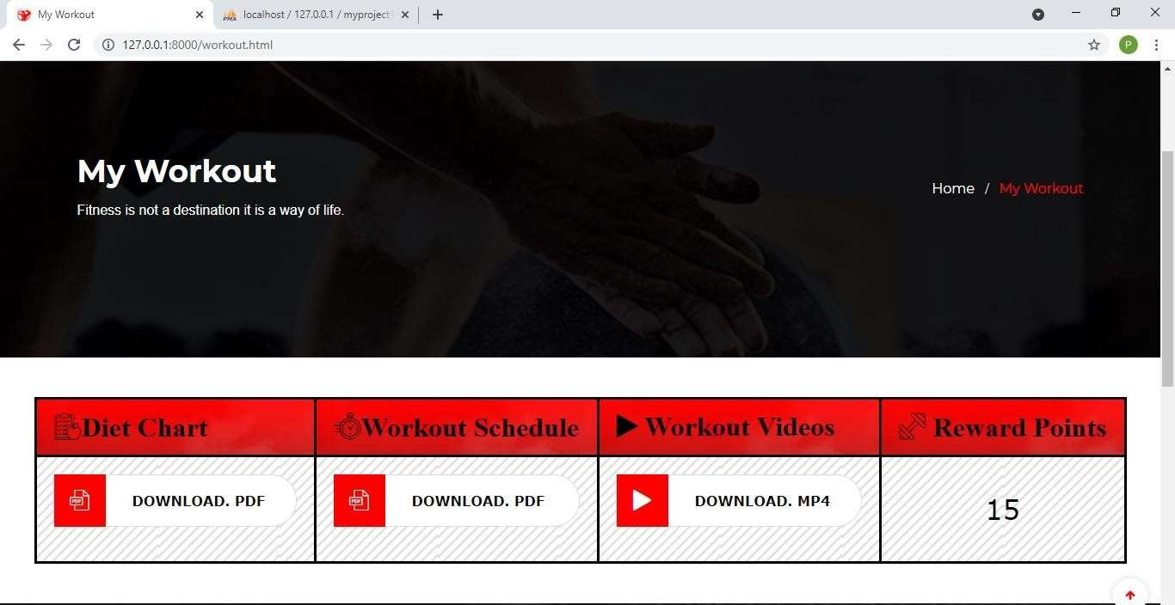

Blog Page:- It contains all the fitness blogs that user can read.

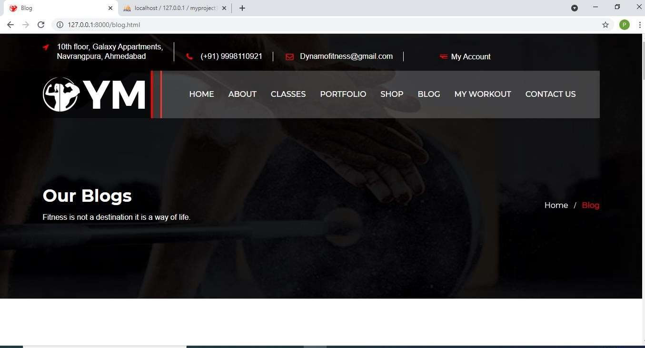

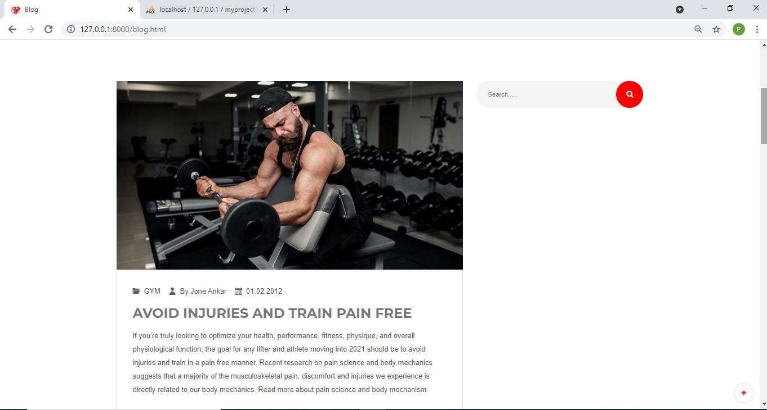

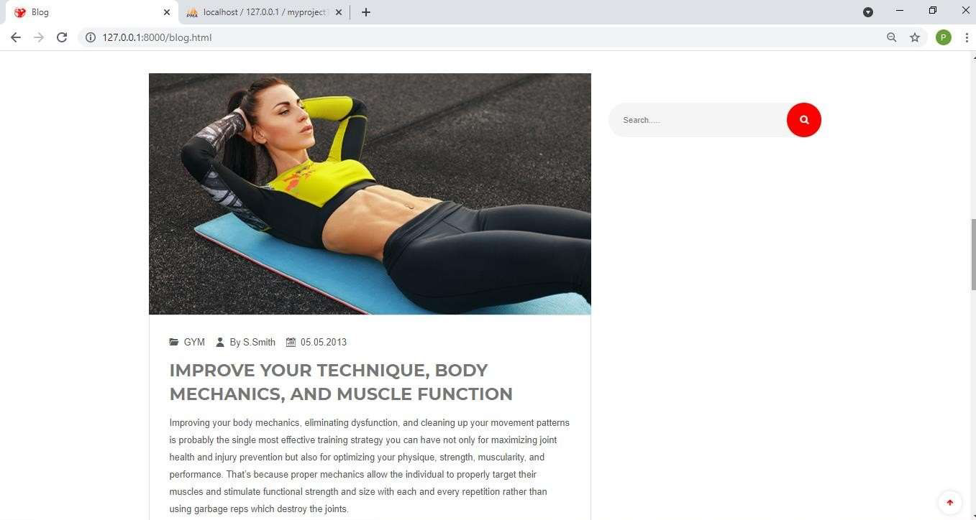

Hompage showing My Account Section having Options Profile, Membership, Attendance, Logout:-

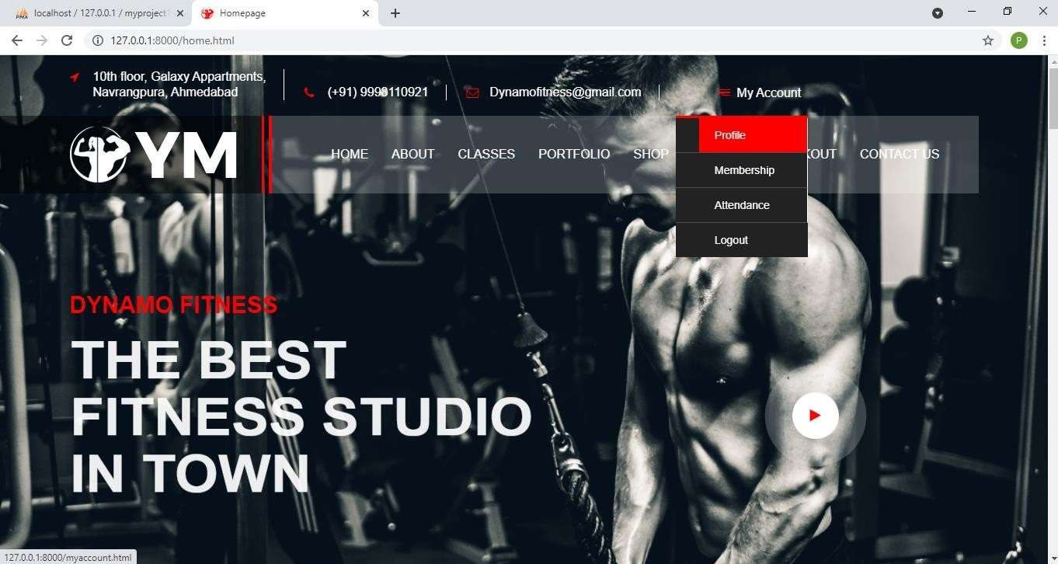

On clicking Profile Option in My Account Section, User will be redirected to My account Page which contains all details of currently Logged In User like name, address, gender, email, mobile, etc. with Edit Profile/Change Password Option.

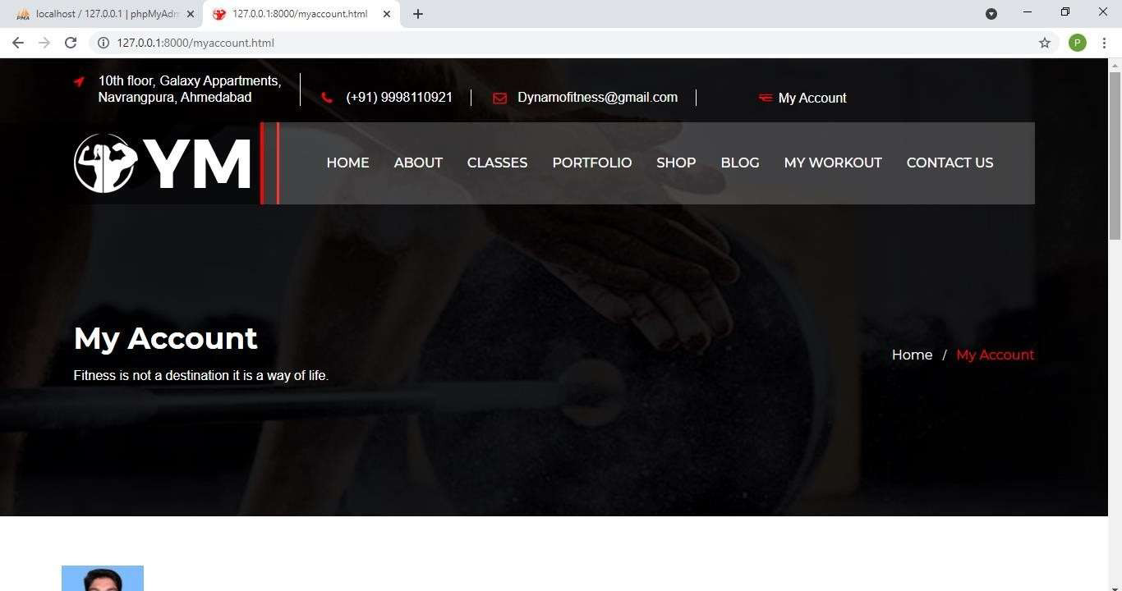

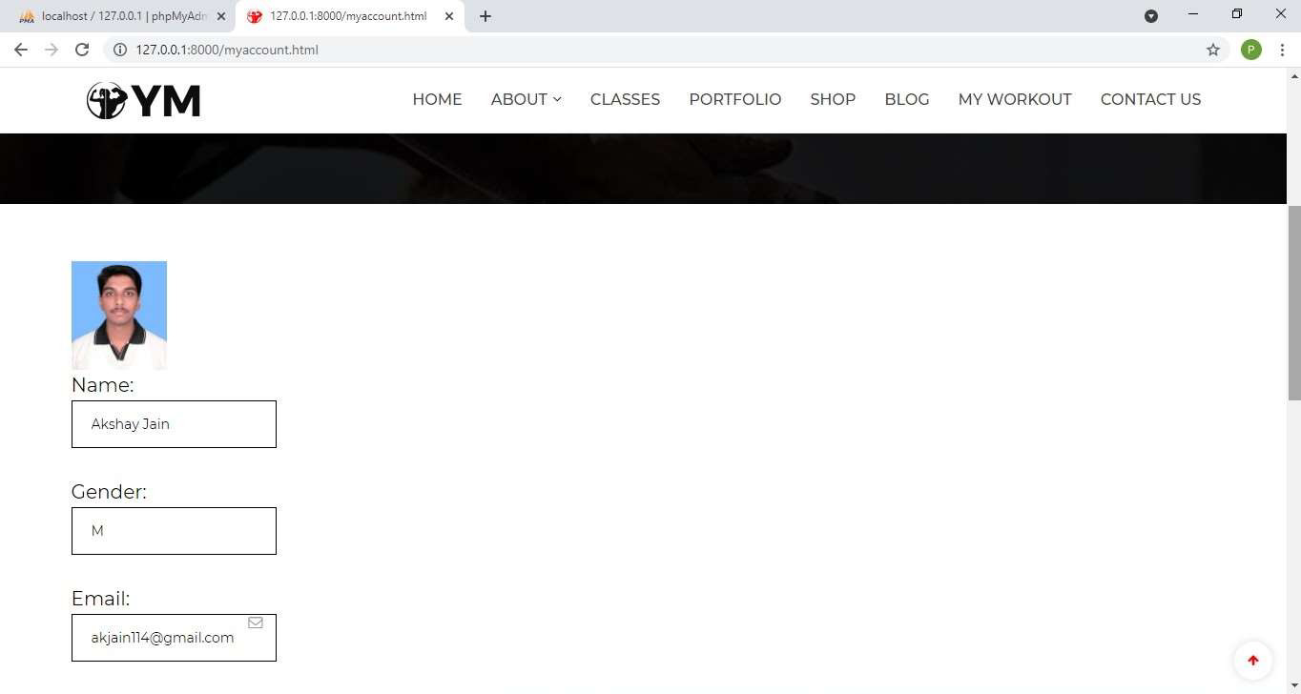

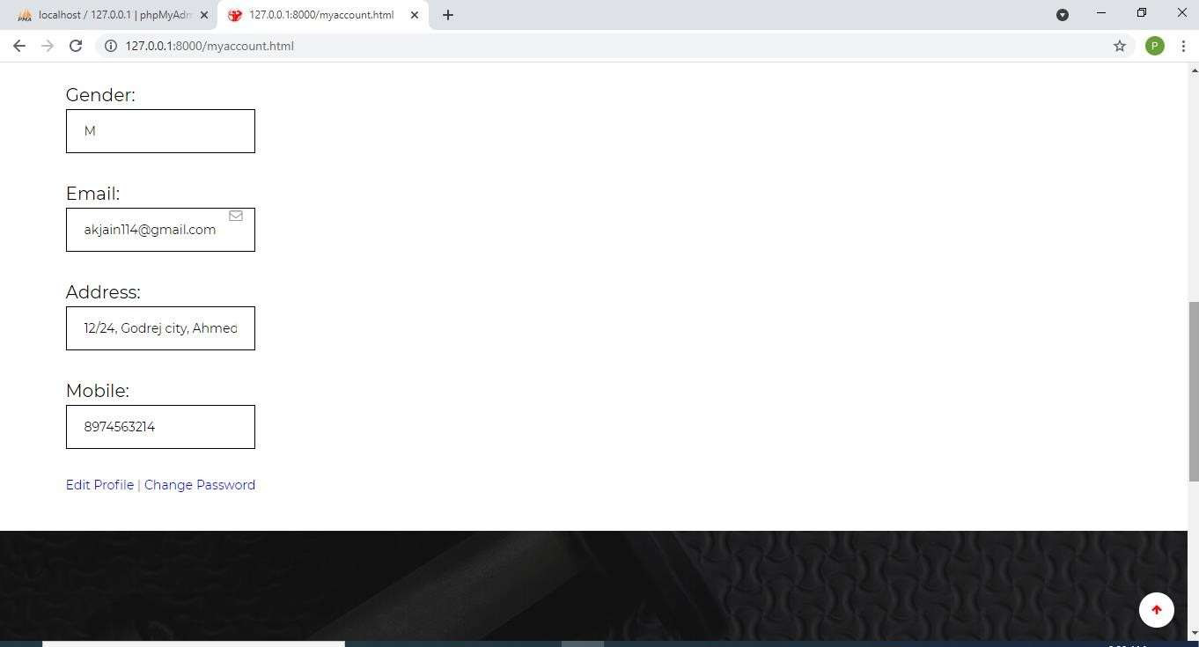

When User Clicks on Change Password, he/she will be redirected to Change password Page where user can change his/her old password new password.

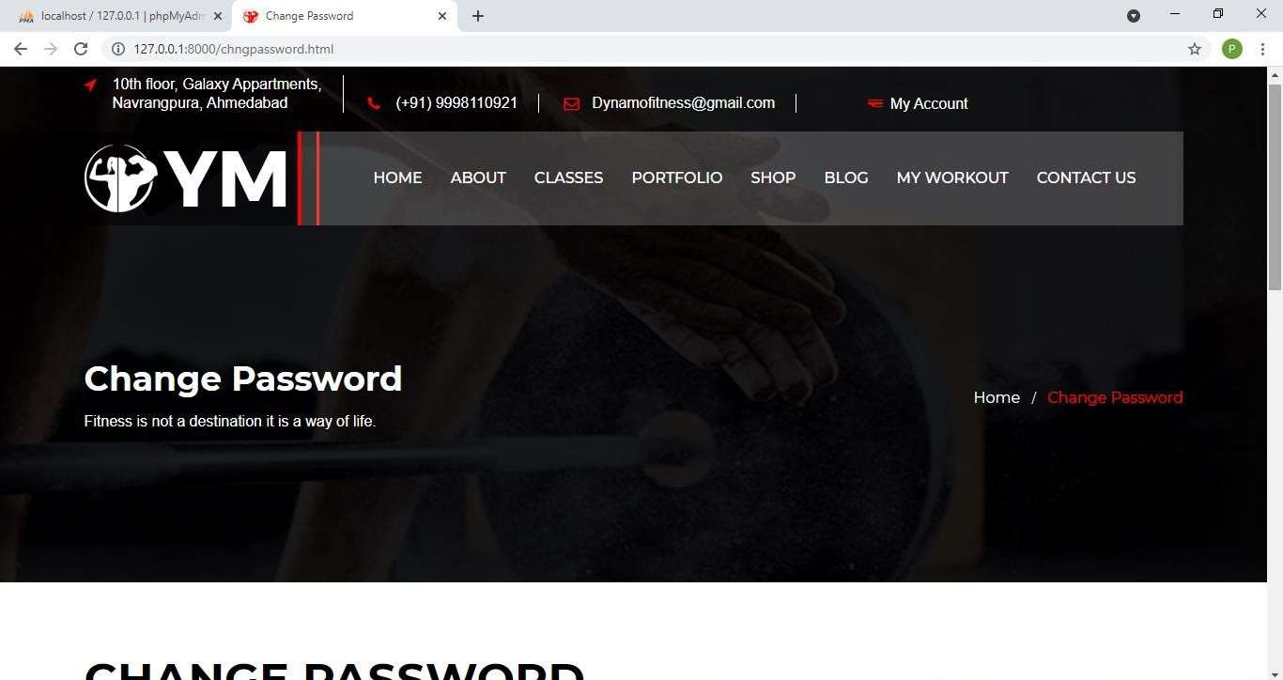

Change password Validations:-

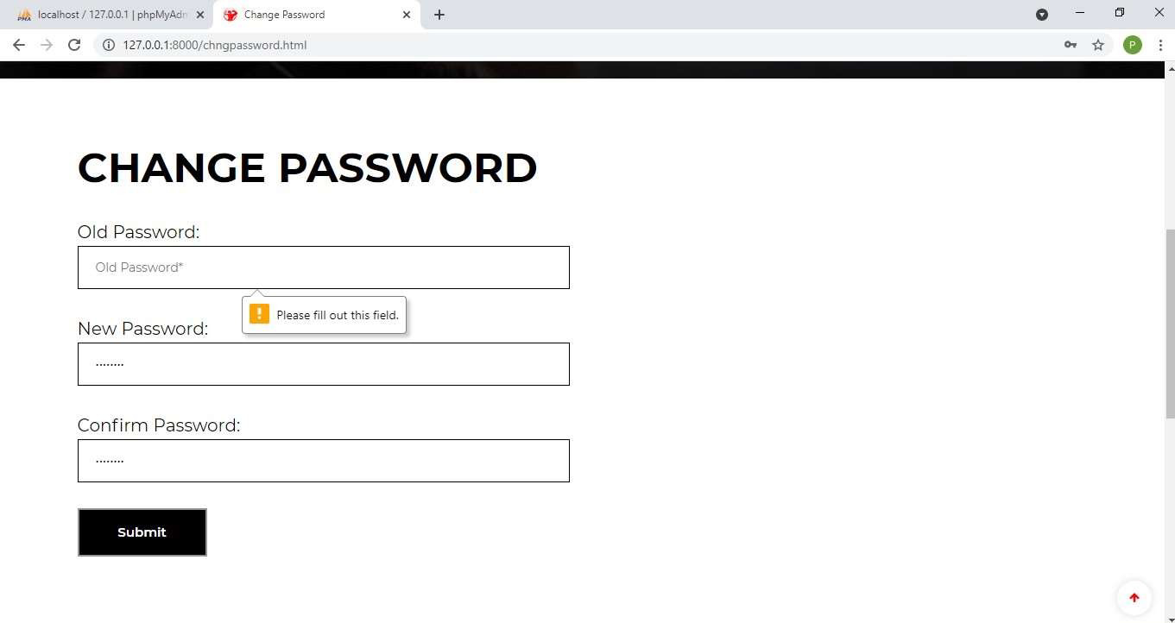

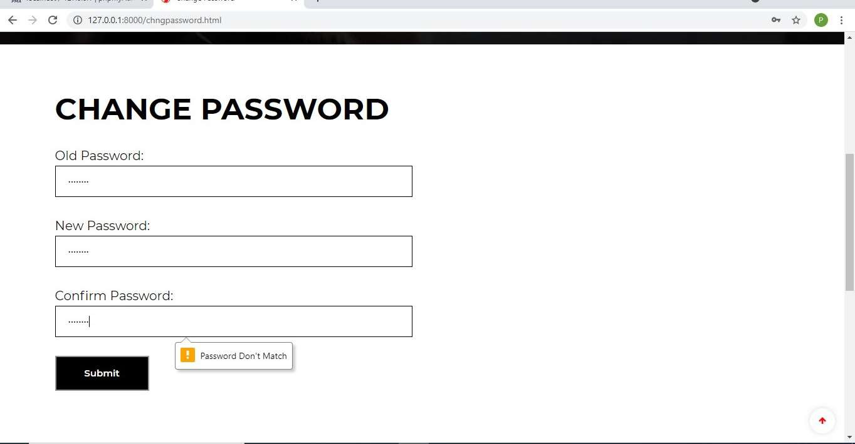

Showing Logout Option In My Account Menu:-

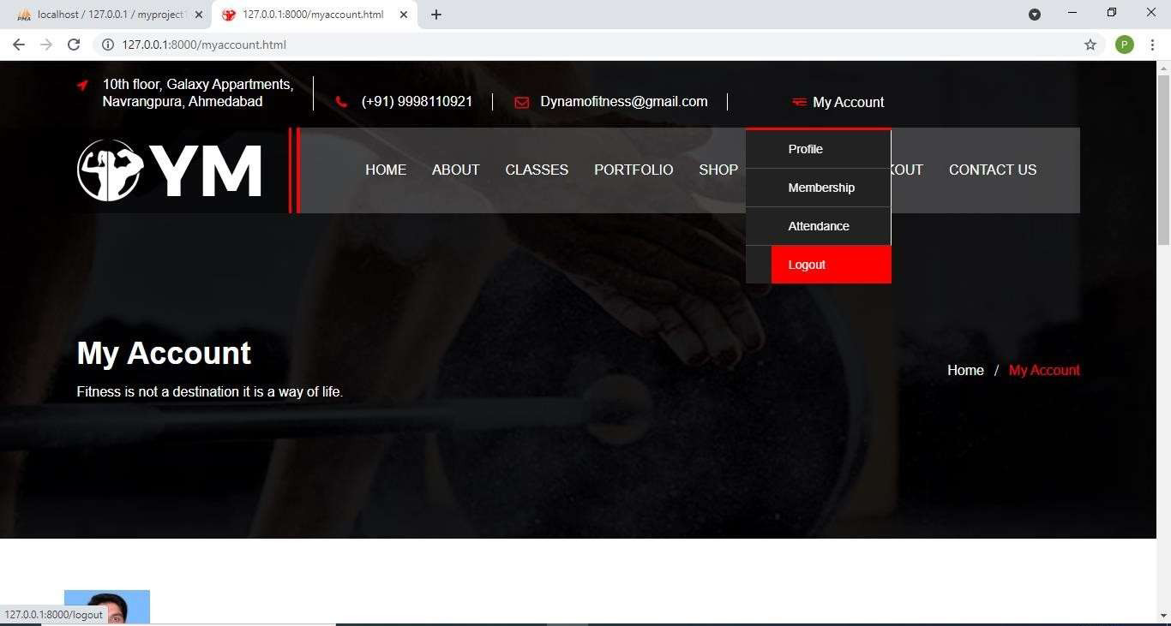

When User Clicks on Logout, he/she will redirected to Login Page.

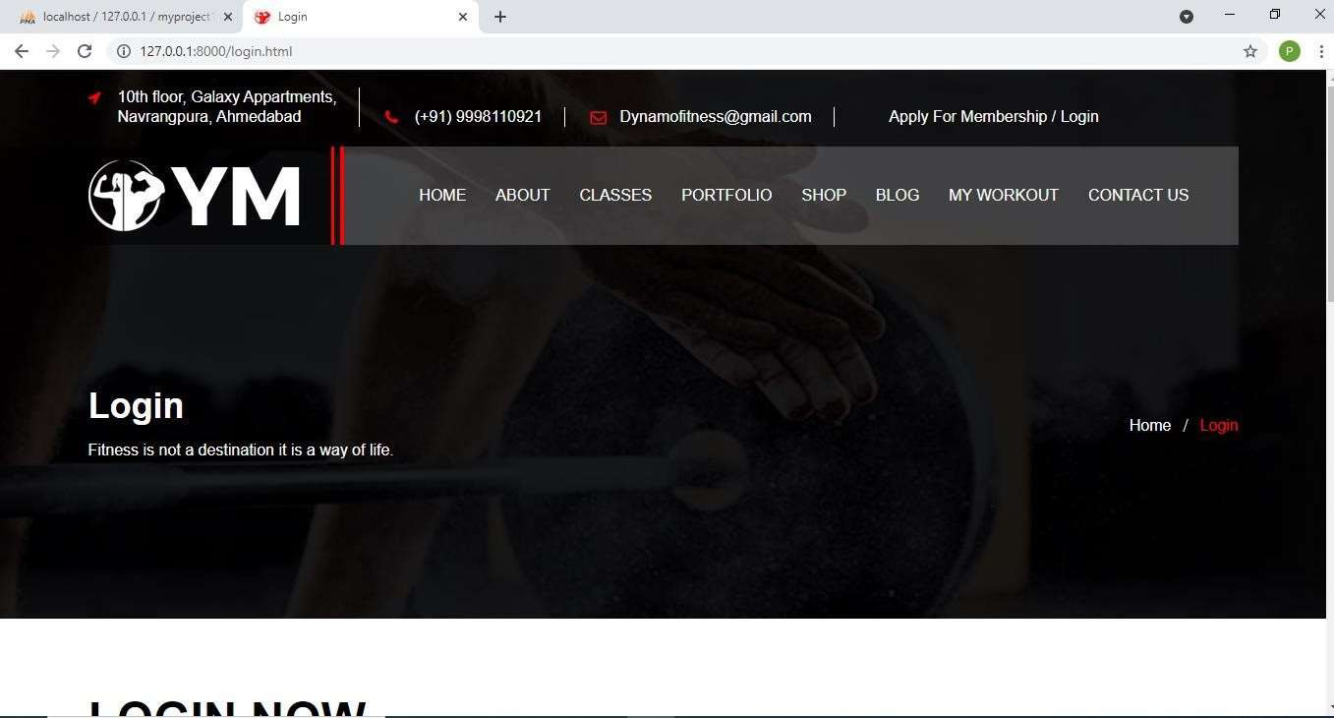

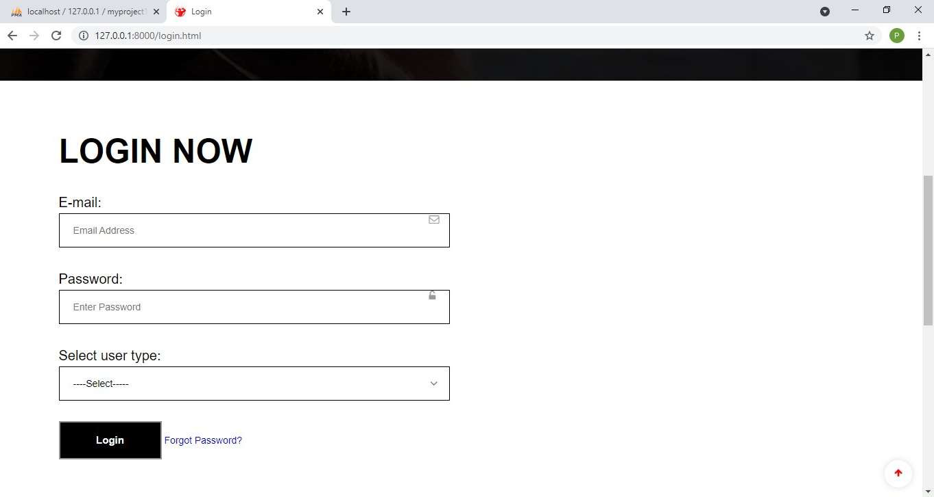

### TECHNICAL IMPLEMENTATION & ANALYSIS

**Login form**

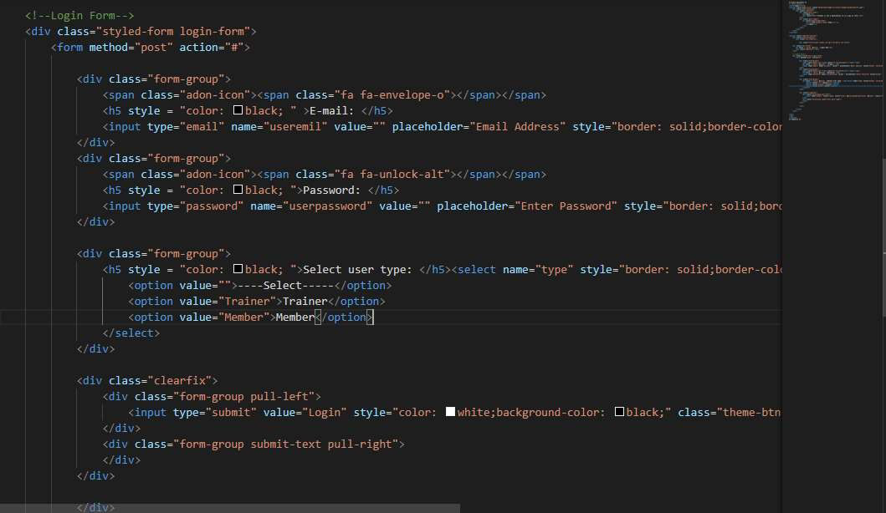

### Home page

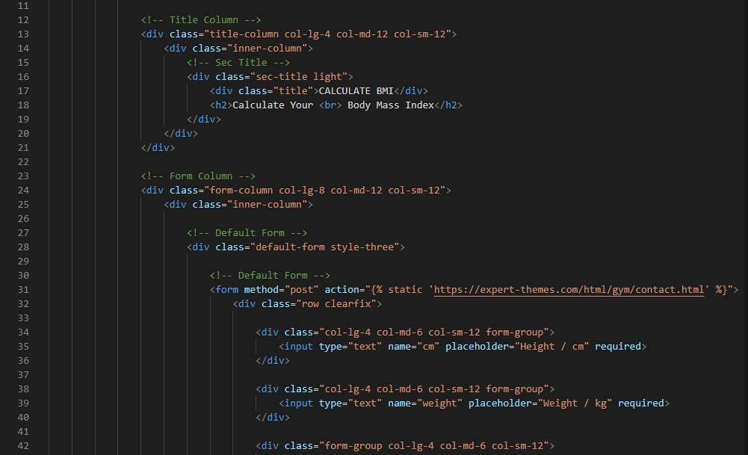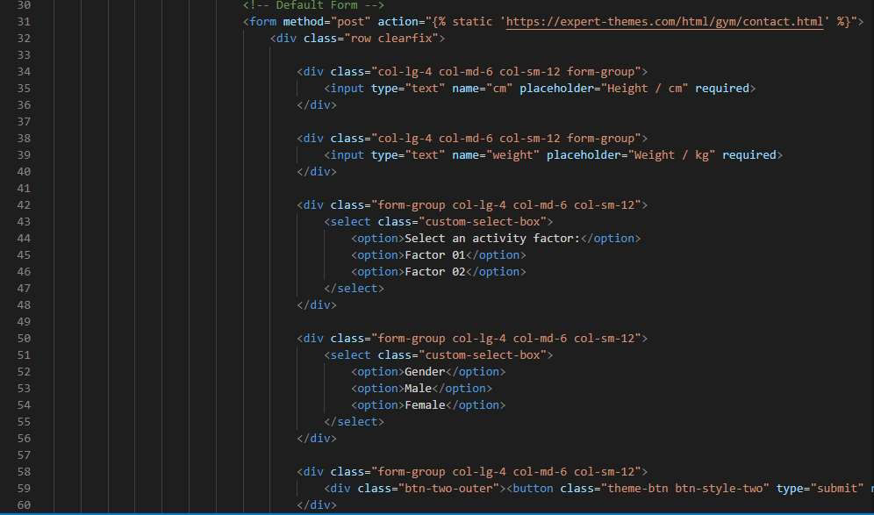

**PROJECT OUTCOME AND APPLICABILITY**

# Outline

Many children across the globe are unable to continue their studies because of their financial condition. And donation sites are flooded by the unauthenticated people which makes it difficult for the students to acquire donation for the studies. This is where Shiksha Anudan came into picture. Shiksha Anudan is across platform application which helps students to acquire funding to continue their education. It connects student to the donor who are willing to fund their education.

Significant project outcomes

#### Managing Donation

With our application Shiksha Anudan, Student register himself/herself submit his/her document fpr the verfivation of the identity as well as educational background. After verification of the Student, his/her profile will be created and it will be available for the donation. Whenever the Student profile receive donation his asked amount will be reduced after the successful transaction by the donor. Until student profile receive full asked amount his/her donation will be kept in his/her Shiksha Anudan profile, when the donation will be receiced in full whole amount will be transferred to student account.

#### Decision-Making Support

Shiksha Anudan include guidance in determining business decisions. This ties into cost reduction, as you can use data from software to **make informed decisions, and carry out those decisions** directly within the software’s features.

This ensures that everything you do is based on real information and not just ‘a hunch’. Plus, you’ll be able to **share your insights with the team, brainstorm solutions, and generate reports** and records to ensure that things are done properly every step of the way.

# Project applicability on Real-world applications

Although there may be nothing wrong with current system, club management software can optimize your fitness center operations. It can help you and your team perform tasks more efficiently, saving time and wasted resources. Sometimes the administrative tasks feel they will completely overload you. If you can automate routine tasks like membership renewal, member check-in, and data entry, it can streamline the way you operate. This will give you and your staff more time and energy to focus on other areas of the business that will impact the bottom line.

#### It helps you to create an incredible member experience

Creating an incredible and unique member experience is a massive part of running a successful fitness business. A great member experience results in happy and satisfied members. When your members enjoy your workout, culture, and community, it can increase member retention and reduce churn.

Software with a user-friendly member mobile app gives customers access to class scheduling, payments, and membership details. The journey from booking to paying for a class should be intuitive without any hurdles. Think about how gym management software can take the hassle out of signing up to the gym. Members can use a digital waiver and avoid a long conversation at the front desk.

It helps you to make better-informed decisions

Although 91% of companies state that data-driven decisions are important for their company, only 57% of companies say that they actually base their decisions on data. If you can harness and understand data, you can make more impactful decisions. We’re living in a time where there has never been more data. Gym management software gives you access to real-time metrics and analytics so that you can have deeper insights into retail sales, membership performance, and the overall state of the business.

# Inference

Using online gym management will benefit you in many ways. People should take advantage of going to the gym when they can and the rest of the time they workout at home with videos. It helps us to feel more relaxed and better about ourselves. And it reduces the workload of the admin by Managing a fitness club involves a slew of administrative tasks such as payments, invoices, contracts, billing, cancellations, etc. Traditionally, you would need a whole team to look after different accounts. In this way, it is very helpful.

CONCLUSIONS AND RECOMMENDATION

**CONCLUSION**

The entire duration of this project has been a great learning experience for us. It has introduced us to the working of the real-life projects and taught us to face obstacles while developing them. By development of this cross platform application, we here by conclude that Shiksha Anudan we have achieved our aim at following:

1. Building a platform where Student can ask for donation for their education. Which can save them into falling into the debt trap where they take bank loan to repay bank loan.
2. We believe that this platform has made it easier for the Donor to find genuine Student for the donation.
3. This platform has also made it easier for administrator to manage donation as well as profile of the Student and Donors.

We also hope to expand the scale of the project and make it ubiquitous by developing it for all digital platforms.

**BIBLIOGRAPHY**

##### Book References:-

1. Mastering html,css and javascript web publishing Publisher: BPB

Author: Laura lemay

1. Starting out with Python Author:Tony Gaddis Publisher: Pearson
2. Book Name: Head First Object-Oriented Analysis and Design:A Brain Friendly Guide to OOA&D

Author: Brett D. McLaughlin, David West, and Gary PollicePublisher: O’Reilly Media

1. Book Name: Systems Analysis & Design Methods

Author: Gary B. Shelly, Thomas J. Cashman, and Harry J. RosenblattPublisher: Cengage Learling

##### Website references: -

[www.tutorialspoint.com](http://www.tutorialspoint.com/)

[www. w3school.com](http://www.w3school.com/)

[www.stackoverflow.com](http://www.stackoverflow.com/)

[www. djangoproject.com](http://www.djangoproject.com/) [www.edrawsoft.com](http://www.edrawsoft.com/)

[www.javatpoint.com](http://www.javatpoint.com/)

[www.lucidchart.com](http://www.lucidchart.com/)

[www.geeksforgeeks.org](http://www.geeksforgeeks.org/)